Work package 2.3

Partner
DTU Space: Rene Forsberg, Louise Sandberg Sørensen
CNRS:
NERSC:

Deliverable 2.3.1 in progress
Deliverable 2.3.2 in progress
Deliverable 2.3.3 CNRS
Deliverable 2.3.4 CNRS

Summary of progress
Ice sheet heights and mass changes of the Greenland ice sheet is obtained from ICESat data covering the period 2003-2008. INPUT NERSC AND CNRS

Task 2.3.1:
INPUT FROM NERSC
Measurements of radar altimeters from a series of satellites (ERS1, ERS-2 and Envisat) will be investigated for surface-elevation changes from 1992 onward. Surface-elevation time series based of crossover analysis will be used to investigate of inter-satellite biases. Correlation between elevation and backscattered power will be taken into account. (month 18)

Task 2.3.2:
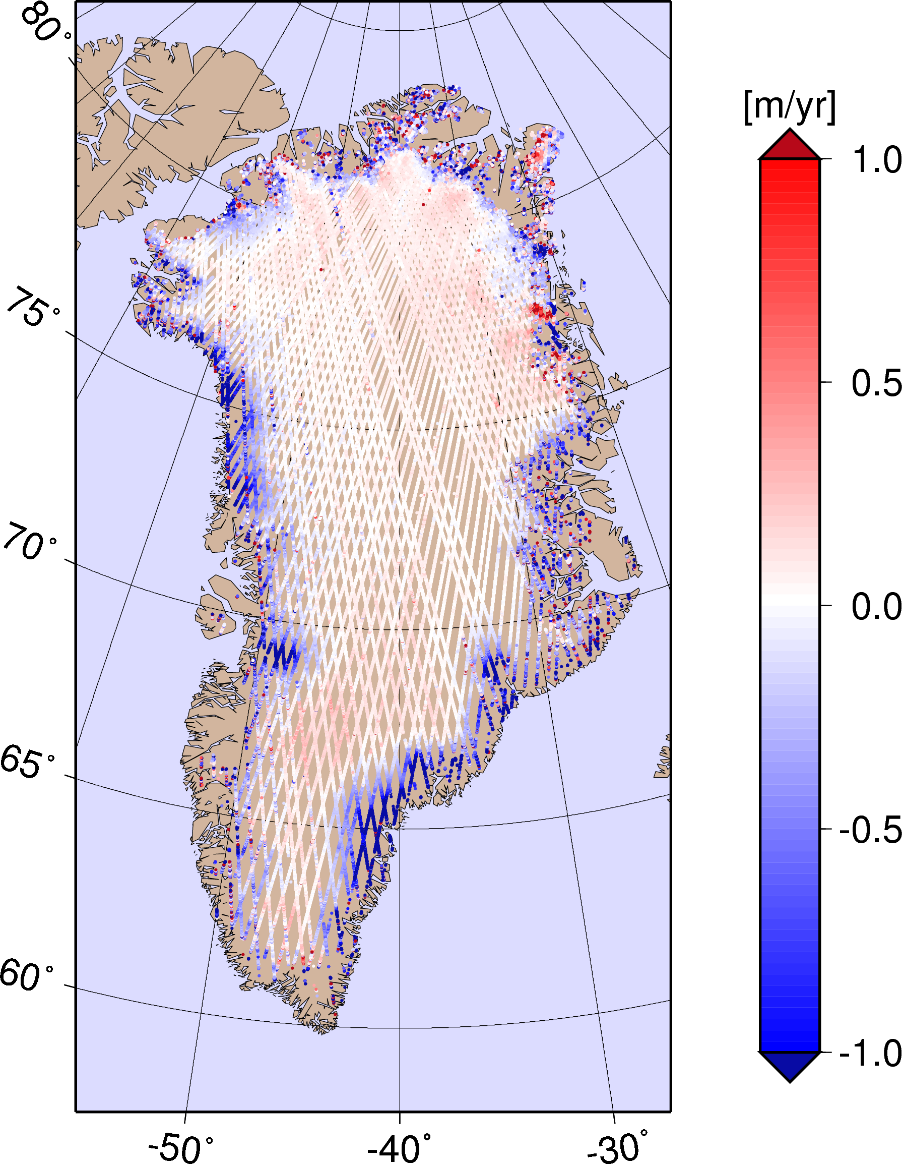Three different methods for deriving surface elevation changes (dH/dt) of the Greenland Ice Sheet from ICESat data have been used. The ICESat data time span is March 2003 to October 2008. The results are presented in Sørensen et al., 2011. The results are available as grids (5km x 5km resolution) and as dH/dt estimates (approx. 500m resolution) in the repeated groundtracks.
The figure to the right shows the rate of surface elevation change in the satellite ground tracks. Based on ICESat data 2003-2008 (Sørensen et al., 2011).

Task 2.3.3:
INPUT FROM CNRS
GRACE satellite data will be investigated from mass-con inversion and filtering solutions, based on monthly or 10-day solutions from different Level-4 processing centers (CSR, GFZ, JPL, LEGOS), and combined into an estimated “joint” GRACE series of monthly mass balance and long-term trends. The GRACE data will be corrected for GIA effects (using different GIA models), to give a best total estimate in GT/year of current freshwater input to the Arctic Ocean, Norwegian-Greenland Seas, and the Baffin Bay/Davis Strait, respectively (and associated contribution to global mean sea level) (month 18)

Task 2.3.4
ADDITIONAL INPUT FROM CNRS
To jointly assess ice volume and mass changes from altimeter and GRACE missions, altimeter measurements of surface elevation change will be combined with modeled data on vertical motion of underlying ground associated with GIA as well. Differences of volume of mass changes will be investigated under the assumptions of temporal firn compaction and density changes, leading to an improved, unified understanding of total mass balance changes. Focus will be on long-term trends, and not the (larger) yearly mass balance. (month 36)
Surface elevation changes (dH/dt) estimates from ICESat are corrected for firn compaction, by a densification model driven by the HIRHAM5 regional climate model. The dH/dt estimates are furthermore corrected for movement of the bedrock (GIA and elastic response) and an ICESat inter-campaign bias. The corrected elevation changes are used to derive mass changes (on a 5km x 5km grid) using a model describing the associated snow/ice densities. The results are presented in Sørensen et al., 2011.
Furthermore, first investigations of validating the firn compaction models by annual layers detected by ASIRAS have been carried out, and the results are presented in Sørensen et al., 2010.
ICESat derived mass changes 2003-2008 given in m ice equivalent per year is shown in the figure to the right (Sørensen et al., 2011).

Impediments to progress
RENE
If applicable, explain the reasons for failing to achieve critical objectives and/or not being on schedule and explain the impact on other tasks as well as on available resources and planning
Outlook
RENE
Please outline the future for your activity and in particular deviations to plans to future deadlines
Resources
RENE
In particular outline and explain deviations between actual and planned person-months per work package and per beneficiary described in “Annex 1 - Description of Work”

List of related publications
L. S. Sørensen, S. B. Simonsen, K. Nielsen, P. Lucas-Picher, G. Spada, G. Adalgeirsdottir, R. Forsberg, C. S. Hvidberg: Mass balance of the Greenland ice sheet (2003–2008) from ICESat data – the impact of interpolation, sampling and ﬁrn density, The Cryosphere, 5, 173-186, 2011, doi:10.5194/tc-5-173-2011, www.the-cryosphere.net/5/173/2011
L. S. Sørensen, L. Stenseng, S. B. Simonsen, R. Forsberg, S. K. Poulsen, V. Helm: Greenland Ice Sheet changes from space using laser, radar and gravity, ESA Living Planet Conference, ESA Special Publication SP-686, 2010.

