WP 6: Comparison of sea ice freeboard heights from satellite altimetry and airborne laser scanner measurements
The airborne data set from 2011 (presented in chapter Airborne laser measurements of sea ice freeboard heights) could, in principle, be compared to CryoSat-2 radar altimetry. However, the CryoSat-2 data are not ready for such comparison studies and is left for later analysis, see section Sea ice freeboard heights from satellite altimetry.
The only overlapping data sets are freeboard heights from airborne laser scanner and ICESat measurements from 2008. The laser scanner freeboard heights are plotted on top of the ICEsat freeboard heights in figure 1. Direct comparison is questionable, as the airborne data set is from April 24, whereas the ICESat is from the period February 17 – March 21. However, the sea ice thickness is about its annual maximum in February-March, and except for the changes due to ice drift there is not expected much changes in the sea ice distribution north of 76⁰N before the beginning of May.
The sea ice freeboard distribution of all airborne laser scanner data from 2008 (figure 1), is plotted in figure 2, together with the freeboard distributions from all ICESat periods 2003-2008. The 2008 ICESat distribution, matches best the distribution of the airborne freeboard heights with FYI representing the major parts. The distribution of ICESat freeboard heights tend to underestimate the presence of thick ice and deformed ice, e.g. the ice represented by the tail of the distribution is not as pronounced as in the case of airborne laser measurements.
This is explained by direct comparison of sea ice freeboard heights from coincident tracks of ICESat and airborne laser scanner measurements. In Skourup and Forsberg (2006) it is shown, that the "lowest-level" filtering technique applied to ICESat data underestimates the sea ice freeboard heights by up to 37 cm in heavy ice conditions with only a few open leads. The bias is a result of the lower spatial sampling of ICESat and of the averaging of the freeboard across the footprint, whereas the high resolution airborne laser scanner data system picks up even the smallest leads and hence freeboard heights from these data should not be biased. This is consistent with results from a similar study made by Kurtz et al. (2008), who found a bias of less than 2 cm, between ICESat freeboard heights and airborne laser freeboard heights, in areas of relative flat ice with many open leads. In areas of thicker ice with fewer open leads they found that the ICESat freeboard heights were underestimated by up to 9 cm. Thus, the biases introduced from the "lowest-level" filtering technique are dependent on sea ice concentration and ice thickness, where thick ice and ice of high concentration are underestimated.
The freeboard distribution plots of the 2011 airborne flights are plotted together with the ICESat distribution plots in figure 3. All the data used is plotted in figure 7 chapter Airborne laser measurements of sea ice freeboard heights. The 2011 freeboard distribution is best represented by the ICESat distributions of 2005 and 2006.

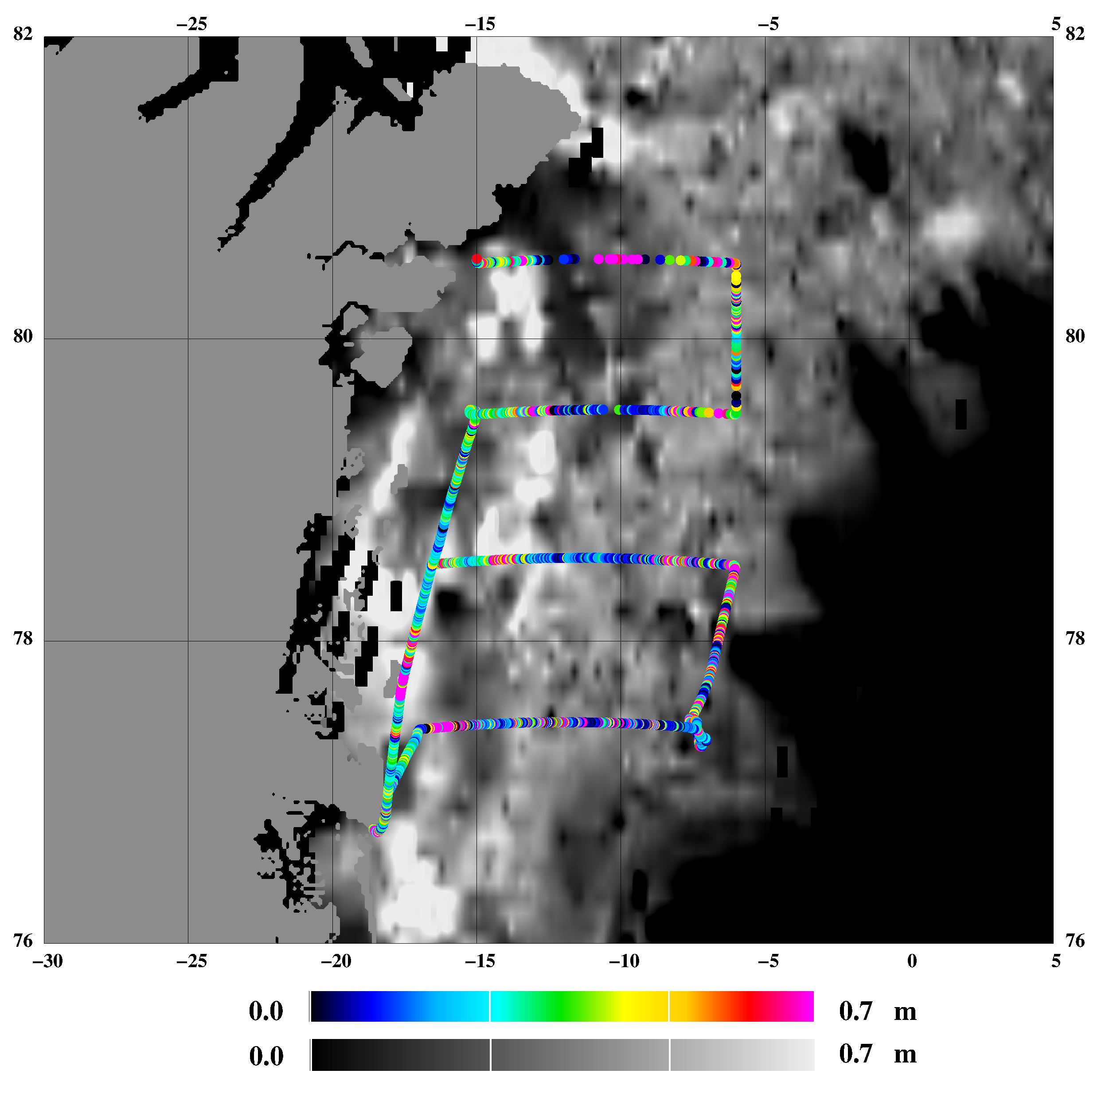
Figure 1: Freeboard heights from 2008 airborne laser scanner (April 24) overlaid ICESat freeboard heights (February 17 – March 21)
Figure 2: Freeboard distribution from 2008 airborne laser scanner (green histogram) and 2003-2008 ICESat (lines)
4
Figure 3: Freeboard distribution from 2011 airborne laser scanner (cyan histogram) and 2003-2008 ICESat (lines)
References
Skourup, H. and R. Forsberg: Sea ice freeboards from ICESat - A comparison to airborne lidar measurements. Arctic Sea Ice Thickness: Past, Present and Future, edited by P. Wadhams and G. Amanatidis. Climate Change and Natural Hazards Series, Brussels, 2006

Kurtz, N. T., Markus, T. M., Cavalieri, D. J., Krabill,W., Sonntag, J. G., and Miller, J.: Comparison of ICESat data with airborne laser altimeter measurements over Arctic sea ice. IEEE Transaction on Geoscience and Remote Sensing, 46(7):1913–1924, 2008

