WP 5: Airborne laser measurements of sea ice freeboard heights

DTU Space coordinated an airborne campaign in April 2011, to obtain high-resolution laser scanner measurements for estimation of sea ice freeboard heights in the Fram Strait. The tracks were selected to match flight tracks from a similar survey conducted in April 2008, see Figure 1.

The Fram Strait campaign was carried out in connection with mobilization of ESA’s CryoSat-2 Validation Experiment (CryoVEx-2011), thus the aircraft was equipped with an advanced 13.5 GHz radar altimeter (ASIRAS), which is an airborne version of the radar altimeter carried onboard CryoSat-2. Processing of the ASIRAS data is ongoing, however, it is rather time consuming and the processed data will not be available until the beginning of 2012. To support the analysis of laser scanner and ASIRAS data, vertical photography and video recordings were collected during flight.

In this study, we present sea ice freeboard heights (including the snow layer) obtained from the laser scanner measurements of the 2011 survey flights. The data is compared to the 2008 airborne survey to demonstrate relative changes in the sea ice freeboard heights. As the airborne laser scanner measures the surface height with higher resolution and precision, than by the use of satellite altimetry, the airborne measurements are used to validate the ICESat freeboard heights, see chapter (comparison of sea ice freeboard heights from satellite altimetry and airborne laser scanner measurements).

The 2011 campaign was a success. The first attempt, to repeat the 2008 survey tracks, was made on April 28 (blue line), see figure 1. However, the survey was cut short, due to low clouds and fog (less than 300m) in the area. To finish the planned tracks, a successful flight was carried out on May 3 (green line) in excellent weather conditions. The major part of the 2008 survey was measured on April 24 (green lines) and on April 21 only the south-eastern corner was measured (blue line). For a more detailed description of the 2008 survey, see Hvidegaard et al (2008).
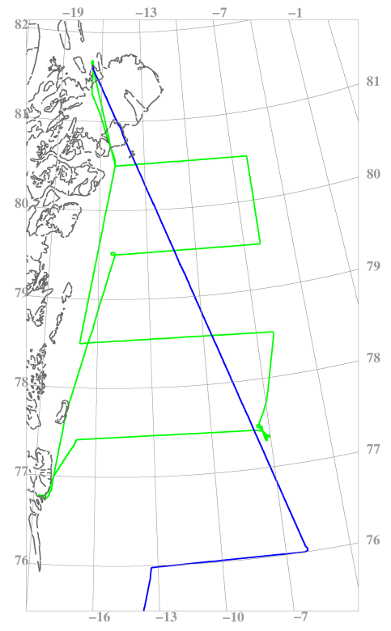
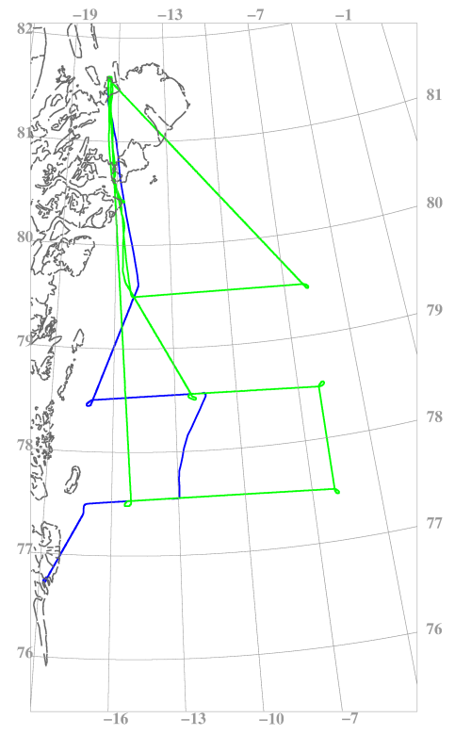
2011
2008

Figure 1: Flight tracks in the Fram Strait 2011 (left) and 2008 (right)
In general the sea ice was broken up with lots of open water leads and leads covered by thin ice (grey-white), see figure 2. Icebergs were primarily frozen into the fast ice near the coast. The shape of the icebergs are best described as large flat tabular or wedged, see figure 3.
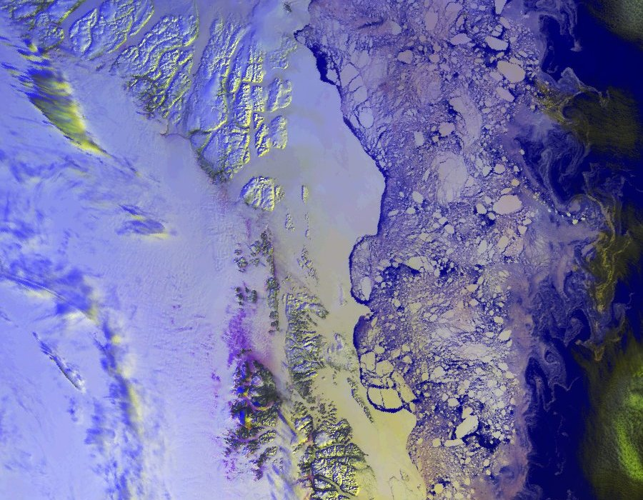

Figure 2: sea ice in the Jøkelbugt, NOAA AVHRR satellite image, 2011-05-03 11:18 UTC.
By courtesy, DMI

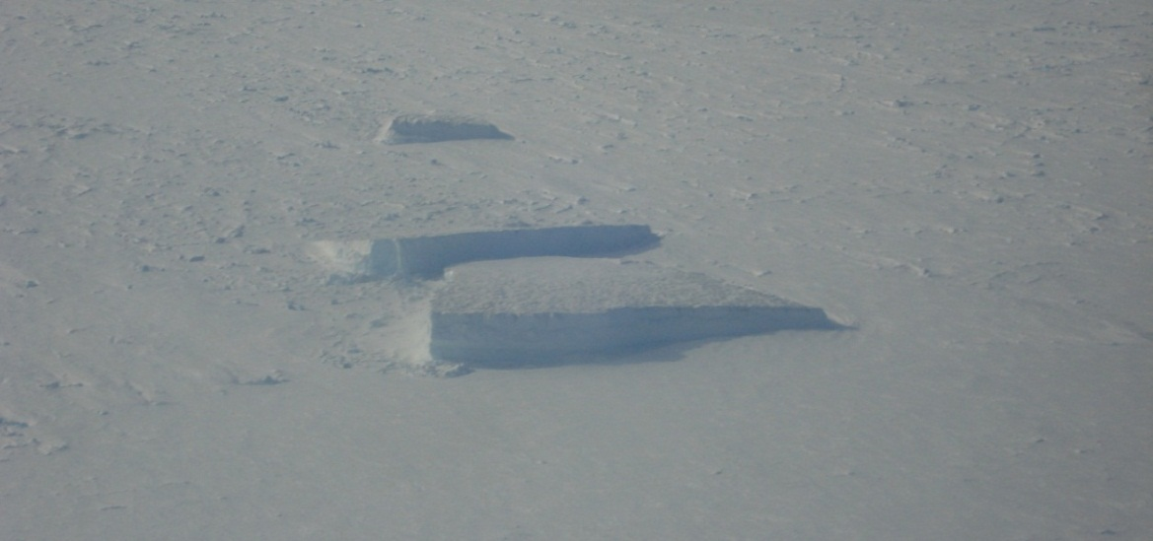

Figure 3: Photo of typical ice bergs (Photo: H. Skourup)
The airborne laser scanner used here, is a laser scanner (Riegl LMS Q240i) measuring with a horizontal resolution of 0.75m x 1m at a flight height of 300m and a ground speed of 250 kph. This is the same scanner as used in the 2008 flights (Hvidegaard et al, 2008). The across-track swath width is roughly equal to the flight height, and the vertical accuracy is in the order of 10 – 20cm depending primarily on uncertainties in the kinematic GPS-solutions, due to long baselines (Krabill et al, 1995). For more information on the airborne instrumentation and the system setup, see Hvidegaard et al (2006).

The freeboard heights are obtained by using a lowest-level estimation method, similar to the method used for the ICESat altimeter. However, it is adapted to the higher resolution of the laser scanner system (Hvidegaard and Forsberg, 2002). An example of sea ice freeboard heights from a full resolution laser scanner swath is shown in figure 4. For consistency, we use the same freeboard to thickness conversion, k=5.5, as used in 2008 for the Fram Strait (Hvidegaard et al, 2008).

Sea ice freeboard distributions from the laser scanner measurements are plotted in figure 5. Each distribution represent sea ice along a latitude (77.5⁰N, 78.5⁰N and 79.5⁰N), thus each distribution includes both fast ice, drifting MYI, as well as marginal ice. The dominant ice has freeboard heights of 60-75cm corresponding to an ice thickness of 3.3-4.1m, which is characterized as MYI or deformed ice. A smaller peak of about 15-35cm is present in the northernmost and southernmost tracks representing FYI.

For comparison the freeboard distributions covering the same tracks from 2008 are shown in figure 6. Here the dominant ice type is FYI, with a peak freeboard height of about 15-25cm corresponding to thicknesses of 0.8-1.4m. The small amount of MYI in the Fram Strait in 2008 is supported by the ice type distribution of scatterometer data (section Ice type from scatterometer data) and sea ice freeboard heights from ICESat (section Sea ice freeboard heights from satellite altimetry), whereas the large amount of MYI in 2011 seems to represent years with a large distribution of thick ice such as 2005 and 2006. A more detailed comparison of sea ice freeboard heights from airborne laser scanner measurements and ICESat is given in chapter Comparison of sea ice freeboard heights from satellite altimetry and airborne laser scanner measurements.

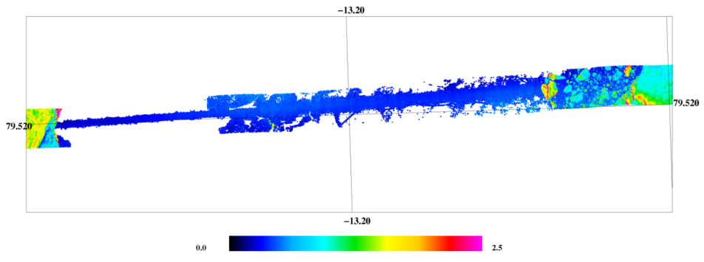
The average ice thickness (using k=5.5) for the 2011 flight, together with the sea ice distribution of ice thicker than 80cm, are shown in Figure 7. Each value represents all data within blocks of 3 degrees longitude x 1 degree latitude. This plot also reveals the differences in distribution of MYI and FYI between 2011 and 2008, when compared to a similar plot from 2008 (Figure 23 in Hvidegaard et al, 2008).

Figure 4: Full resolution sea ice freeboard heights from airborne laser scanner (unit is given in m)
79.5⁰N  Freeboard : 15-20cm and 60-65cm  Thickness: 0.8-1.1m and 3.3-3.6m | 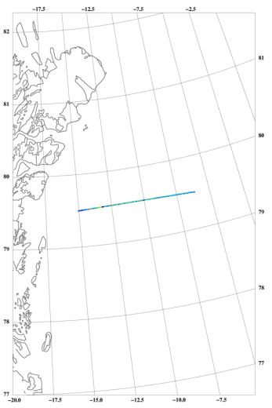
78.5⁰N  Freeboard : 60-65cm  Thickness: 3.3-3.6m | 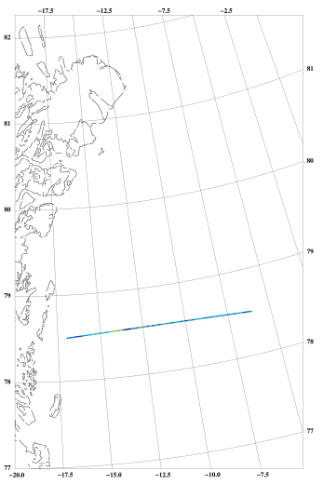
77.5⁰N  Freeboard : 25-35cm and 70-75cm  Thickness: 1.4-1.9m and 3.9-4.1m | 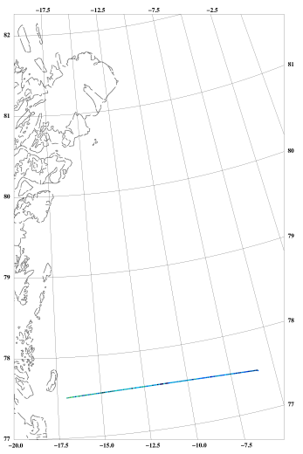

Figure 4: Distribution of sea ice freeboard heights from airborne laser scanner measurements from May 3, 2011
79.5⁰N
Freeboard : 15-20cm
Thickness: 0.8-1.1m
78.5⁰N
Freeboard : 20-25cm and 45-50cm
Thickness: 1.1-1.4m and 2.5-2.8m
77.5⁰N
Freeboard : 20-25cm and 45-50cm
Thickness: 1.1-1.4m and 2.5-2.8m
77.5⁰N
Freeboard : 20-25cm and 45-50cm
Thickness: 1.1-1.4m and 2.5-2.8m
Figure 6: Distribution of sea ice freeboard heights from airborne laser scanner measurements from April 24, 2008

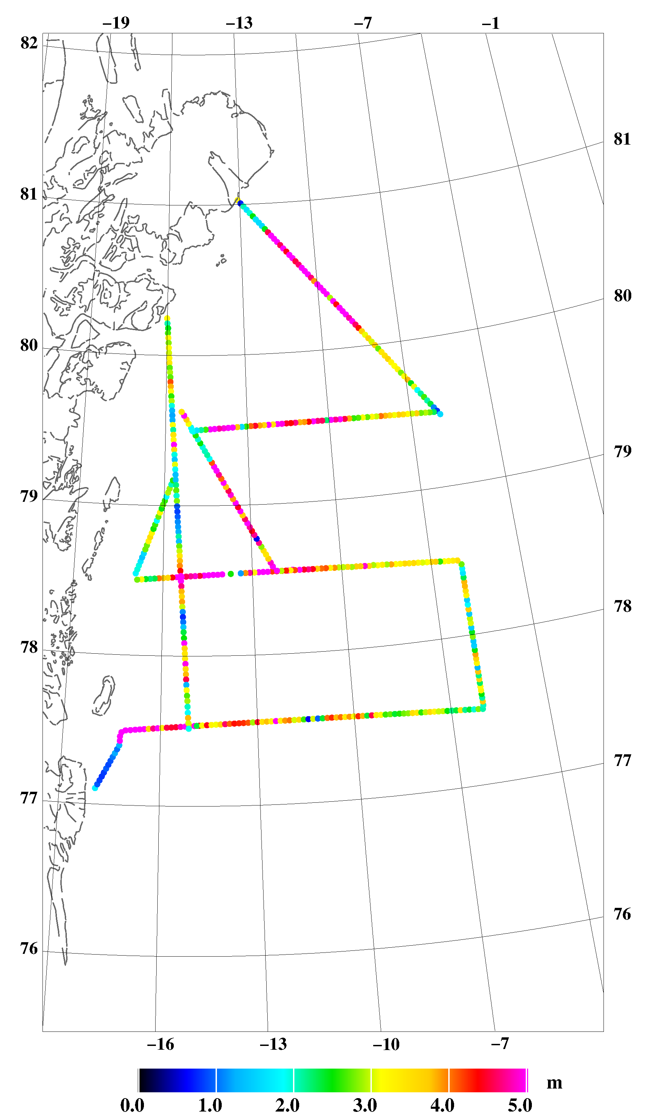
4.25 m
85 %
3.43 m
75 %
3.32 m
80 %
3.08 m
88 %
2.65 m
78 %
2.82 m
79 %
3.40 m
93 %
4.00 m
83 %
3.17 m
89 %
3.26 m
94 %
4.41 m
80 %
3.51 m
89 %
2.40 m
75 %
4.75 m
92 %

Figure 7: Ice thickness in the NE Greenland shelf area from lidar. Numbers show averages in 3 degree longitude x 1 degree latitude blocks, along with probability of ice thickness greater than 80 cm

References

Hvidegaard, S. M., R. Forsberg, S. Hanson, H. Skourup, and L. T. Pedersen: Sea ice conditions off NW and NE Greenland from satellite measurements, airborne and in-situ data. Contract report for Greenland Bureau of Minerals and Petroleum, October 2008

Krabill, W. B., R. H. Thomas, C. F. Martin, R. N. Swift, and E. B. Frederick. Accuracy of airborne
laser altimetry over the Greenland icesheet. Int. J. Remote Sensing, 16(7):1211–1222, 1995

Hvidegaard, S.M, R. Forsberg, and H. Skourup. Sea ice thickness estimates from airborne laser
scanning. In P. Wadhams and G. Amanatidis, editors, Arctic Sea Ice Thickness: Past, Present and
Future. Climate Change and Natural Hazards Series, Brussels, 2006

Hvidegaard, S. M. and Forsberg, R. 2002: Sea-ice thickness from airborne laser altimetry over the Arctic Ocean north of Greenland. Geophysical Research Letters, 29(20):1952, 2002

