WP 2: Sea ice freeboard heights from satellite altimetry

Recent studies have proved satellite altimetry to be used for estimating Arctic Ocean sea ice freeboard heights (Skourup (2010), Farrell et al (2009), Giles et al (2008), Kwok et al (2007, 2005, 2004), Forsberg and Skourup (2005), Peacock and Laxon (2004), Laxon et al (2003)).

In this study, we estimate freeboard heights from NASA’s Ice, Cloud and land Elevation Satellite (ICESat), which provided laser altimetry measurements of sea ice from January 2003 to October 2009. To obtain sea ice freeboard heights beyond ICESat, ESA launched the Earth explorer satellite CryoSat-2 in April 2010, dedicated to measure the cryosphere of the Earth by advanced radar altimetry. Unfortunately, there are problems with the processing of the special “sea ice mode” used in sea ice covered areas. Reprocessing of data is planned to be carried out by ESA during December 2011, and the improved data set will be available to the users in the beginning of 2012, where sea ice freeboard maps of the Arctic will be estimated accordingly. Some first results of CryoSat-2 data sea ice and related issues are presented and discussed in Poulsen (2011). The only group (Centre for Polar Observation and Modelling, University College London) having access to raw CryoSat data, have been able to process CryoSat to obtain Arctic Ocean sea ice thicknesses for January-February 2011, see appendix Arctic Ocean sea ice thickness from CryoSat measurements. Based on a similar study for the Baffin Bay (reference til WESTKYSTRAPPORTEN), it is concluded that the ice thicknesses in the Baffin Bay are overestimated in the CryoSat ice thickness map.

We have used a lowest-level estimation method to derive sea ice freeboard heights (including the snow layer) for the Fram Strait from ICESat measurements. For a more detailed description of the procedures, see Skourup (2010). We include winter conditions (February-March) for each of the years 2003-2008, where the sea ice is close to the annual maximum (see chapter Rasmus). The maps of sea ice freeboard heights are shown in figure 2-7 with the licence areas marked by white lines. Each map represents data covering approx. 30 days of observation. ICESat measurements are obtained 40 times a second corresponding to an along-track separation of 172m. Within the 30 days observation period the track spacing is 20km at 75⁰N. Each ICESat measurement covers a surface spot-size (footprint) of approximately 70m in diameter with a vertical accuracy better than 15cm.

The sea ice freeboard height (f) to thickness (t) conversion $(t=k*f$) is debated in many papers and is highly variable depending primarily on snow conditions and to a less extent on sea ice type and settings. In previous studies of high resolution airborne laser scanner measurements of sea ice in the Fram Strait a k-factor of 5.5 was used, based on in situ measurements (Hvidegaard et al, 2008). However, when averaging over footprint areas similar to ICESat, recent studies of the relation between freeboard heights and draft by Doble et al (2011), finds a k-value of 4.4 for level ice and 5.2 for deformed ice in the central Arctic Ocean. Thus, it is suggested to use the value of 5.2 to convert the sea ice freeboard heights of ICESat into sea ice thicknesses in the license areas.

According to definitions of the WMO (World Meteorological Organization) sea ice nomenclature the thickness of multiyear ice (MYI) is defined to be thicker than 2m and firstyear ice (FYI) thinner than 2m. This, corresponds to freeboard heights of 38cm (using k=5.2). Thus, MYI or deformed ice are primarily found in areas with freeboard heights represented by yellow-red colours in figure 2-7, and FYI with freeboard heights represented by blue-green colours.

Visually, the distribution of MYI and FYI based on sea ice freeboard heights show good correlation with the “mode” distribution based on backscatter values from Quikscat scatterometer data with all the distinct ice characteristics for the area, see chapter ice type from scatterometer data, even part of the Odden area is present in the 2004 ICESat freeboard map.

The mean and standard deviation of the freeboard heights in the Fram Strait are given below the respective plots. The minimum freeboard height of 29cm is found in 2008 and the maximum of 45cm is found in 2005. Using a k-factor of 5.2 this corresponds to an average ice thickness of 1.5 and 2.3m, respectively. This is less than the Fram Strait average thickness of 3.25m (see chapter Rasmus). However, the lowest-level estimation method is dependent on open water leads and tends to underestimate ICESat sea ice freeboard heights in areas of thick ice or ice of high concentration. For a further discussion, see chapter Comparison of sea ice freeboard heights from satellite altimetry and airborne laser scanner measurements.

ICESat freeboard distributions are plotted in figure 1 with freeboard resolution of 0.1 m. Each histogram represents one ICESat period in the Fram Strait area. In general, the freeboard distributions have an asymmetric shape with a sharp increase in the leading edge and a long tail. This shape is characteristic for sea ice freeboard heights, drafts and thicknesses, where the long tail represents the presence of thick MYI and deformed ice due to ridging and rafting processes. The vertical black line represents the freeboard height separating FYI from MYI. The years 2005 and 2006 have distinct peaks for both MYI and FYI, and both distributions have a large amount of thick ice. The sea ice conditions in 2007 still have a larger amount of MYI, whereas the freeboard distributions of 2003, 2004 and 2008 have less deformed ice and a larger amount of FYI. This is consistent with the distribution of FYI and MYI in the Quikscat scatterometer data (chapter ice type from scatterometer data).

Figure 1: Distribution of sea ice freeboard heights in the Fram Strait

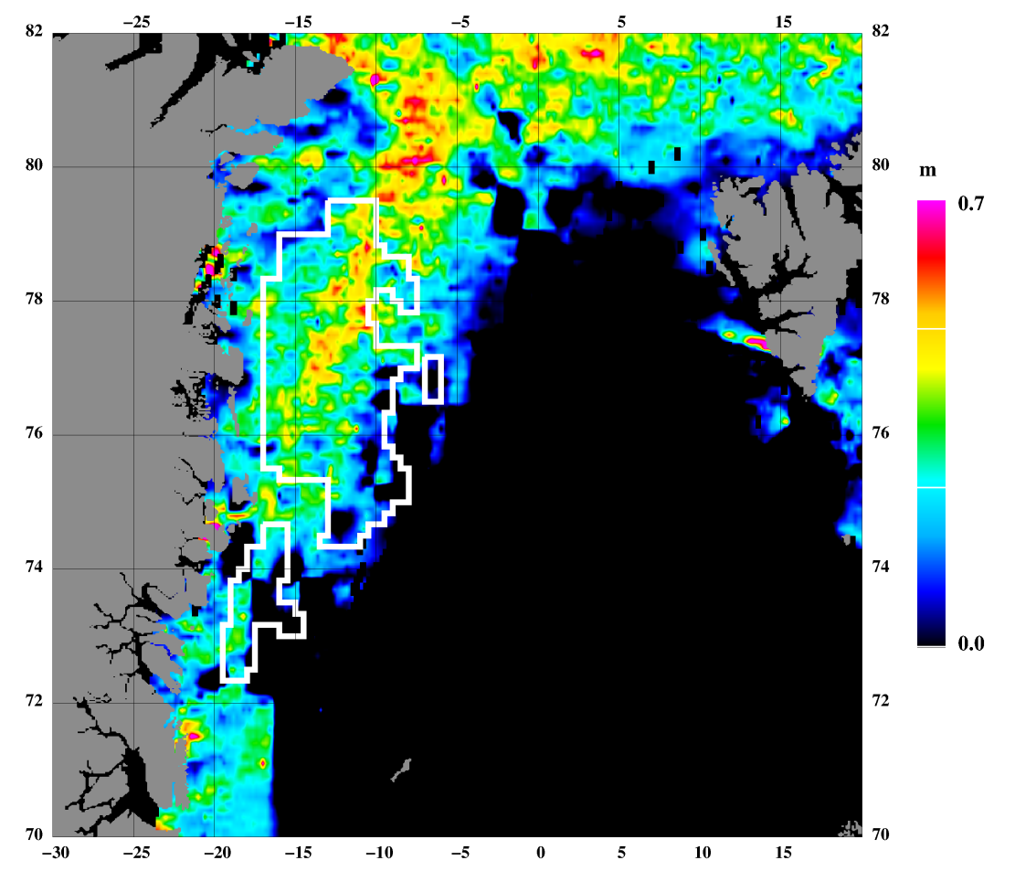
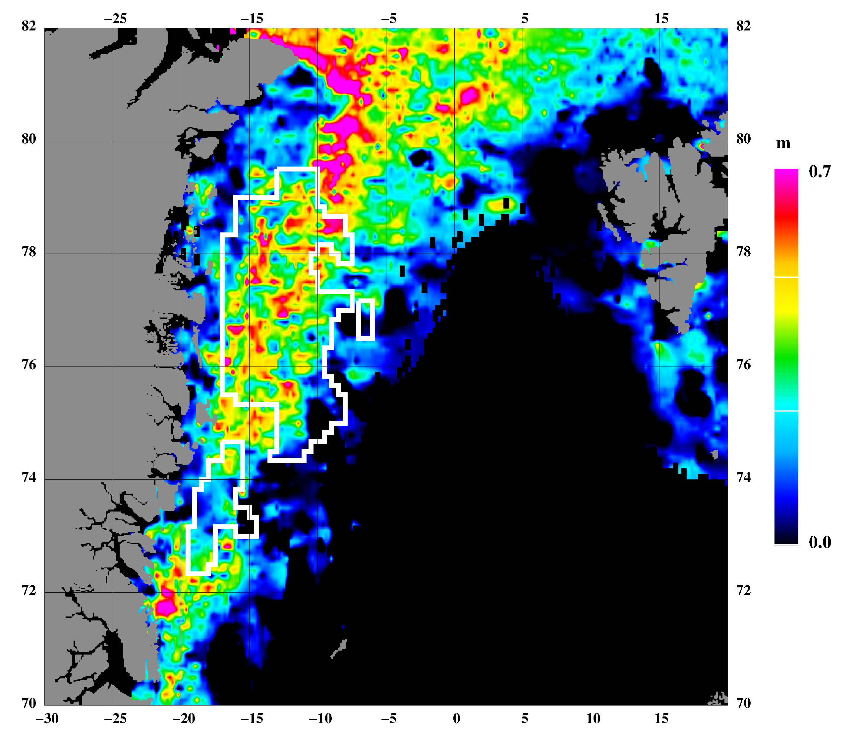
Sea ice freeboard heights FEB 20 – MAR 29, 2003
Mean: 0.30m, std: 0.27m Source: ICESat
Sea ice freeboard heights FEB 17 – MAR 21, 2004
Mean: 0.32m, std: 0.31m Source: ICESat
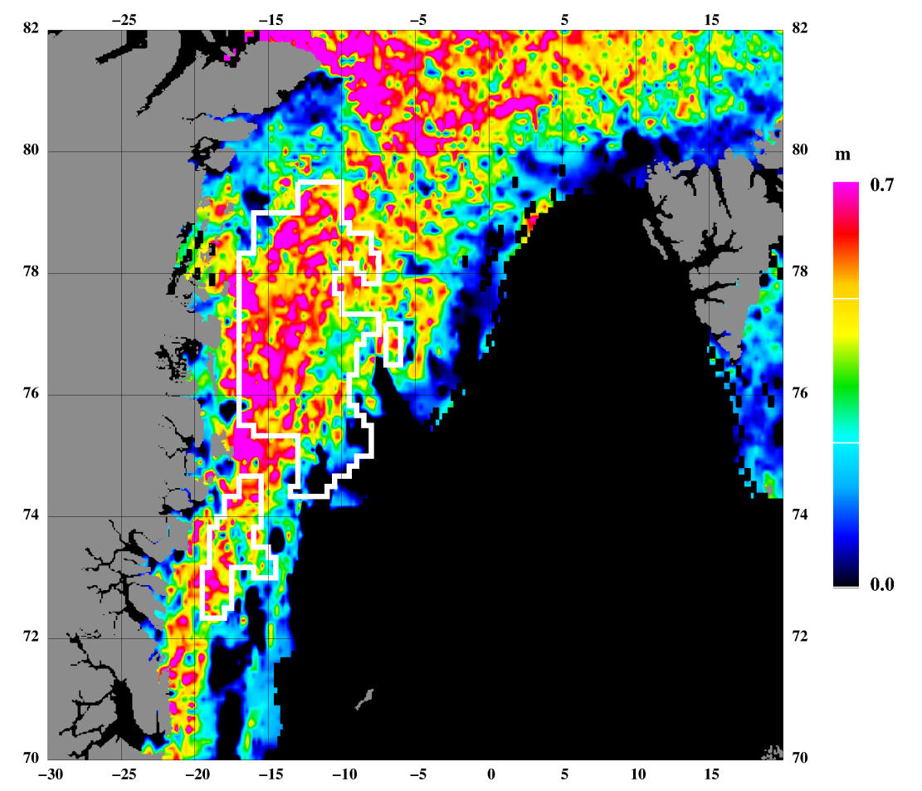
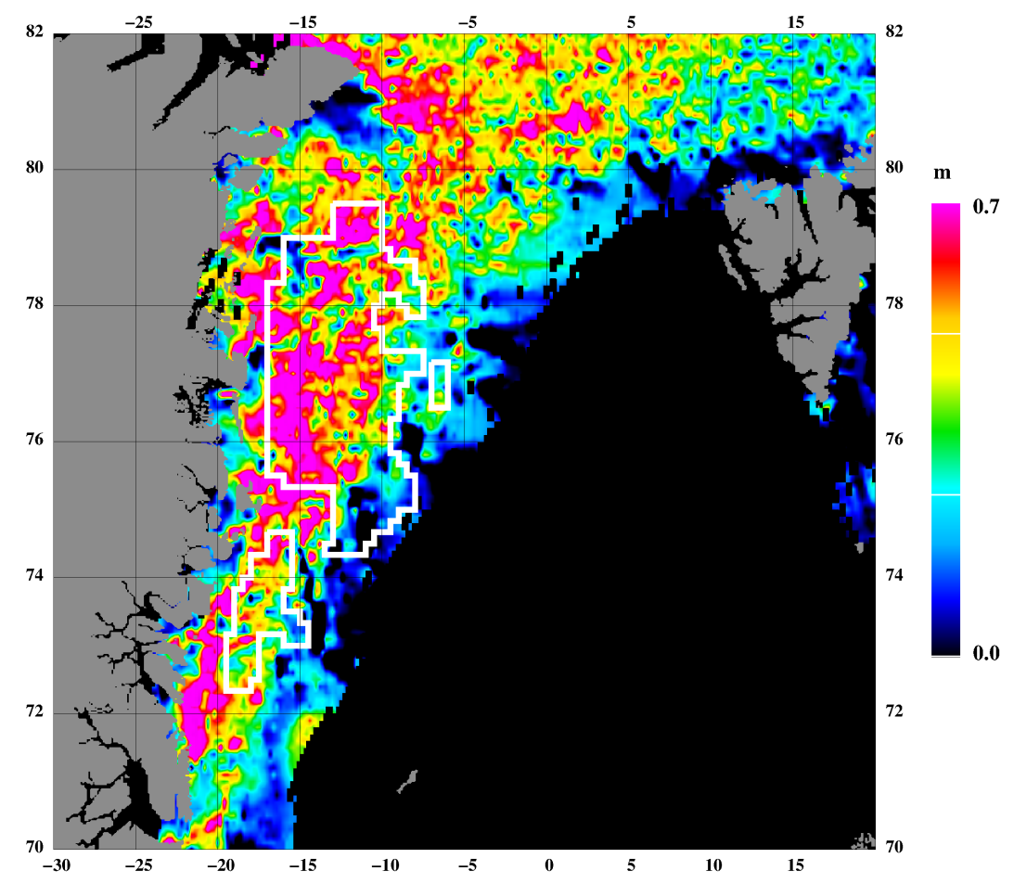
Sea ice freeboard heights FEB 22 – MAR 27, 2006
Mean: 0.44m, std: 0.36m Source: ICESat
Sea ice freeboard heights FEB 17 – MAR 24, 2005
Mean: 0.45m, std: 0.37m Source: ICESat
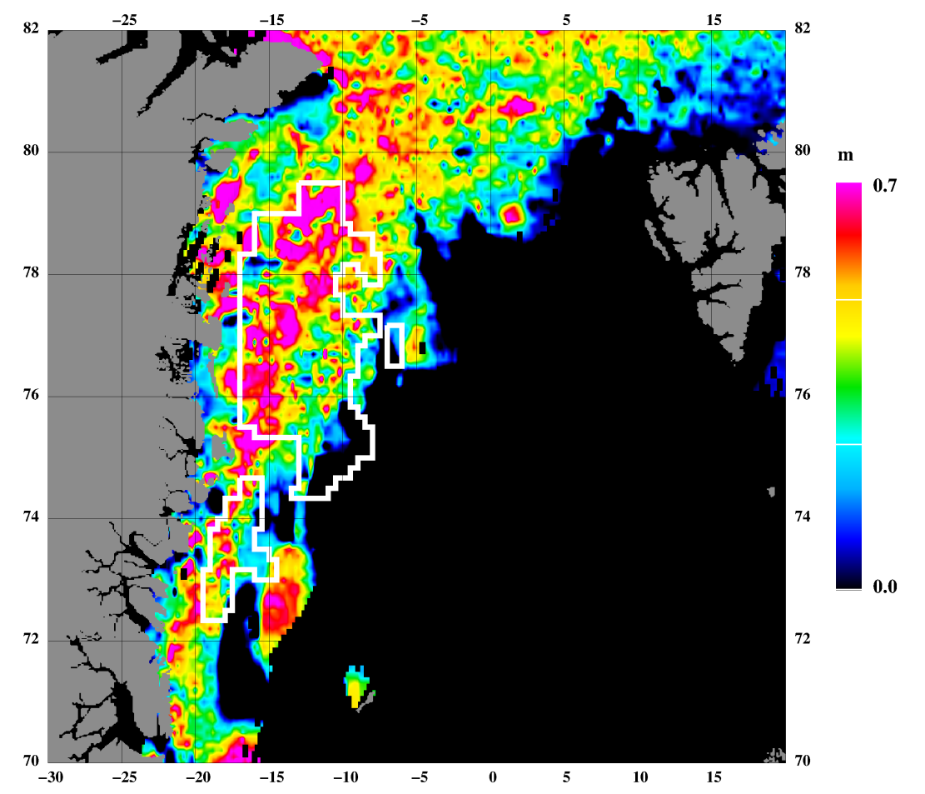

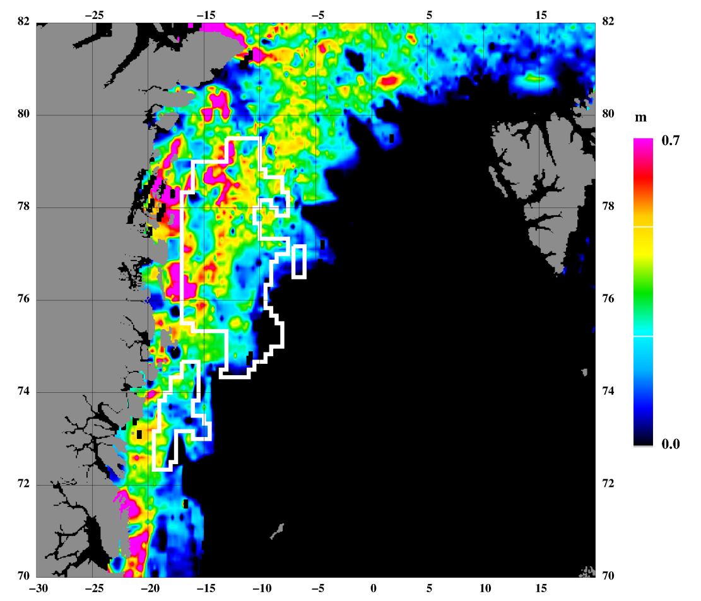
Sea ice freeboard heights FEB 17 – MAR 21, 2008
Mean: 0.29m, std: 0.27m Source: ICESat
Sea ice freeboard heights MAR 12–APR 14, 2007
Mean: 0.40m, std: 0.34m Source: ICESat
References

Doble, M. J., Skourup, H., Wadhams, P., and Geiger, C.: The relation between sea ice surface elevation and draft: Results from high-resolution mapping by co-incident AUV sonar and airborne scanning laser. JGR Oceans, 2011JC007076, 2011, in press

Farrell, S. L., S. W. Laxon, D. C. McAdoo, D. Yi, and H. J. Zwally: Five years of Arctic sea ice freeboard measurements from the Ice, Cloud and land Elevation Satellite, J. Geophys. Res., 114, C04008, doi:10.1029/2008JC005074, 2009

Forsberg, R. and Skourup, H. : Arctic Ocean gravity, geoid and sea ice freeboard heights from ICESat and GRACE. Geophysical Research Letters, 32(L21502), 2005

Giles, K. A., S. W. Laxon, and A. L. Ridout: Circumpolar thinning of Arctic sea ice following the 2007 record ice extent minimum, Geophys. Res. Lett., 35, L22502, doi:10.1029/2008GL035710, 2008

Hvidegaard, S. M., R. Forsberg, S. Hanson, H. Skourup, and L. T. Pedersen: Sea ice conditions off NW and NE Greenland from satellite measurements, airborne and in-situ data. Contract report for Greenland Bureau of Minerals and Petroleum, October 2008

Kwok, R., Cunningham, G. F., Zwally, H. J., and Yi, D.: ICESat over Arctic sea ice: Interpretation of altimetric and reflectivity profiles. Journal of Geophysical Research, 111(C06006), 2006

Kwok, R., Cunningham, G. F., Zwally, H. J., and Yi, D.: Ice, Cloud, and land Elevation Satellite (ICESat) over Arctic sea ice: Retrieval of freeboard. Journal of Geophysical Research, 112(C12013), 2007

Kwok, R., Zwally, H. J., and Yi, D: ICESat observations of Arctic sea ice: A first look. Geophysical Research Letters, 31(L16401), 2004

Laxon, S., Peacock, N., and Smith, D.: High interannual variability of sea ice thickness in the Arctic region. Nature, 425:947–950, 2003

Peacock, N. R. and Laxon, S. W.: Sea surface height determination in the Arctic Ocean from ERS altimetry. Journal of Geophysical Research, 109, 2004

Poulsen, S. K., L. Stenseng, H. Skourup, L. T. Pedersen, R. Forsberg, and L. S. Sørensen: Initial results of CryoSat-2 data from the Arctic. In proceedings CryoSat Validation Workshop, Frascati, Italy, February 1-3, 2011

Skourup, H.: A study of Arctic sea ice freeboard heights, gravity anomalies and dynamic topography from ICESat measurements. PhD Thesis, University of Copenhagen, 2010

Skourup, H. and R. Forsberg: Sea ice freeboards from ICESat – A comparison to airborne lidar measurements. Arctic Sea Ice Thickness: Past, present and future, edited by P. Wadhams and G. Amanaditis. Climate Change and Natural Hazards Series, Brussels, 2006
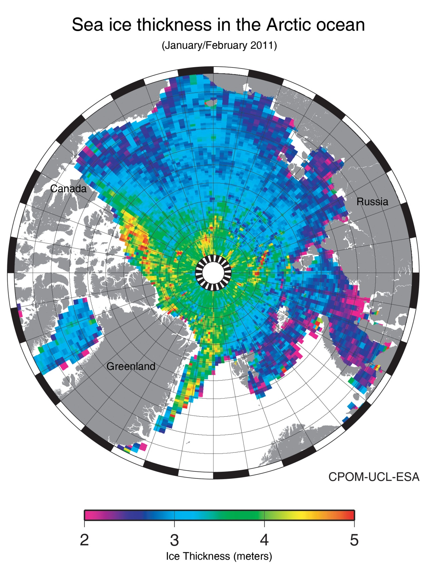
Appendix: Arctic Ocean sea ice thickness from CryoSat measurements

