THOR Observation Target List – Starting GMT 253 – 06:00
Refer to JEDI 44-0296 for big picture words
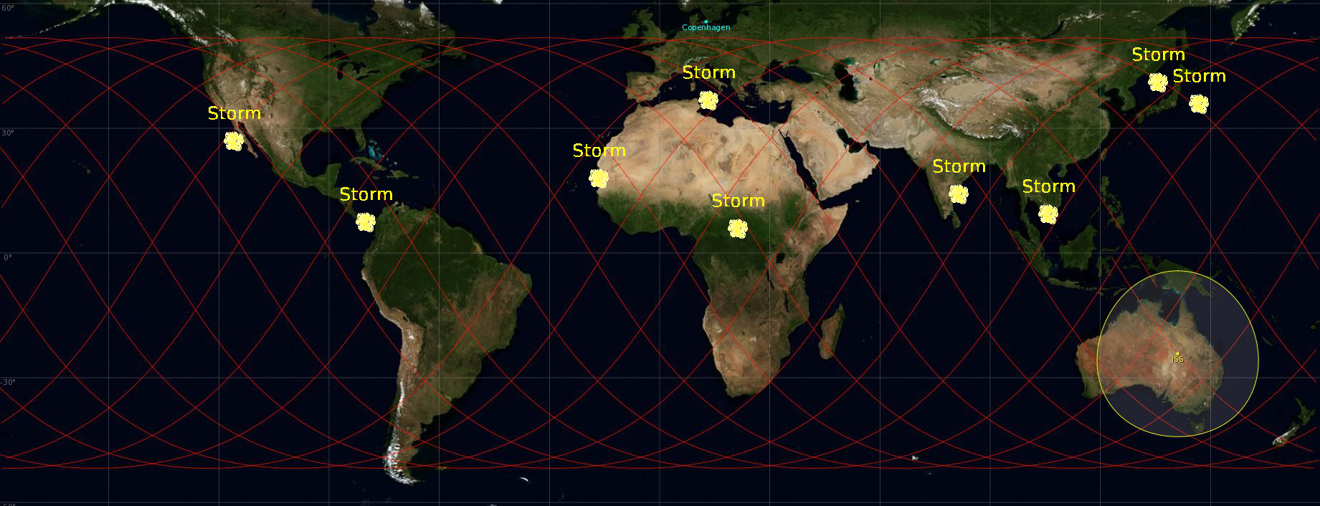

Particularities of GMT253
Target 2-5, 7-9, 11-13, 14-16, 18-19, 21-22, 23-24, 25-27, 28-29 and 30-32 can be grouped. Observations 2-4, 7, 13, 15-17, 23-24, 27 and 32-33 have sun facing the observing window, but not in the camera FOV.
Observations 12, 16 and 27 are Night-time activities, but are partly during ISS Daytime. Nevertheless, the targets are still in the dark.
Target Summary GMT253
TARGET | Type / Config | Start | End | Start Pointing | PIRS Window | Quality
1 | TLEs | 253/06:34 | 253/06:38 | Az: -38.2 º El -19.9 º | PORT | 3
2 | CTs | 253/07:01 | 253/07:05 | Az: 78.0 º El -21.0 º | STBD | 3
3 | CTs | 253/07:02 | 253/07:06 | Az: 82.1 º El -22.5 º | STBD | 3
4 | CTs | 253/07:19 | 253/07:23 | Az: 89.8 º El -34.8 º | STBD | 3
5 | CTs | 253/07:19 | 253/07:24 | Az: -30.0 º El -19.9 º | PORT | 3
6 | TLEs | 253/08:14 | 253/08:19 | Az: 89.9 º El -28.1 º | STBD | 3
7 | CTs | 253/08:39 | 253/08:43 | Az: 80.3 º El -23.8 º | STBD | 3
8 | CTs | 253/08:40 | 253/08:44 | Az: 89.5 º El -30.0 º | STBD | 3
9 | CTs | 253/08:51 | 253/08:56 | Az: -44.1 º El -19.9 º | PORT | 3
10 | TLEs | 253/09:46 | 253/09:50 | Az: -55.4 º El -19.9 º | PORT | 3
11 | CTs | 253/10:12 | 253/10:16 | Az: -9.3 º El -20.0 º | PORT | 3
12 | CTs | 253/10:16 | 253/10:20 | Az: 152.0 º El -59.5 º | STBD | 3
13 | TLEs | 253/11:26 | 253/11:29 | Az: 168.5 º El -42.6 º | STBD | 3
14 | CTs | 253/11:48 | 253/11:52 | Az: -41.8 º El -20.0 º | PORT | 3
15 | CTs | 253/11:49 | 253/11:53 | Az: -60.7 º El -20.0 º | PORT | 3
16 | CTs | 253/12:01 | 253/12:05 | Az: 118.8 º El -42.4 º | STBD | 3
17 | TLEs | 253/13:01 | 253/13:05 | Az: 80.2 º El -20.5 º | STBD | 3
18 | CTs | 253/13:27 | 253/13:32 | Az: 89.8 º El -26.8 º | STBD | 3
19 | CTs | 253/13:34 | 253/13:38 | Az: -55.2 º El -19.9 º | PORT | 3
20 | CTs | 253/15:00 | 253/15:04 | Az: -32.1 º El -19.9 º | PORT | 3
21 | TLEs | 253/17:32 | 253/17:37 | Az: -16.7 º El -20.1 º | PORT | 3
22 | TLEs | 253/17:33 | 253/17:37 | Az: -60.8 º El -20.0 º | PORT | 3
23 | CTs | 253/17:56 | 253/17:59 | Az: 75.9 º El -19.8 º | STBD | 3
24 | CTs | 253/18:08 | 253/18:13 | Az: 90.1 º El -28.4 º | STBD | 3
25 | TLEs | 253/18:56 | 253/19:00 | Az: -9.0 º El -20.0 º | PORT | 3
26 | TLEs | 253/19:07 | 253/19:11 | Az: -10.4 º El -20.1 º | PORT | 3
27 | TLEs | 253/19:13 | 253/19:18 | Az: 90.5 º El -29.2 º | STBD | 3
28 | CTs | 253/19:34 | 253/19:39 | Az: 89.3 º El -36.8 º | STBD | 3
29 | CTs | 253/19:40 | 253/19:45 | Az: -38.3 º El -19.9 º | PORT | 3
30 | TLEs | 253/20:30 | 253/20:35 | Az: -14.4 º El -20.0 º | PORT | 3
31 | TLEs | 253/20:36 | 253/20:40 | Az: 77.3 º El -20.2 º | STBD | 3
32 | CTs | 253/20:48 | 253/20:53 | Az: 90.4 º El -30.8 º | STBD | 3
33 | CTs | 253/20:50 | 253/20:54 | Az: 80.0 º El -20.6 º | STBD | 3
34 | CTs | 253/21:06 | 253/21:11 | Az: -36.8 º El -20.0 º | PORT | 3

Particularities of GMT254
Target 6-7 can be grouped. Observations 1 and 5 have sun facing the observing window, but not in the camera FOV.
Target Summary GMT254
TARGET | Type / Config | Start | End | Start Pointing | PIRS Window | Quality
1 | CTs | 254/06:25 | 254/06:29 | Az: 78.5 º El -25.7 º | STBD | 3
2 | TLEs | 254/07:16 | 254/07:20 | Az: -5.7 º El -20.0 º | PORT | 3
3 | CTs | 254/07:57 | 254/08:02 | Az: -31.0 º El -19.9 º | PORT | 3
4 | TLEs | 254/08:56 | 254/09:00 | Az: 75.9 º El -20.0 º | STBD | 3
5 | CTs | 254/11:07 | 254/11:12 | Az: 82.2 º El -22.6 º | STBD | 3
6 | CTs | 254/12:33 | 254/12:37 | Az: 81.8 º El -22.5 º | STBD | 3
7 | CTs | 254/12:39 | 254/12:44 | Az: -25.8 º El -20.0 º | PORT | 3
8 | CTs | 254/14:05 | 254/14:10 | Az: -18.8 º El -19.9 º | PORT | 3

Camera Summary/Cue card

Camera Settings | CT | TLE
Lens | 24-70mm Lens | 58mm Noct Lens
Mode | S | M
Shutter speed | 1000 | 25
Aperture | Automatically adjusted | f1.2
Frame Rate | S | S
Body focus mode | AF | M
ISO | 200 | 6400
Picture/movie | Picture | For inspection camera settings: Picture  Observations: Movie
Image quality | RAW | RAW
Frame size/frame rate (movie) | N/A | 1920x1080; 24 fps
Movie quality | N/A | High

Procedures:
  - PODF 1.100 THOR D4 Time Set-Up
  - PODF 2.101 THOR CT Observations Day
  - PODF 2.201 THOR TLE Observations

Pointing information:

The azimuth angle is defined with respect to the ISS velocity vector. A positive azimuth corresponds to starboard side; a negative azimuth is on the port side. The elevation angle is defined as the angle between the target and the observer's local horizon, where a negative elevation corresponds to direction Nadir.

PORT: target comes from the horizon moving slowly and disappears underneath the ISS rapidly.
STBD: target comes rapidly in view from underneath the ISS and disappears slowly toward horizon (more difficult).

Detailed Target List

Target 1 | TLEs above Costa_Rica | Quality ***
Day  Start Time  End Time  ISS Site  Pointing | 2015/09/10 Nightime  253/06:34  253/06:38  Target on PORT side, coming from horizon  Start Az: -38.2 º El -19.9 º  End Az: -98.0 º El -22.8 º | 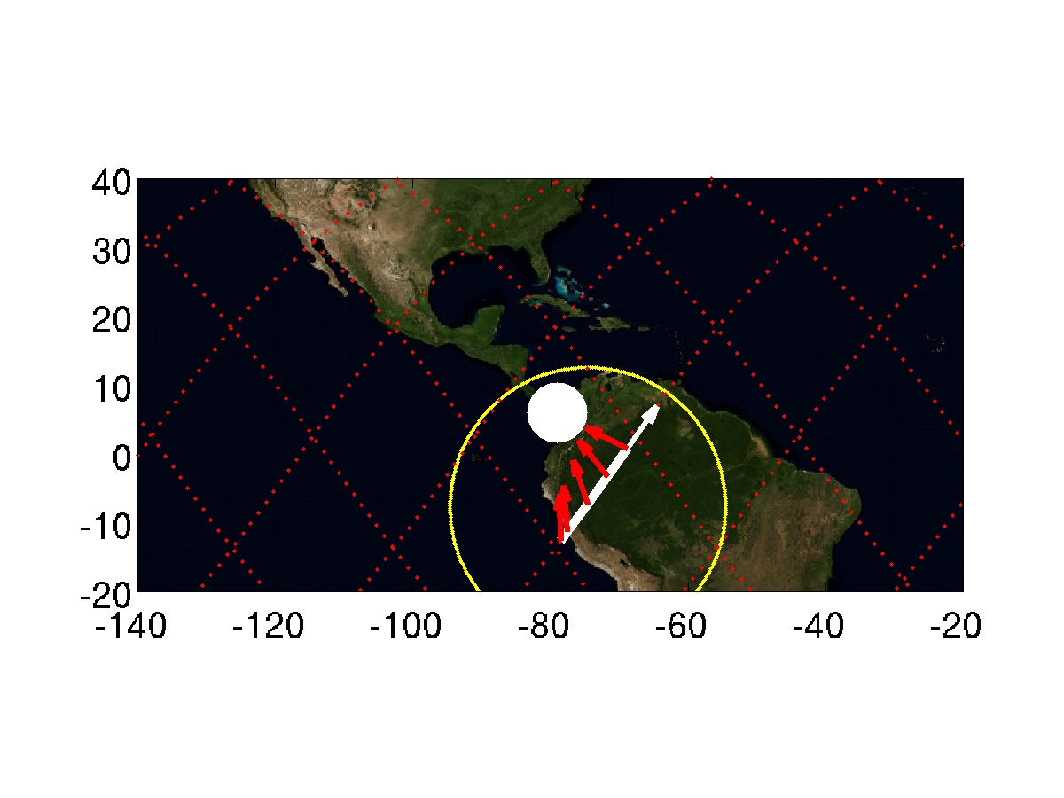

Target 2 | CTs above Libya | Quality ***
Day  Start Time  End Time  ISS Site  Pointing | 2015/09/10 Daytime  253/07:01  253/07:05  Target on STBD side, moving toward horizon  Start Az: 78.0 º El -21.0 º  End Az: 133.4 º El -19.9 º  Sun facing the observing window | 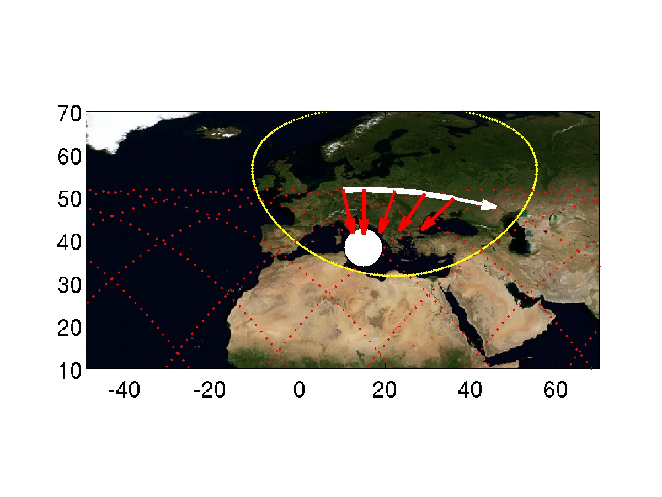

Target 3 | CTs above Greece | Quality ***
Day  Start Time  End Time  ISS Site  Pointing | 2015/09/10 Daytime  253/07:02  253/07:06  Target on STBD side, moving toward horizon  Start Az: 82.1 º El -22.5 º  End Az: 137.5 º El -20.1 º  Sun facing the observing window | 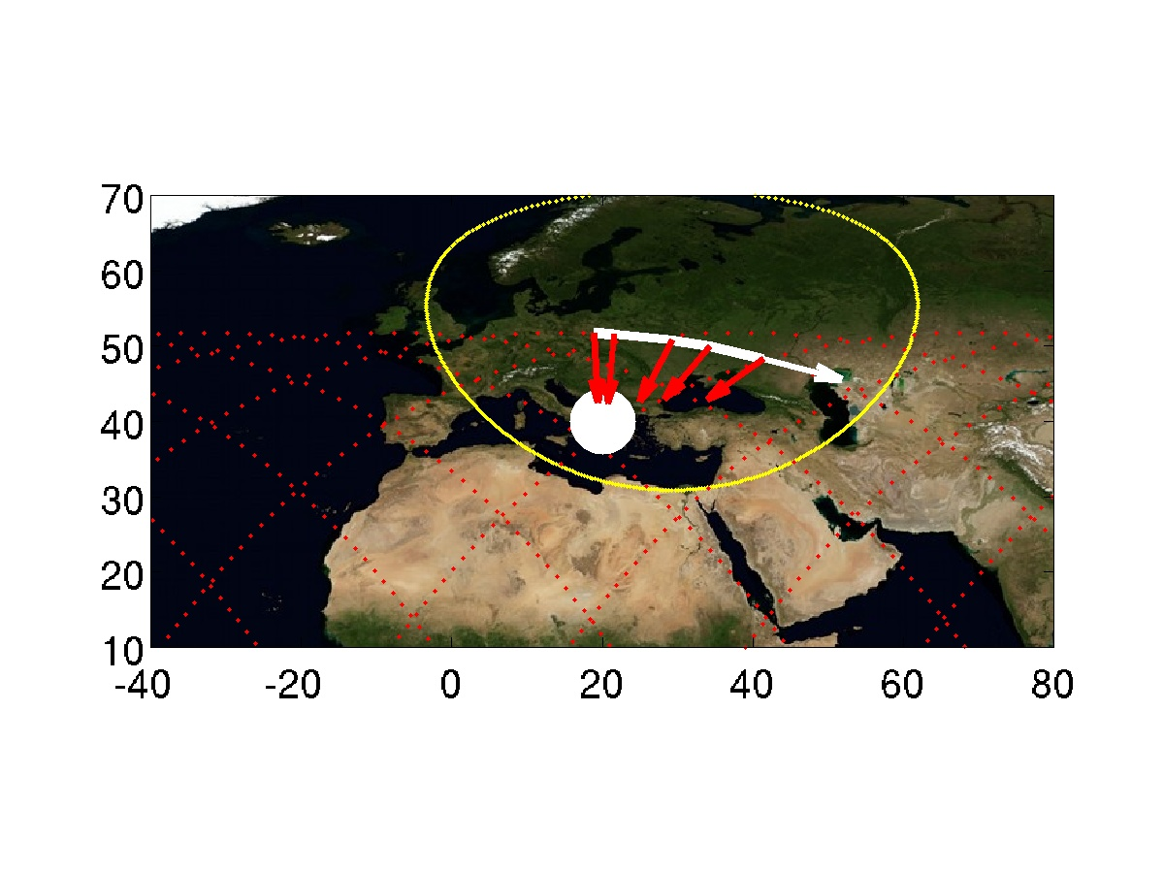

Target 4 | CTs above Bay_of_Bengal | Quality ***
Day  Start Time  End Time  ISS Site  Pointing | 2015/09/10 Daytime  253/07:19  253/07:23  Target on STBD side, moving toward horizon  Start Az: 89.8 º El -34.8 º  End Az: 161.8 º El -20.0 º  Sun facing the observing window | 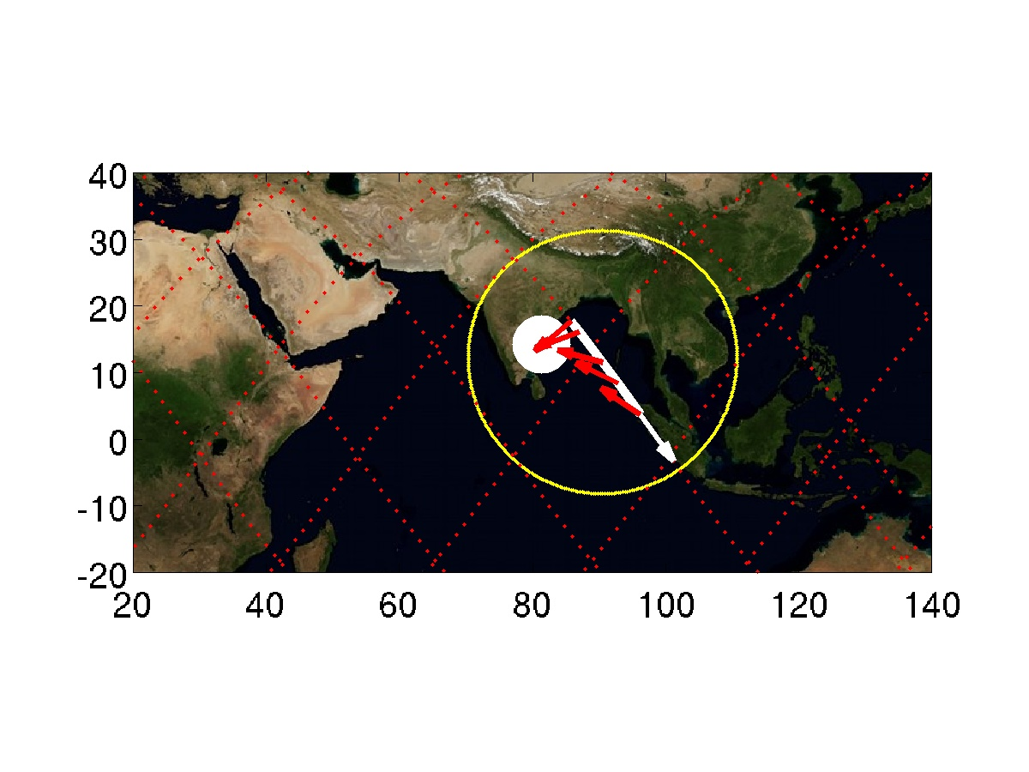

Target 5 | CTs above Vietnam | Quality ***
Day  Start Time  End Time  ISS Site  Pointing | 2015/09/10 Daytime  253/07:19  253/07:24  Target on PORT side, coming from horizon  Start Az: -30.0 º El -19.9 º  End Az: -101.2 º El -25.4 º | 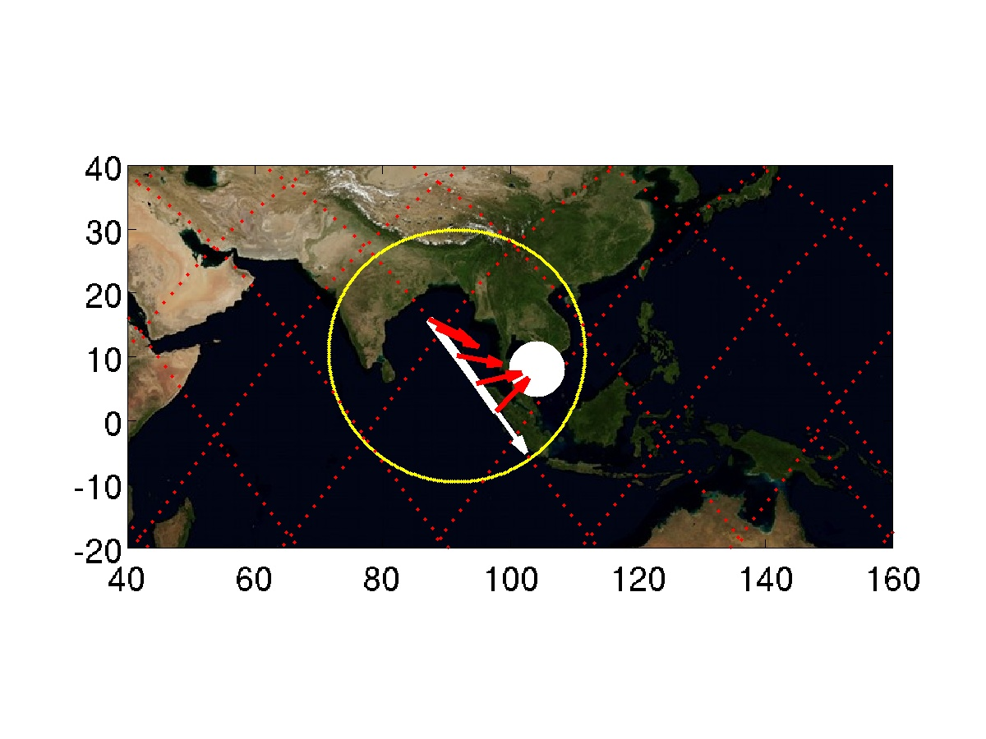

Target 6 | TLEs above Costa_Rica | Quality ***
Day  Start Time  End Time  ISS Site  Pointing | 2015/09/10 Nightime  253/08:14  253/08:19  Target on STBD side, moving toward horizon  Start Az: 89.9 º El -28.1 º  End Az: 154.0 º El -19.9 º | 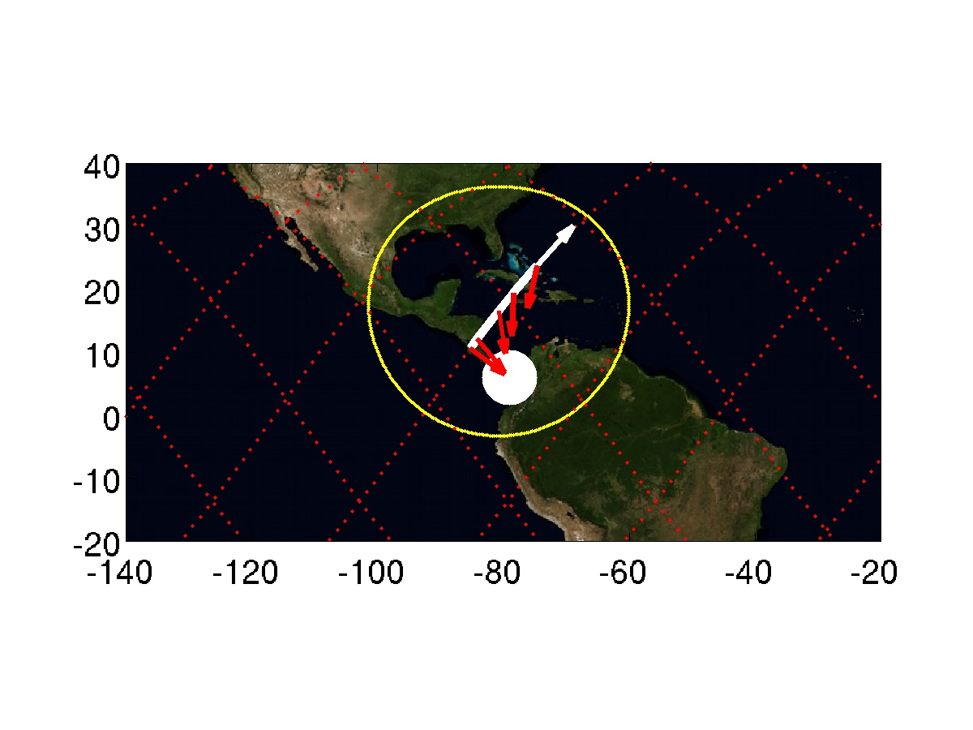

Target 7 | CTs above Libya | Quality ***
Day  Start Time  End Time  ISS Site  Pointing | 2015/09/10 Daytime  253/08:39  253/08:43  Target on STBD side, moving toward horizon  Start Az: 80.3 º El -23.8 º  End Az: 142.7 º El -20.2 º  Sun facing the observing window | 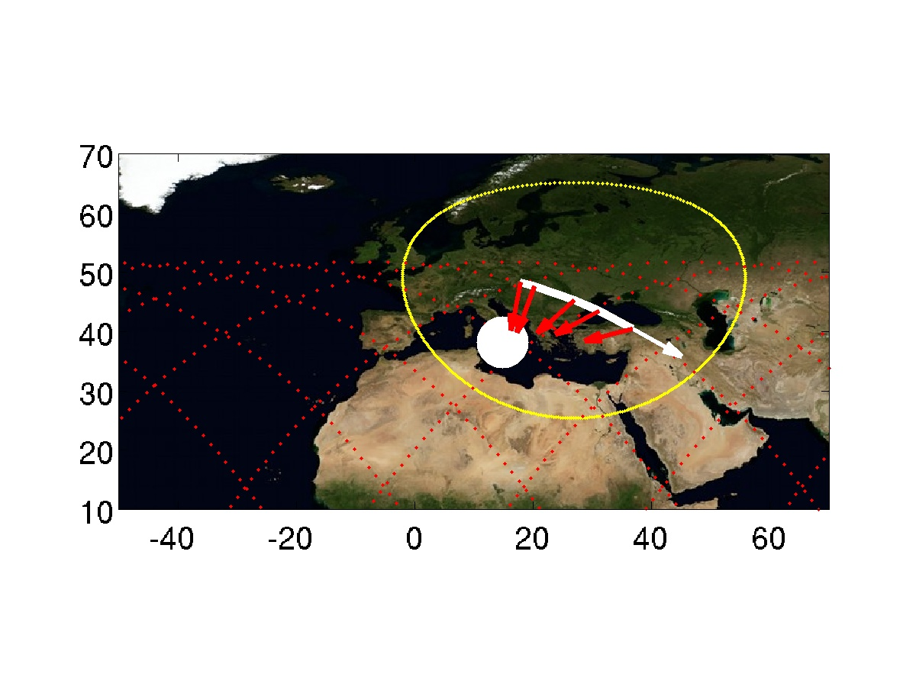

Target 8 | CTs above Greece | Quality ***
Day  Start Time  End Time  ISS Site  Pointing | 2015/09/10 Daytime  253/08:40  253/08:44  Target on STBD side, moving toward horizon  Start Az: 89.5 º El -30.0 º  End Az: 154.3 º El -20.3 º | 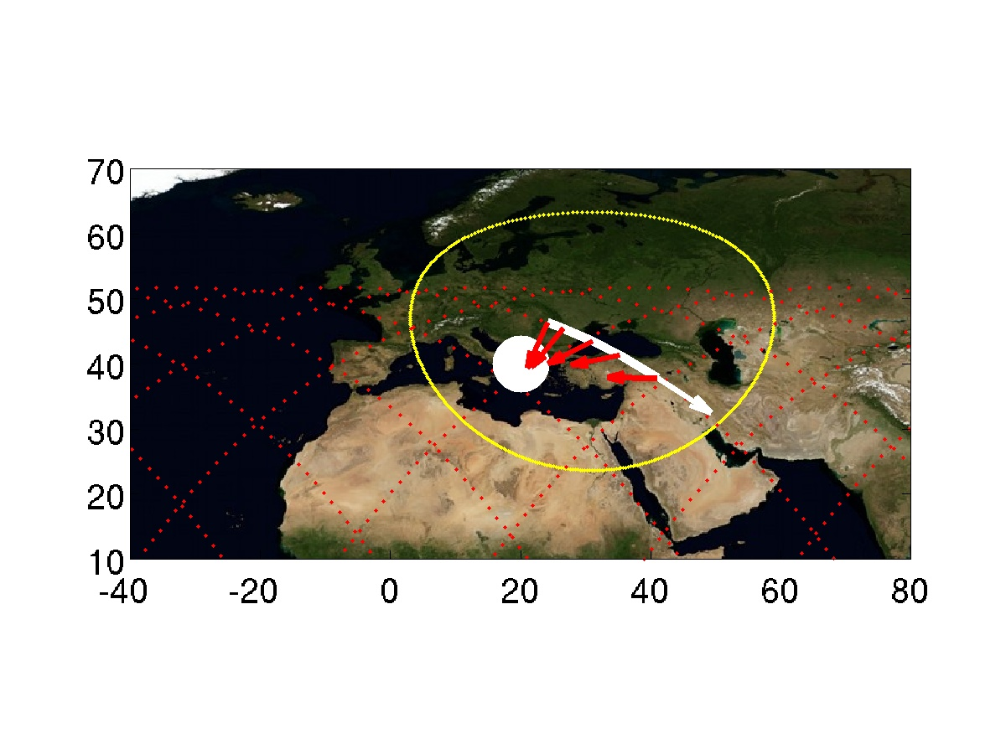

Target 9 | CTs above Bay_of_Bengal | Quality ***
Day  Start Time  End Time  ISS Site  Pointing | 2015/09/10 Daytime  253/08:51  253/08:56  Target on PORT side, coming from horizon  Start Az: -44.1 º El -19.9 º  End Az: -103.0 º El -21.4 º | 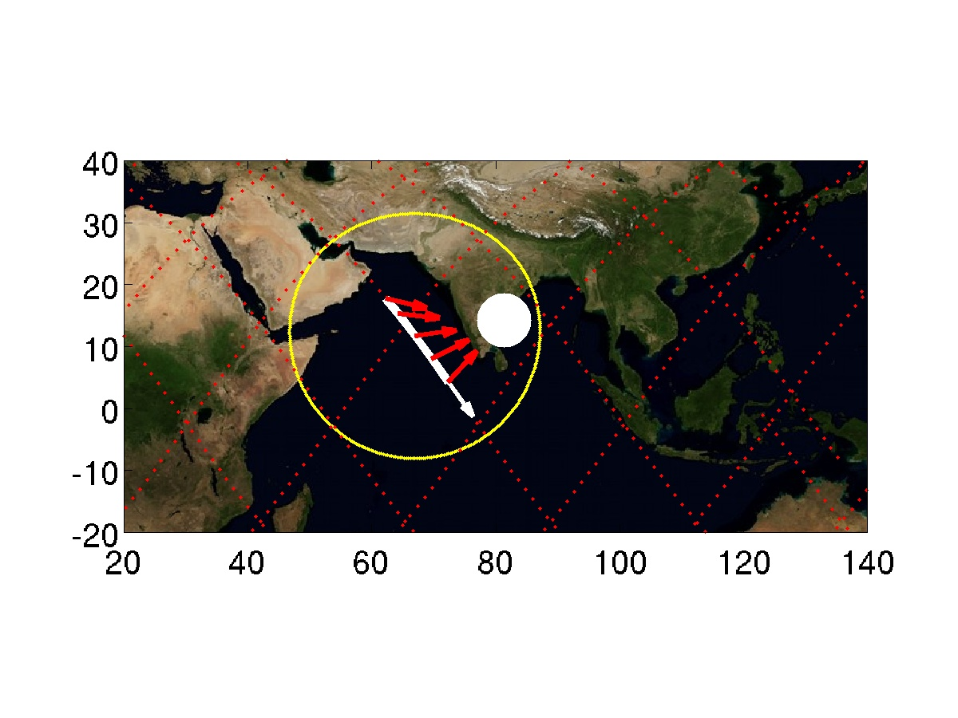

Target 10 | TLEs above California | Quality ***
Day  Start Time  End Time  ISS Site  Pointing | 2015/09/10 Nightime  253/09:46  253/09:50  Target on PORT side, coming from horizon  Start Az: -55.4 º El -19.9 º  End Az: -103.3 º El -20.3 º | 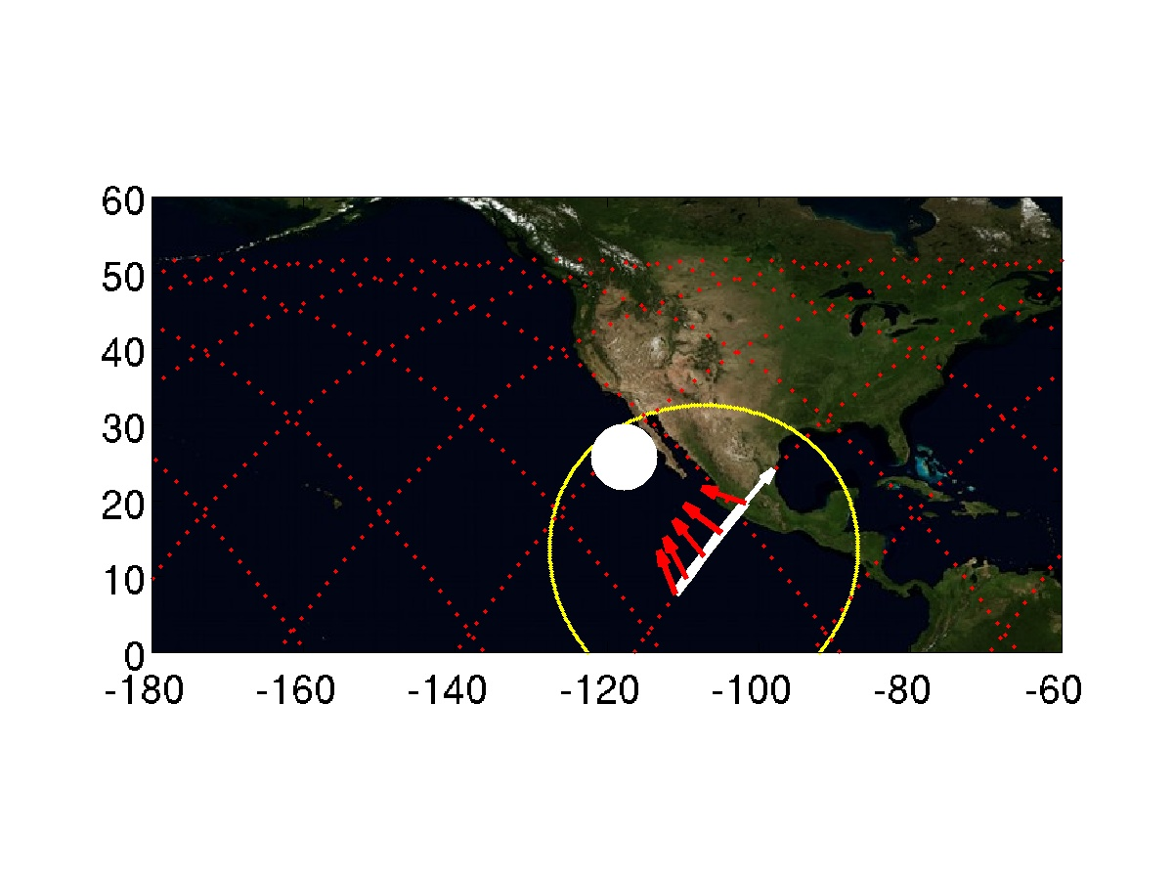

Target 11 | CTs above Libya | Quality ***
Day  Start Time  End Time  ISS Site  Pointing | 2015/09/10 Daytime  253/10:16  253/10:20  Target on STBD side, moving toward horizon  Start Az: 152.0 º El -59.5 º  End Az: 176.4 º El -20.5 º | 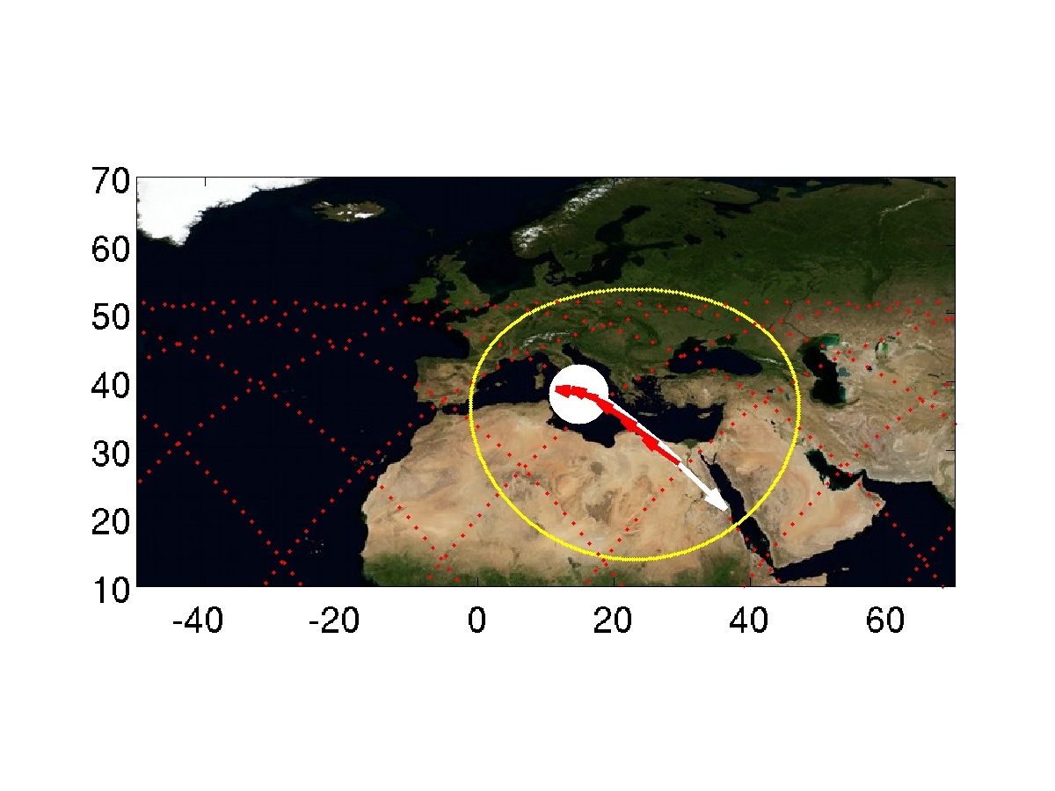

Target 12 | TLEs above California | Quality ***
Day  Start Time  End Time  ISS Site  Pointing | 2015/09/10 Nightime  253/11:26  253/11:29  Target on STBD side, moving toward horizon  Start Az: 168.5 º El -42.6 º  End Az: 176.9 º El -20.3 º  ISS in daytime. | 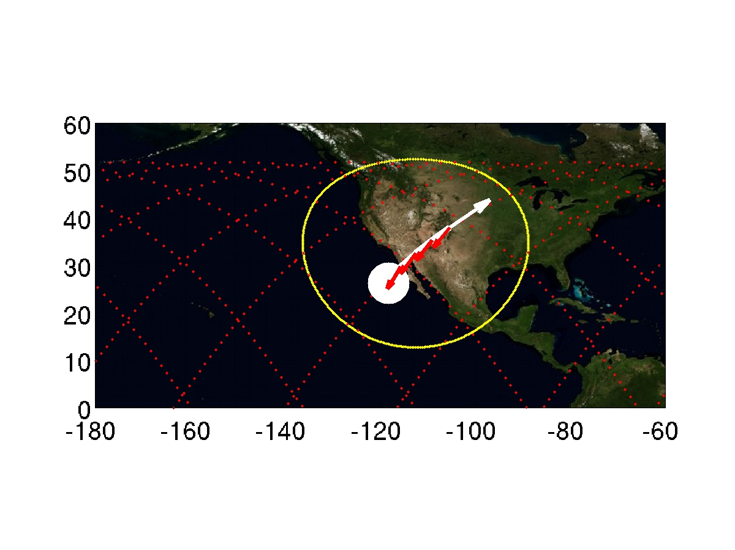

Target 13 | CTs above Libya | Quality ***
Day  Start Time  End Time  ISS Site  Pointing | 2015/09/10 Daytime  253/11:48  253/11:52  Target on PORT side, coming from horizon  Start Az: -41.8 º El -20.0 º  End Az: -96.7 º El -22.0 º  Sun facing the observing window | 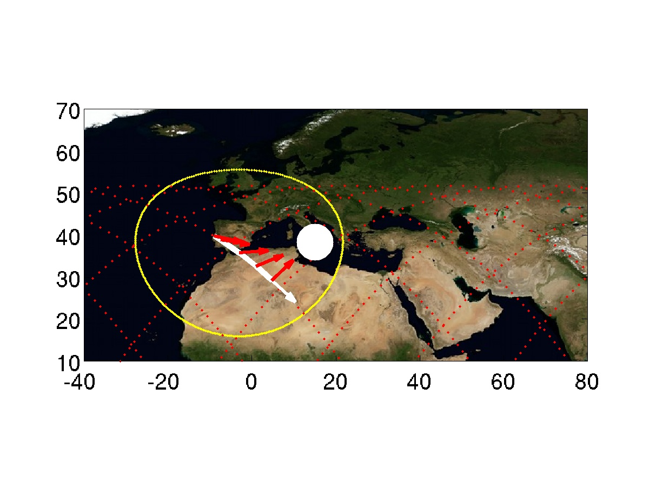

Target 14 | CTs above Greece | Quality ***
Day  Start Time  End Time  ISS Site  Pointing | 2015/09/10 Daytime  253/11:49  253/11:53  Target on PORT side, coming from horizon  Start Az: -60.7 º El -20.0 º  End Az: -103.6 º El -20.1 º

Target 15 | CTs above Central_Africa | Quality ***
Day  Start Time  End Time  ISS Site  Pointing | 2015/09/10 Daytime  253/12:01  253/12:05  Target on STBD side, moving toward horizon  Start Az: 118.8 º El -42.4 º  End Az: 168.4 º El -20.0 º  Sun facing the observing window | 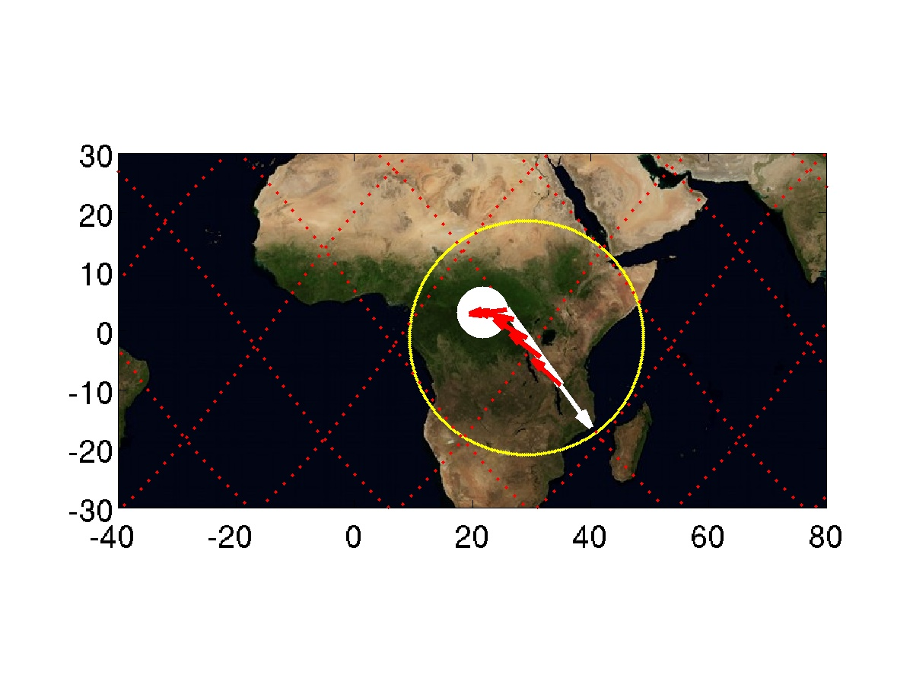

Target 16 | TLEs above California | Quality ***
Day  Start Time  End Time  ISS Site  Pointing | 2015/09/10 Nightime  253/13:01  253/13:05  Target on STBD side, moving toward horizon  Start Az: 80.2 º El -20.5 º  End Az: 128.1 º El -19.8 º  ISS in daytime, Sun facing the observing window. | 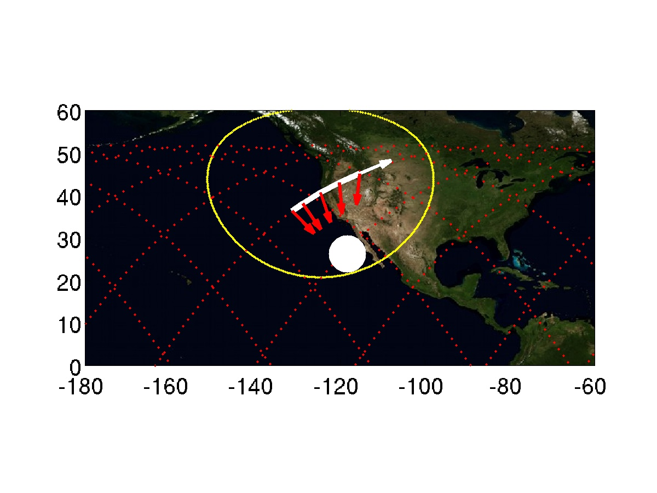

Target 17 | CTs above Senegal | Quality ***
Day  Start Time  End Time  ISS Site  Pointing | 2015/09/10 Daytime  253/13:27  253/13:32  Target on STBD side, moving toward horizon  Start Az: 89.8 º El -26.8 º  End Az: 152.3 º El -20.0 º  Sun facing observing window | 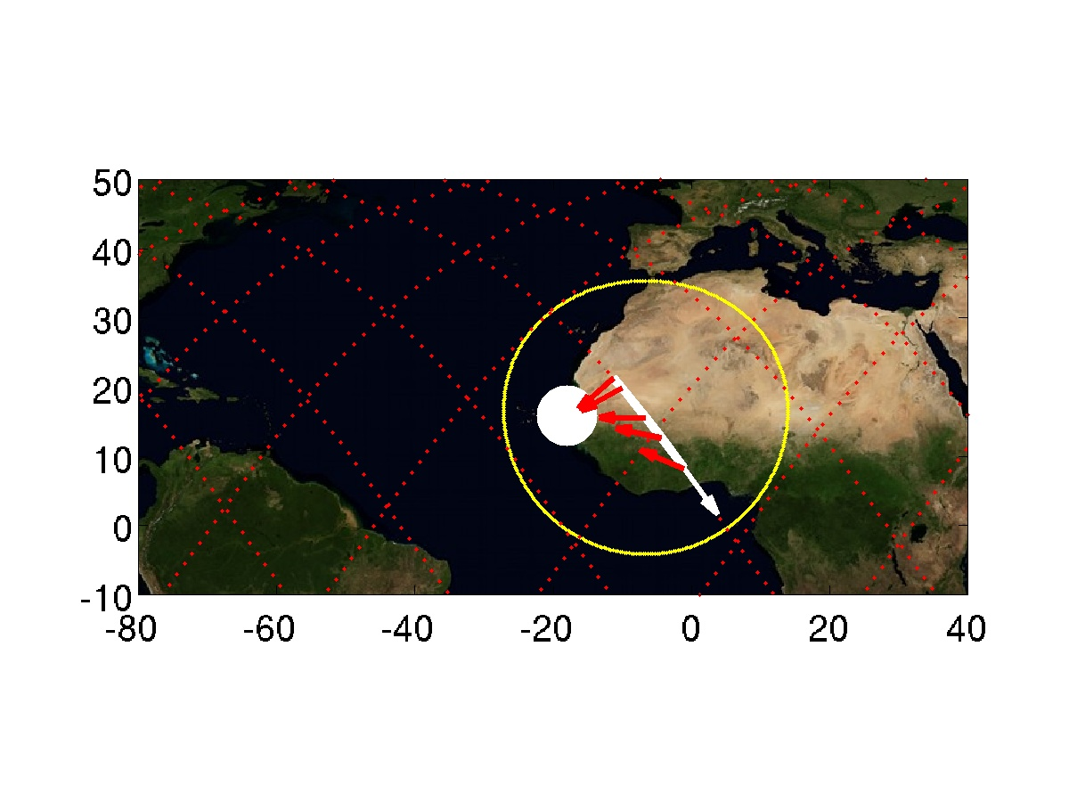

Target 18 | CTs above Central_Africa | Quality ***
Day  Start Time  End Time  ISS Site  Pointing | 2015/09/10 Daytime  253/13:34  253/13:38  Target on PORT side, coming from horizon  Start Az: -55.2 º El -19.9 º  End Az: -103.3 º El -20.3 º | 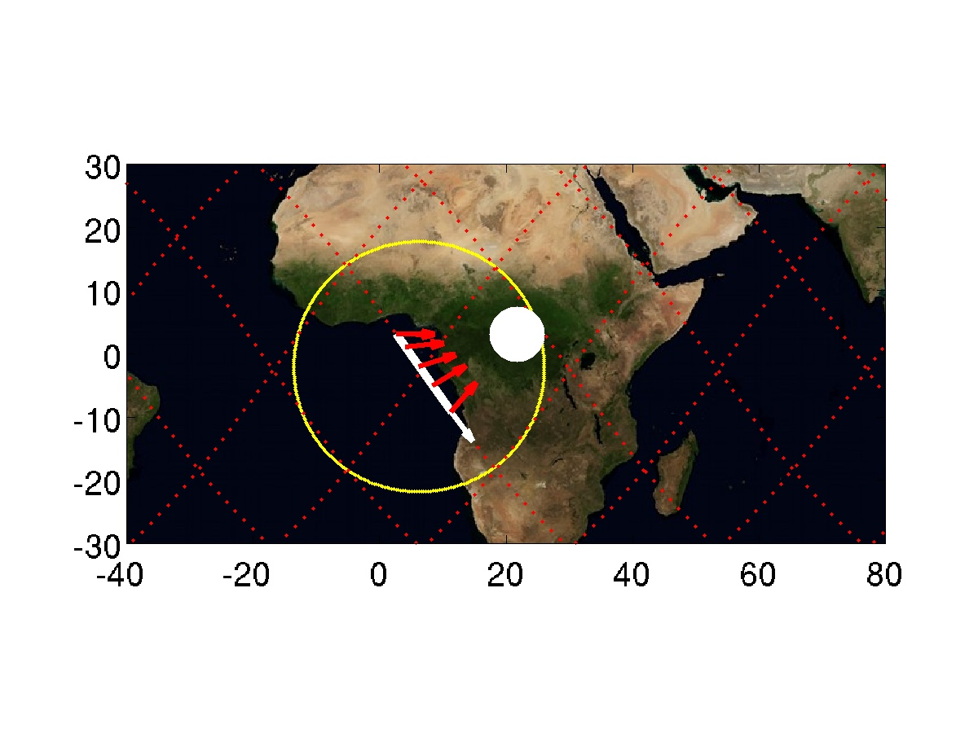

Target 19 | CTs above Senegal | Quality ***
Day  Start Time  End Time  ISS Site  Pointing | 2015/09/10 Daytime  253/15:00  253/15:04  Target on PORT side, coming from horizon  Start Az: -32.1 º El -19.9 º  End Az: -100.1 º El -24.5 º | 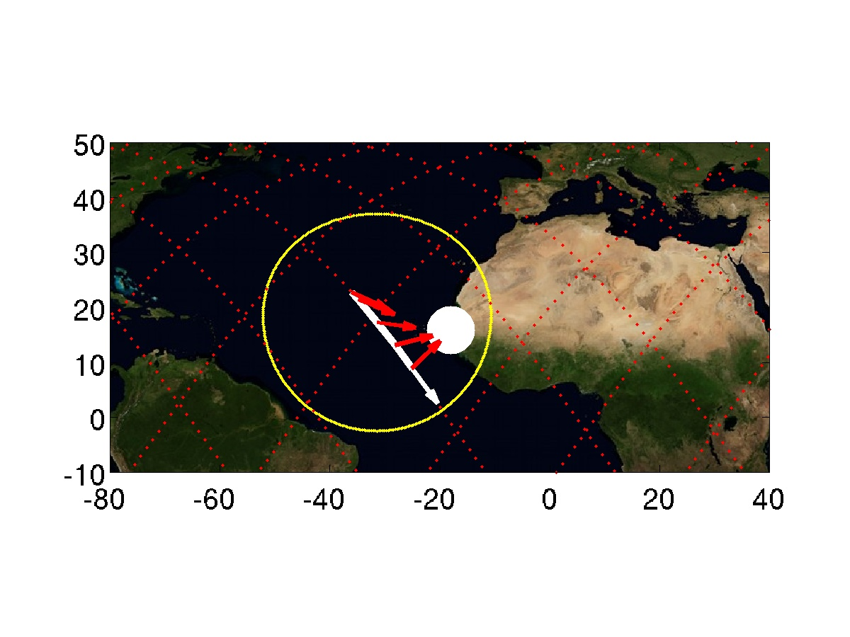

Target 20 | TLEs above Western_Pacific | Quality ***
Day  Start Time  End Time  ISS Site  Pointing | 2015/09/10 Nightime  253/17:32  253/17:37  Target on PORT side, coming from horizon  Start Az: -16.7 º El -20.1 º  End Az: -90.7 º El -37.6 º | 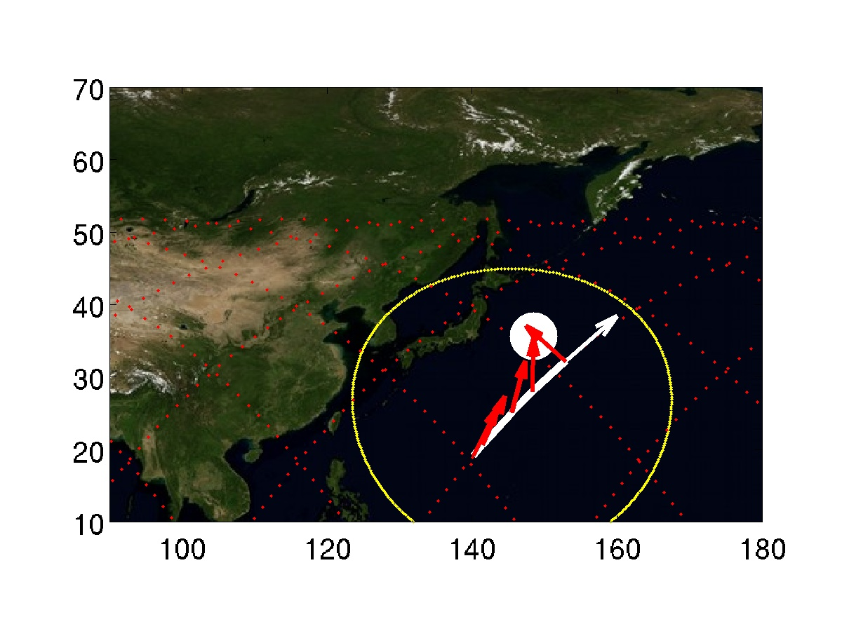

Target 22 | TLEs above Japan | Quality ***
Day  Start Time  End Time  ISS Site  Pointing | 2015/09/10 Nightime  253/17:33  253/17:37  Target on PORT side, coming from horizon  Start Az: -60.8 º El -20.0 º  End Az: -101.1 º El -20.2 º | 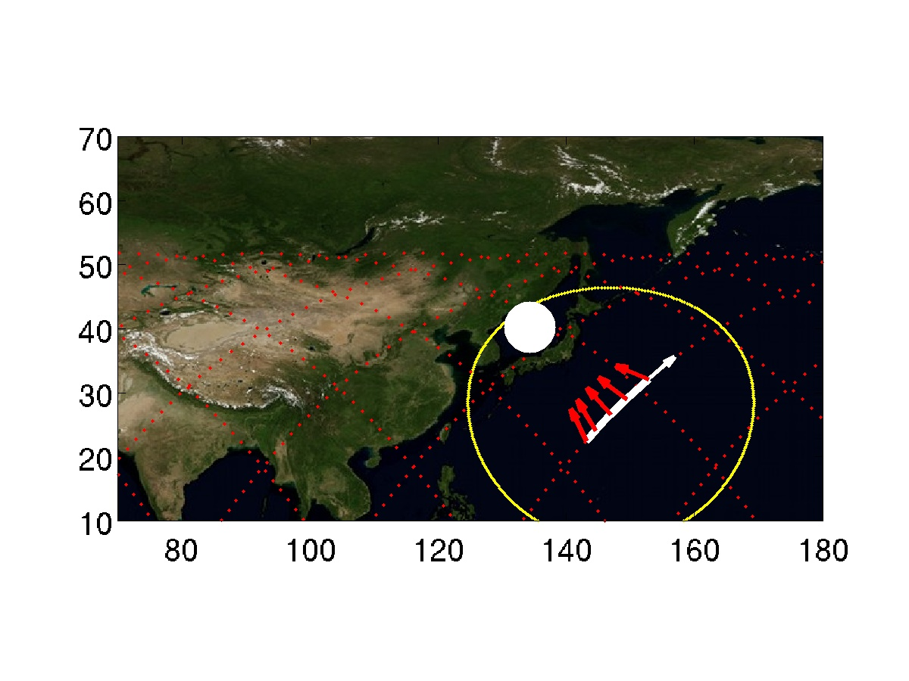

Target 23 | CTs above California | Quality ***
Day  Start Time  End Time  ISS Site  Pointing | 2015/09/10 Daytime  253/17:56  253/17:59  Target on STBD side, moving toward horizon  Start Az: 75.9 º El -19.8 º  End Az: 114.0 º El -19.8 º  Sun facing observing window | 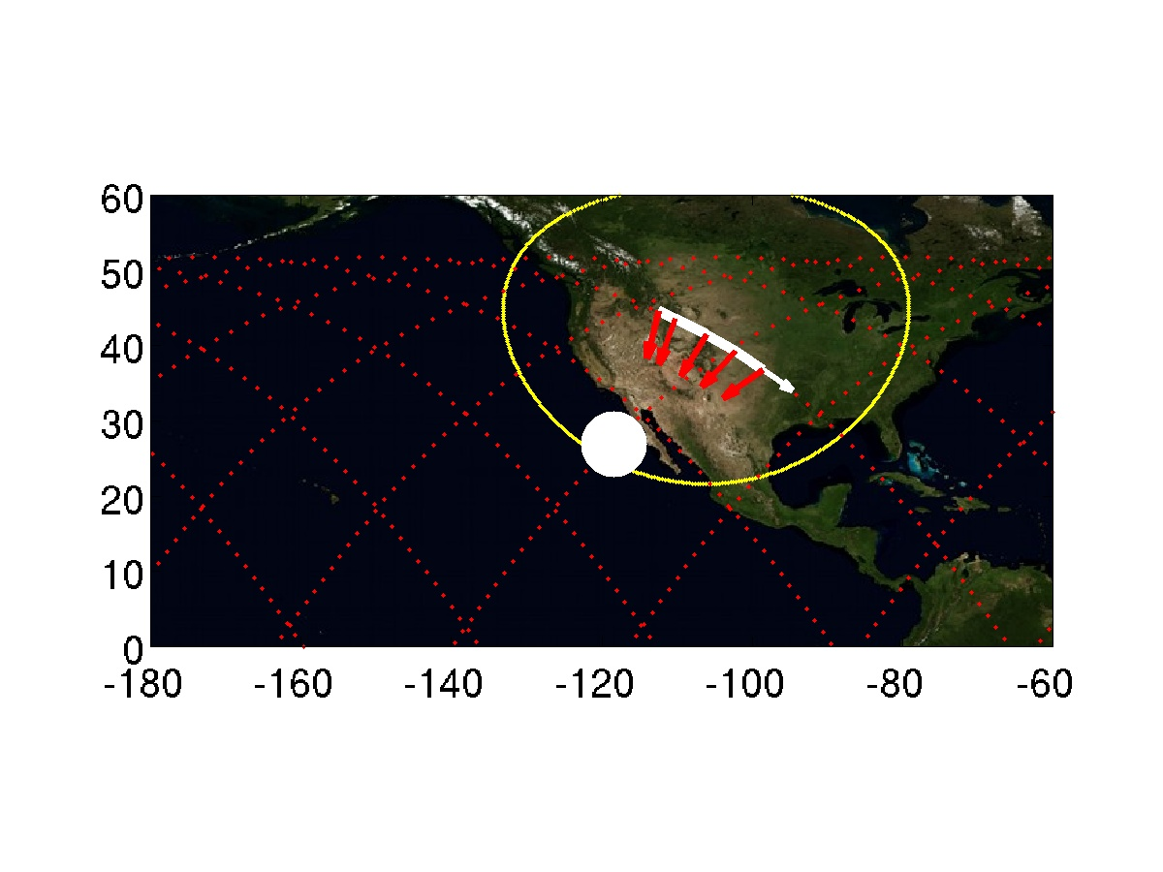

Target 24 | CTs above Costa_Rica | Quality ***
Day  Start Time  End Time  ISS Site  Pointing | 2015/09/10 Daytime  253/18:08  253/18:13  Target on STBD side, moving toward horizon  Start Az: 90.1 º El -28.4 º  End Az: 154.9 º El -20.0 º  Sun facing observing window | 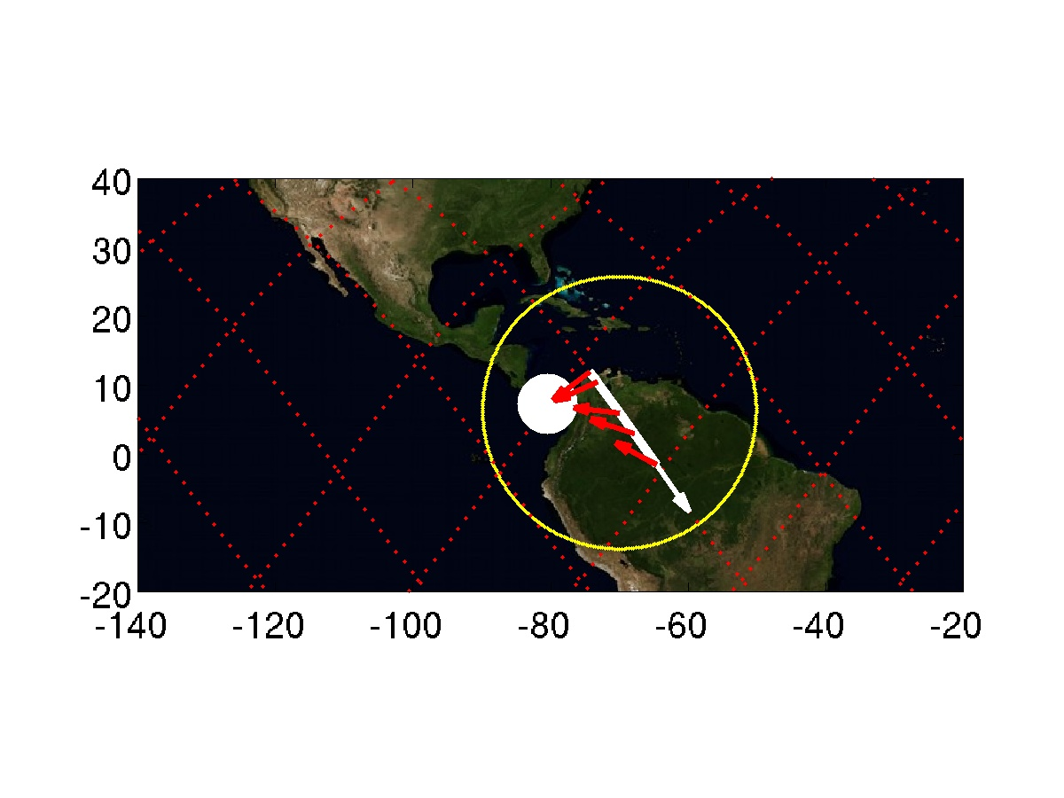

Target 25 | TLEs above Vietnam | Quality ***
Day  Start Time  End Time  ISS Site  Pointing | 2015/09/10 Nightime  253/18:56  253/19:00  Target on PORT side, coming from horizon  Start Az: -9.0 º El -20.0 º  End Az: -53.6 º El -48.1 º | 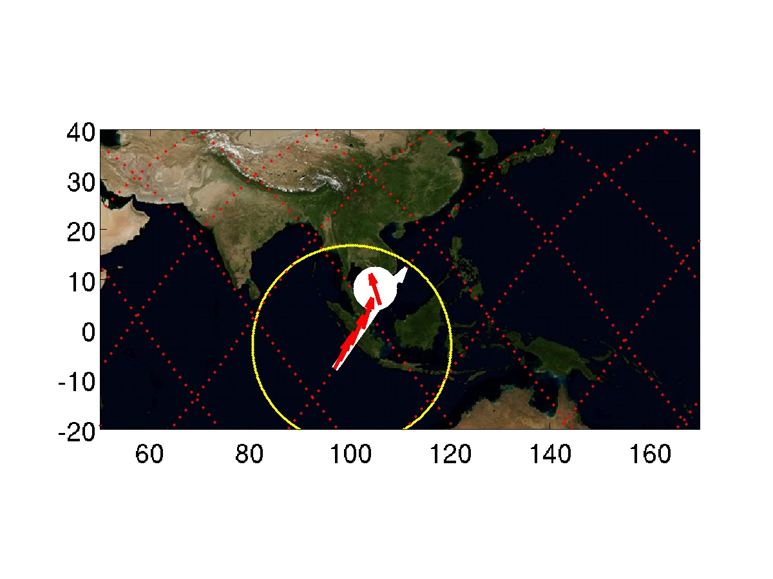

Target 26 | TLEs above Japan | Quality ***
Day  Start Time  End Time  ISS Site  Pointing | 2015/09/10 Nightime  253/19:07  253/19:11  Target on PORT side, coming from horizon  Start Az: -10.4 º El -20.1 º  End Az: -58.9 º El -45.9 º | 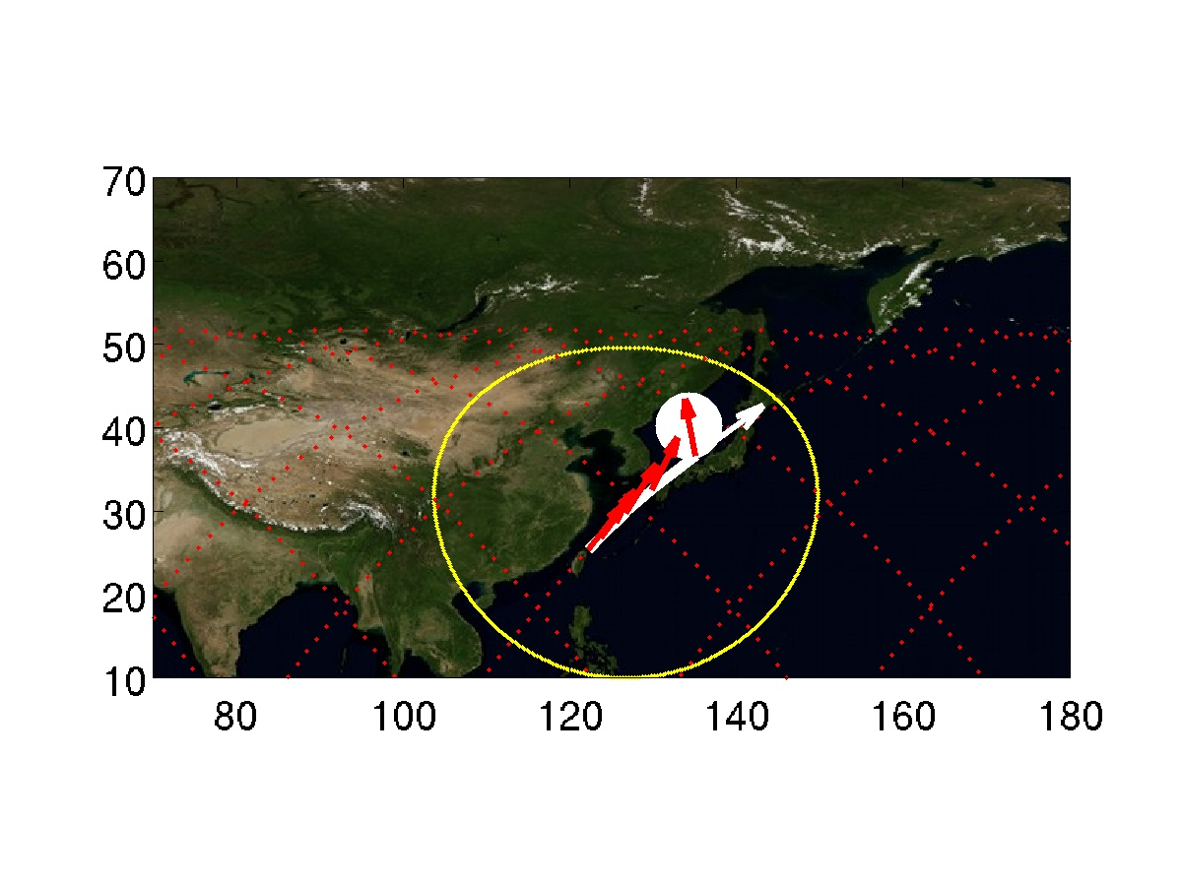

Target 27 | TLEs above Western_Pacific | Quality ***
Day  Start Time  End Time  ISS Site  Pointing | 2015/09/10 Nightime  253/19:13  253/19:18  Target on STBD side, moving toward horizon  Start Az: 90.5 º El -29.2 º  End Az: 155.7 º El -20.0 º  ISS in daytime, Sun facing the observing window. | 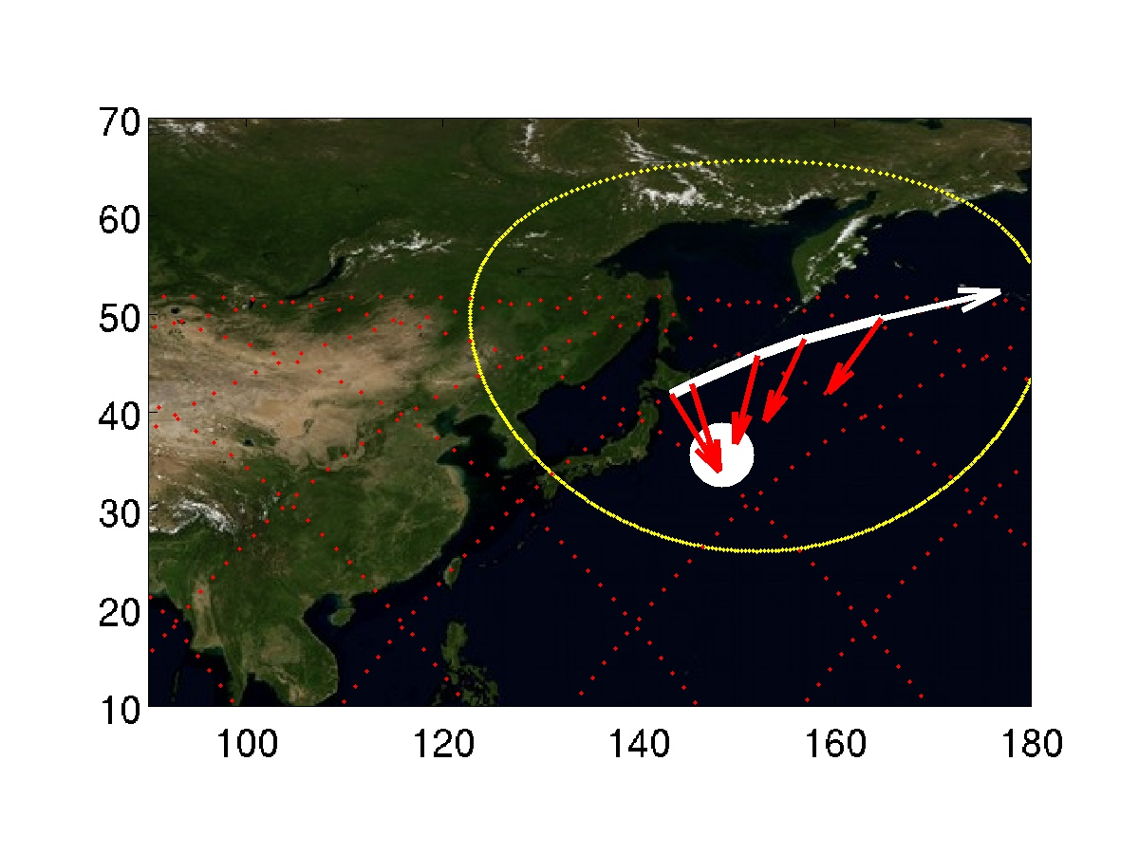

Target 28 | CTs above California | Quality ***
Day  Start Time  End Time  ISS Site  Pointing | 2015/09/10 Daytime  253/19:34  253/19:39  Target on STBD side, moving toward horizon  Start Az: 89.3 º El -36.8 º  End Az: 163.2 º El -20.1 º | 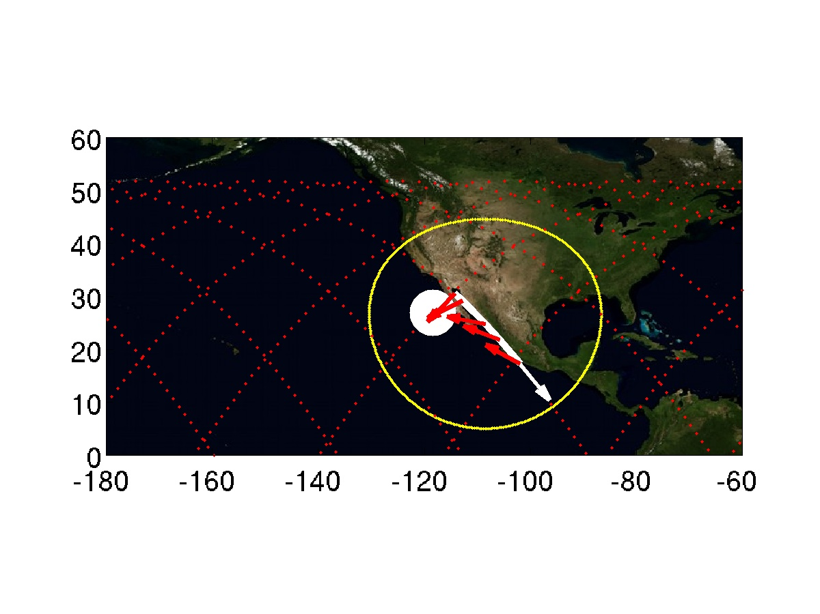

Target 29 | CTs above Costa_Rica | Quality ***
Day  Start Time  End Time  ISS Site  Pointing | 2015/09/10 Daytime  253/19:40  253/19:45  Target on PORT side, coming from horizon  Start Az: -38.3 º El -19.9 º  End Az: -98.3 º El -22.6 º | 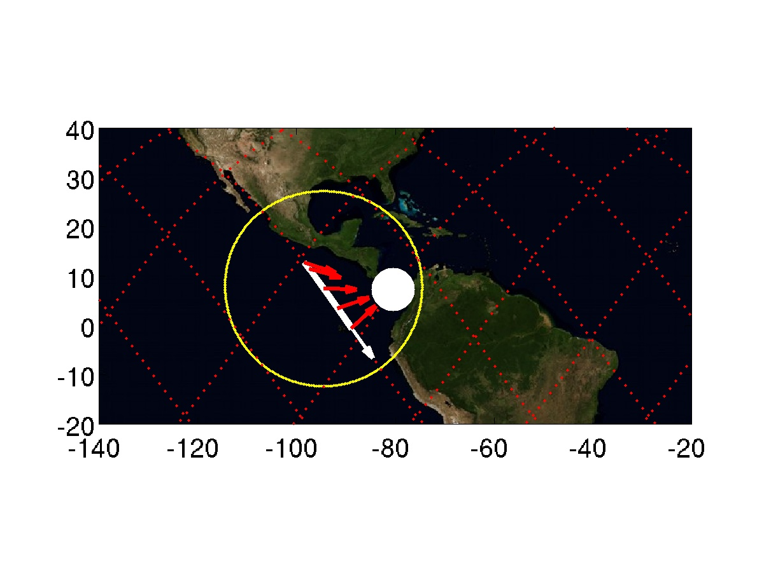

Target 30 | TLEs above Bay_of_Bengal | Quality ***
Day  Start Time  End Time  ISS Site  Pointing | 2015/09/10 Nightime  253/20:30  253/20:35  Target on PORT side, coming from horizon  Start Az: -14.4 º El -20.0 º  End Az: -90.1 º El -41.3 º | 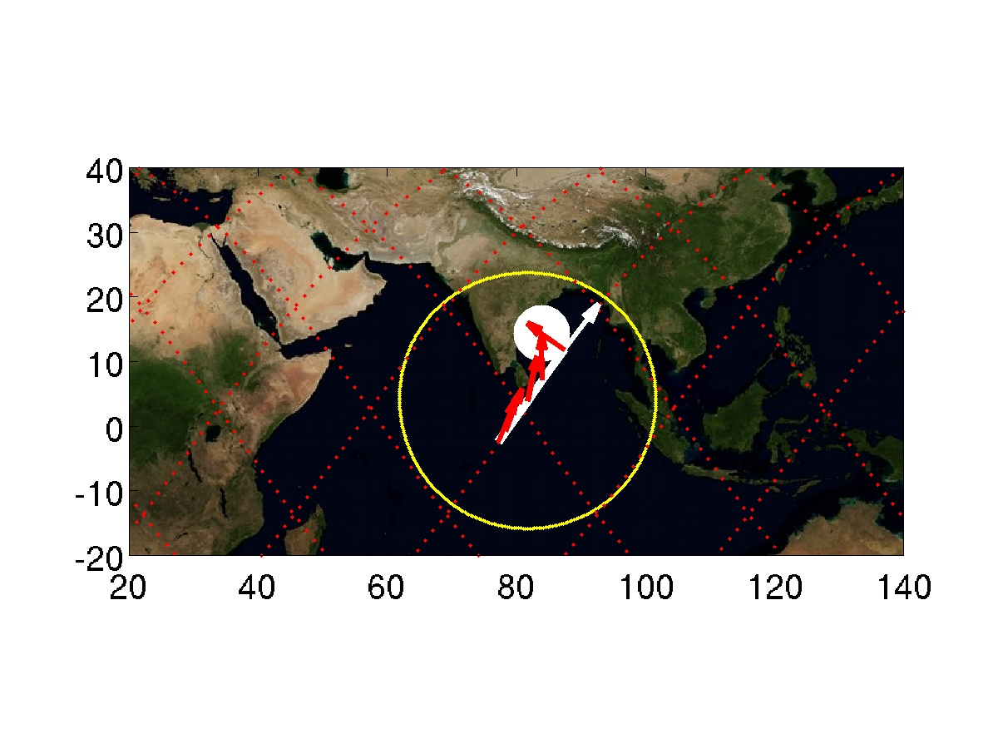

Target 31 | TLEs above Vietnam | Quality ***
Day  Start Time  End Time  ISS Site  Pointing | 2015/09/10 Nightime  253/20:36  253/20:40  Target on STBD side, moving toward horizon  Start Az: 77.3 º El -20.2 º  End Az: 123.8 º El -19.8 º | 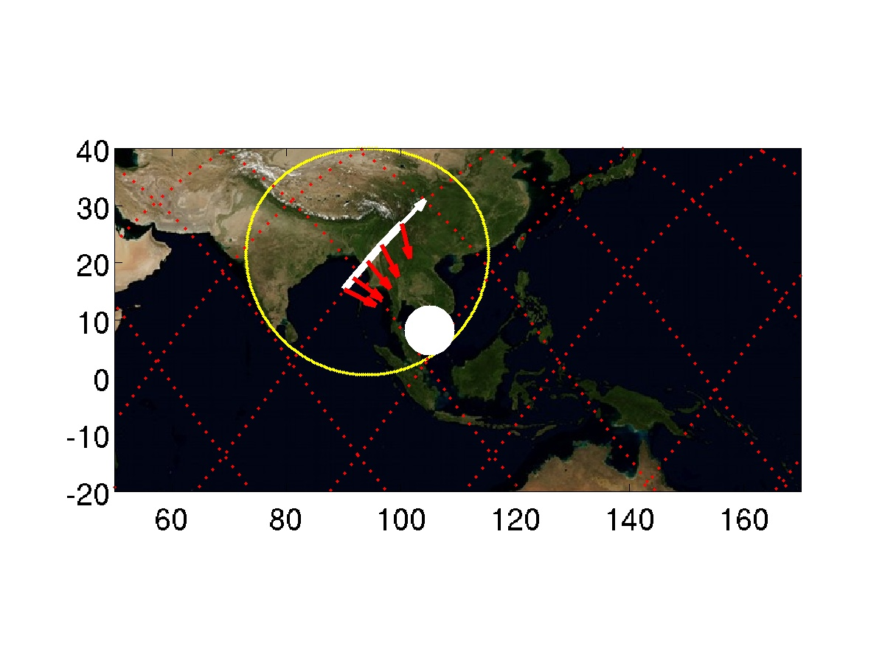

Target 32 | CTs above Japan | Quality ***
Day  Start Time  End Time  ISS Site  Pointing | 2015/09/10 Daytime  253/20:48  253/20:53  Target on STBD side, moving toward horizon  Start Az: 90.4 º El -30.8 º  End Az: 157.6 º El -20.0 º  Sun facing observing window. | 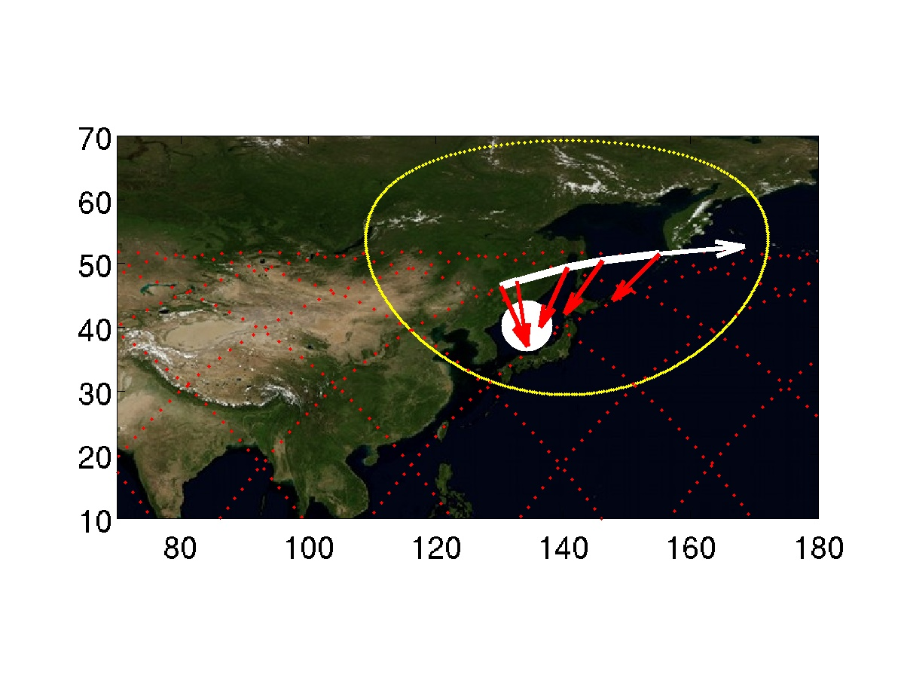

Target 33 | CTs above Western_Pacific | Quality ***
Day  Start Time  End Time  ISS Site  Pointing | 2015/09/10 Daytime  253/20:50  253/20:54  Target on STBD side, moving toward horizon  Start Az: 80.0 º El -20.6 º  End Az: 128.4 º El -19.9 º  Sun facing observing window | 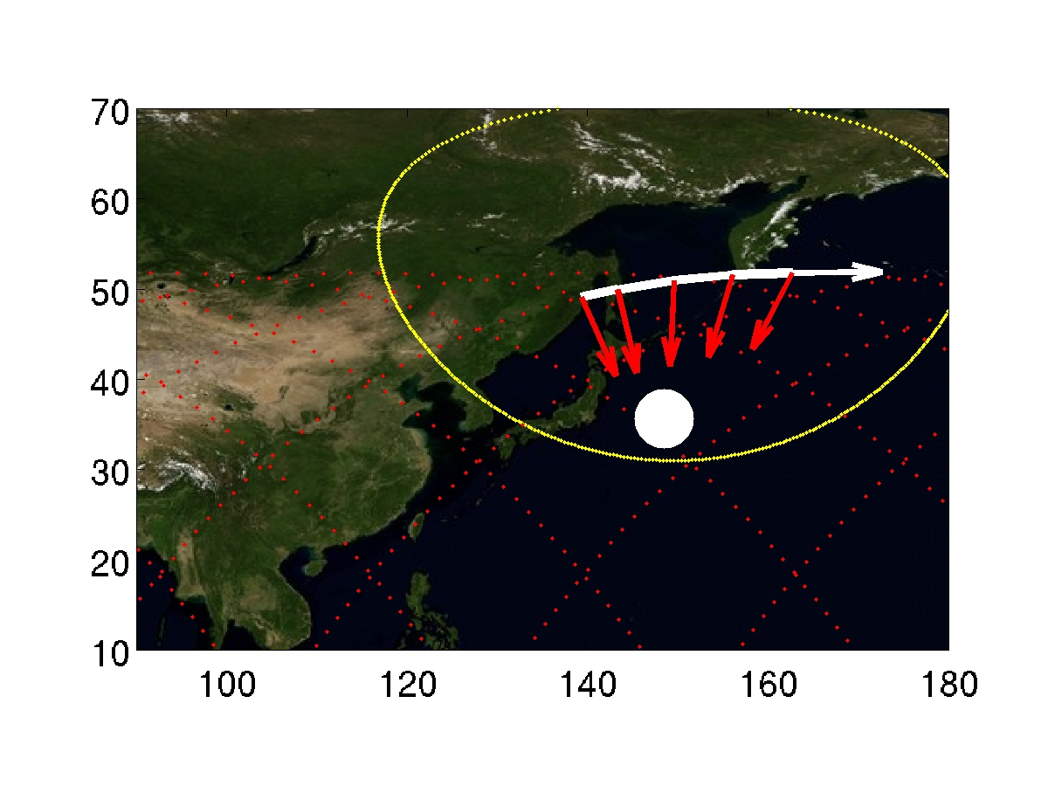

Target 34 | CTs above California | Quality ***
Day  Start Time  End Time  ISS Site  Pointing | 2015/09/10 Daytime  253/21:06  253/21:11  Target on PORT side, coming from horizon  Start Az: -36.8 º El -20.0 º  End Az: -98.2 º El -23.1 º | 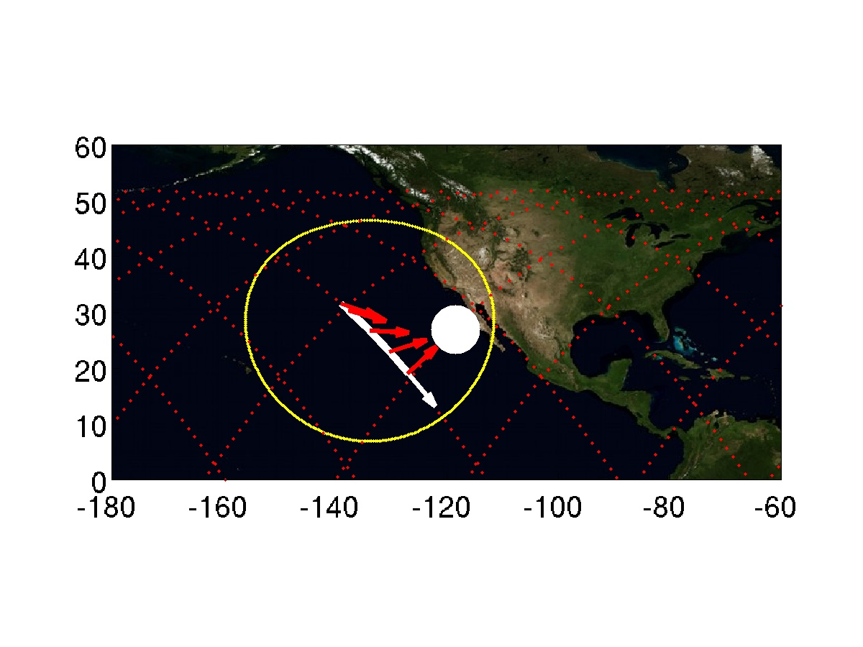

Target 1 | CTs above Bay_of_Bengal | Quality ***
Day  Start Time  End Time  ISS Site  Pointing | 2015/09/11 Daytime  254/06:25  254/06:29  Target on STBD side, moving toward horizon  Start Az: 78.5 º El -25.7 º  End Az: 147.9 º El -20.2 º  Sun facing observing window | 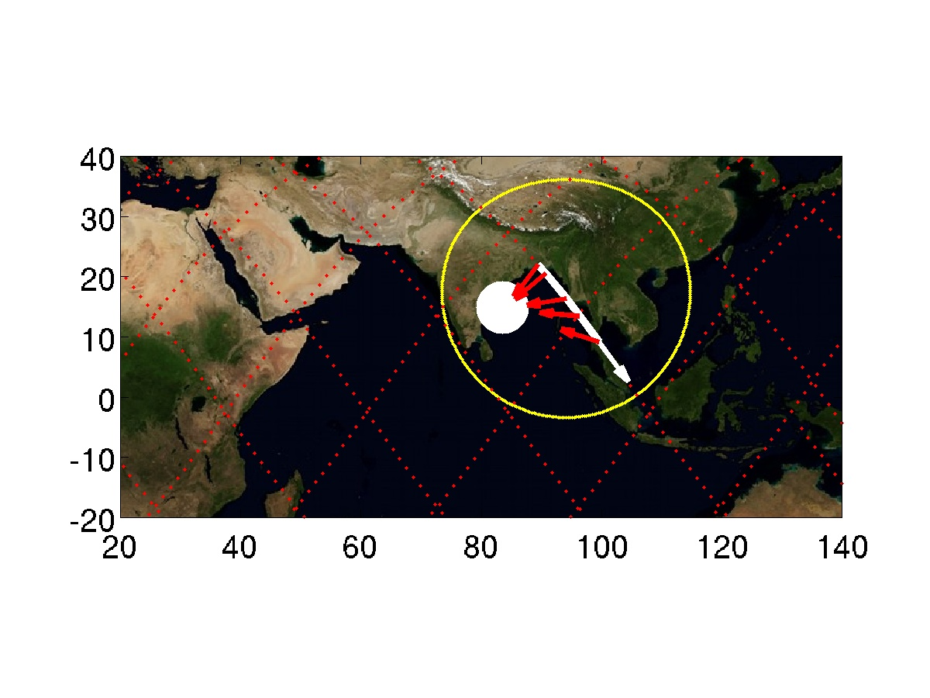

Target 2 | TLEs above Costa_Rica | Quality ***
Day  Start Time  End Time  ISS Site  Pointing | 2015/09/11 Nightime  254/07:16  254/07:20  Target on PORT side, coming from horizon  Start Az: -5.7 º El -20.0 º  End Az: -39.9 º El -54.7 º | 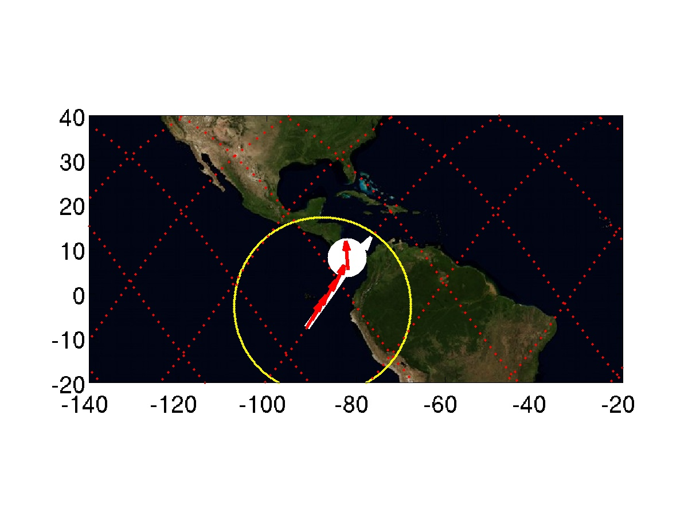

Target 3 | CTs above Bay_of_Bengal | Quality ***
Day  Start Time  End Time  ISS Site  Pointing | 2015/09/11 Daytime  254/07:57  254/08:02  Target on PORT side, coming from horizon  Start Az: -31.0 º El -19.9 º  End Az: -100.6 º El -25.0 º | 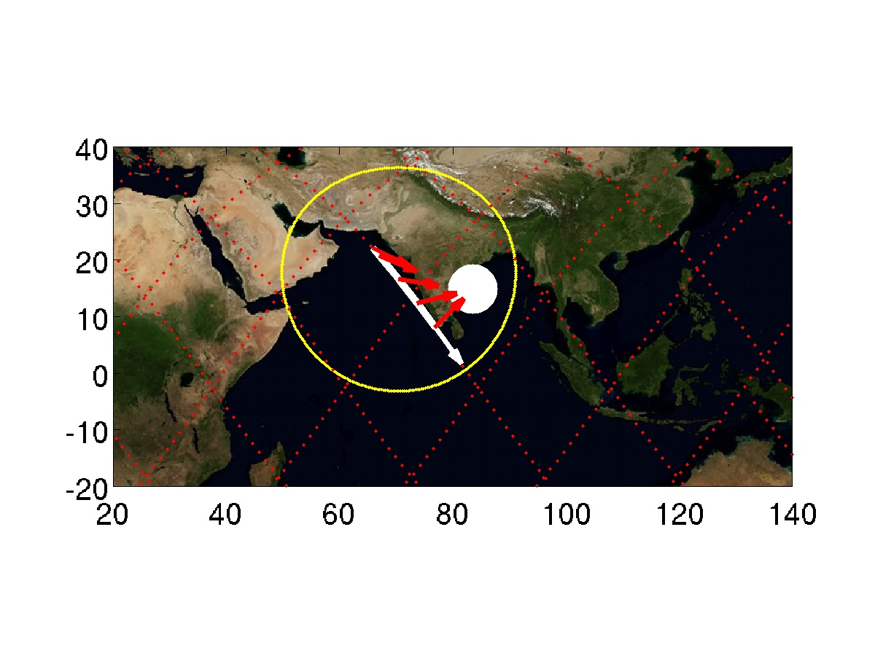

Target 4 | TLEs above Costa_Rica | Quality ***
Day  Start Time  End Time  ISS Site  Pointing | 2015/09/11 Nightime  254/08:56  254/09:00  Target on STBD side, moving toward horizon  Start Az: 75.9 º El -20.0 º  End Az: 116.4 º El -19.8 º | 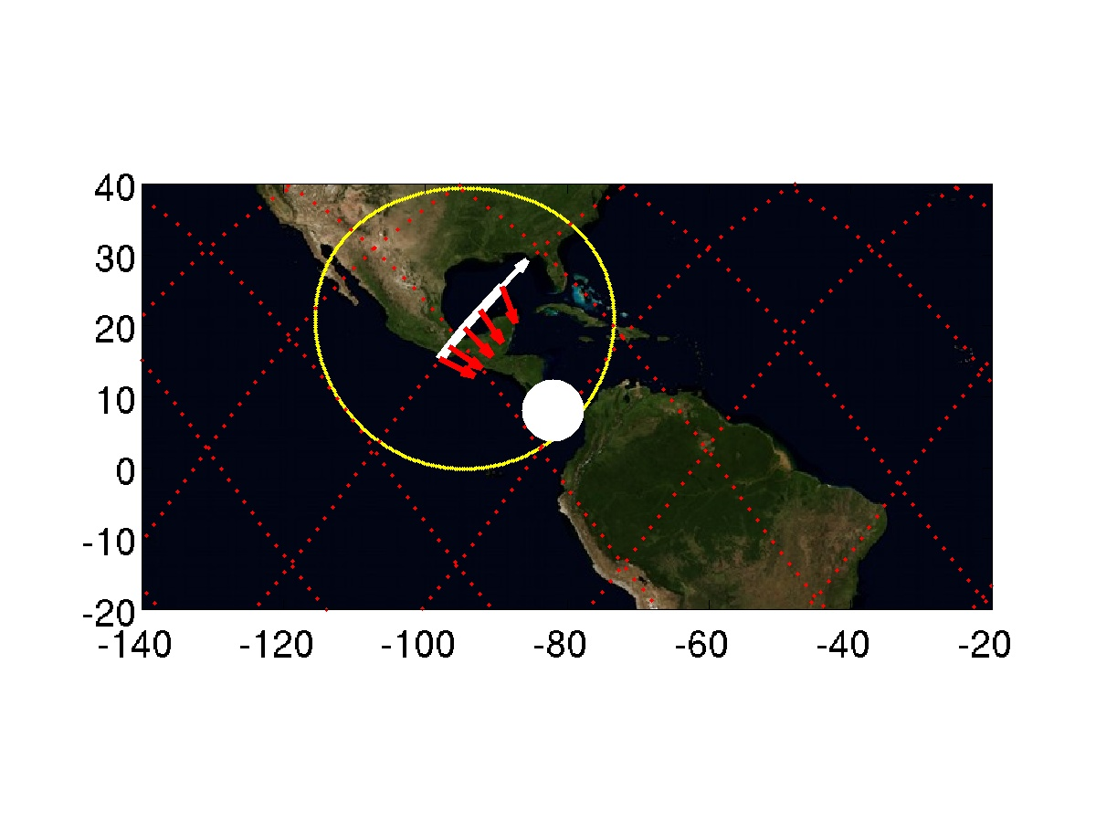

Target 5 | CTs above Central_Africa | Quality ***
Day  Start Time  End Time  ISS Site  Pointing | 2015/09/11 Daytime  254/11:07  254/11:12  Target on STBD side, moving toward horizon  Start Az: 82.2 º El -22.6 º  End Az: 141.8 º El -20.0 º  Sun facing observing window | 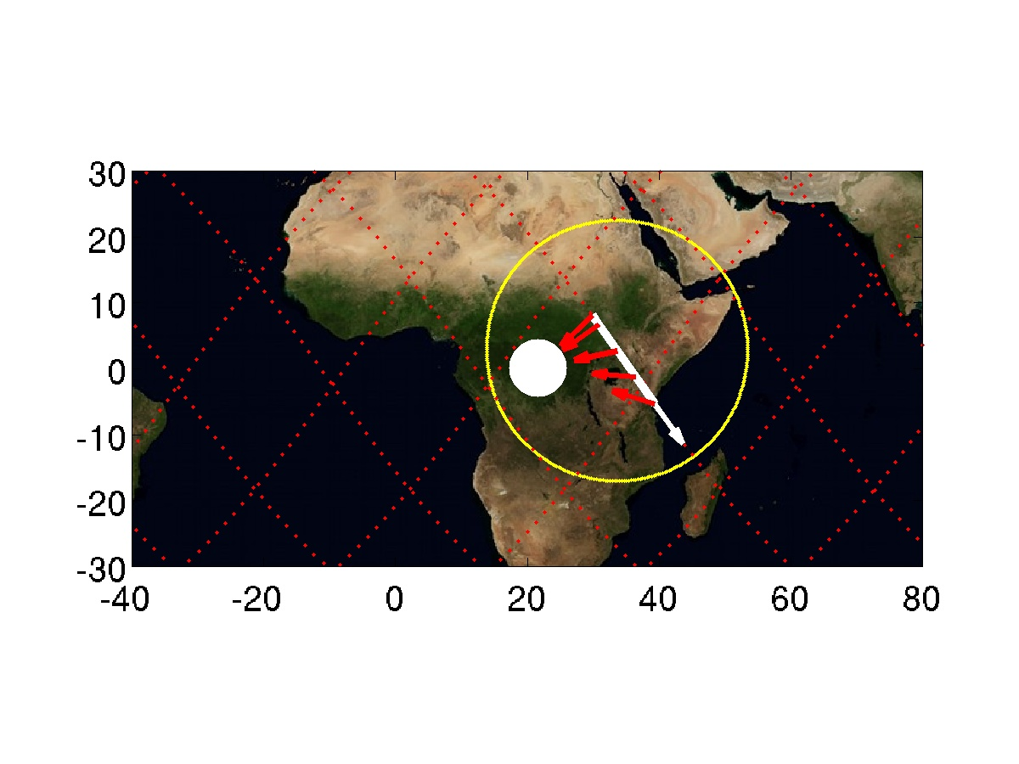

Target 6 | CTs above Senegal | Quality ***
Day  Start Time  End Time  ISS Site  Pointing | 2015/09/11 Daytime  254/12:33  254/12:37  Target on STBD side, moving toward horizon  Start Az: 81.8 º El -22.5 º  End Az: 138.1 º El -20.1 º | 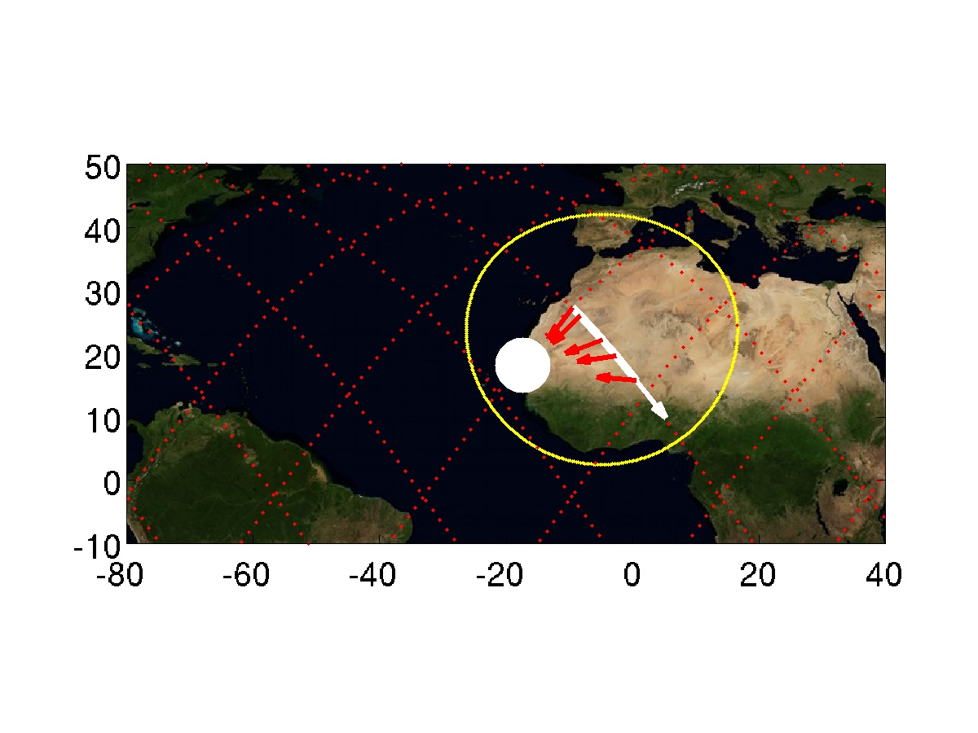

Target 7 | CTs above Central_Africa | Quality ***
Day  Start Time  End Time  ISS Site  Pointing | 2015/09/11 Daytime  254/12:39  254/12:44  Target on PORT side, coming from horizon  Start Az: -25.8 º El -20.0 º  End Az: -90.5 º El -28.0 º | 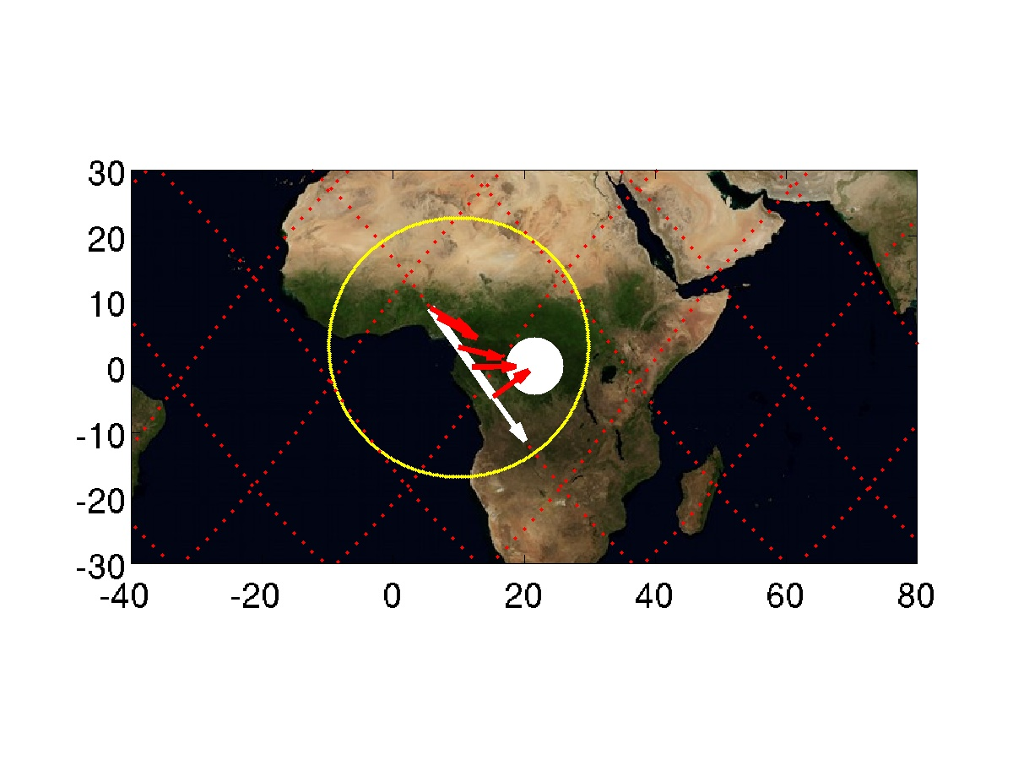

Target 8 | CTs above Senegal | Quality ***
Day  Start Time  End Time  ISS Site  Pointing | 2015/09/11 Daytime  254/14:05  254/14:10  Target on PORT side, coming from horizon  Start Az: -18.8 º El -19.9 º  End Az: -89.8 º El -34.0 º | 