ESA AO/1-10461/20/I-NB

POLAR SCIENCE CLUSTER

Collaborative Research Actions
Interdisciplinary Networking Actions

DETAILED PROPOSAL

ALBATROSS
ALtimetry for BAthymetry and Tide Retrievals for the Southern Ocean, Sea ice and ice Shelves

- TECHNICAL PROPOSAL
  - PROPOSED DEVELOPMENT
[Provide a summary description of what is to be developed]

The ALBATROSS project aims to revisit the bathymetry and the ocean tide modelling around Antarctica by exploiting the most recent satellite datasets available in the region and by bringing together high-level international interdisciplinary expertise and knowledge about bathymetry processing, physical oceanography, ocean tide modelling and sea ice and ice shelf dynamics. The need for more accurate bathymetry and ocean tide datasets is widely recognized as a limiting factor to the understanding and improvement of many other related ocean and ice parameters. This project is thus at the crossroads of many disciplines that will benefit from its outputs, both in terms of products and scientific knowledge.

First, we propose to compute a new bathymetry dataset all around Antarctica, which will benefit from the decade-long time series of the most recently reprocessed CRYOSAT dataset. The high-resolution SAR and SARin modes on-board CRYOSAT will bring invaluable information to improve the knowledge about the ocean bottom topography in the Southern Ocean, especially in the sea ice leads. Using a new product of sea ice surface roughness based on optical images together with existing sea ice satellite products, we will also quantify the behaviour of the sea ice, which appears thinner, smoother and more fragmented in regions of steep bathymetry gradients, and use these sea ice characteristics as a proxy to improve the location of these bathymetry gradients. This is of particular importance as the ocean tides are very sensitive to the shelf break but also as some recent studies suggest that increased turbulence and tidal activity observed at location of steep topography enhance the vertical heat fluxes and could contribute to the shelf break surface features and intermittent formation of polynya in the Southern Ocean. To improve the definition of the ocean floor topography under the ice shelves, we will compile the best available data of local bathymetry, grounding line location and ice shelf thickness, as this is one of the most challenging aspects of tide modelling in such a region.

Then we will implement a high-resolution hydrodynamic model to simulate the ocean tides in the Southern Ocean, based on the most advanced developments in terms of ocean tide modelling. The bathymetry dataset collated during the first step of the project will feed the model. The high sensitivity of the model to the bathymetry quality will be used to assess the bathymetry in an iterative process. Once the best hydrodynamic solution obtained, we will proceed with data assimilation of tide gauge and altimetry observations, using the most complete altimetry-derived tidal dataset ever used in the Southern Ocean. The model will be validated in the ocean, using tide gauges and satellite altimetry observations, and on the ice shelves, using ICESat-2 and GPS measurements.

Finally, this new tidal model will be assessed through independent analyses within the ALBATROSS project. On the one hand, we will evaluate its capability to improve the CRYOSAT sea surface heights and sea ice products from the CRYOSAT+ Antarctic Ocean (CSAO) project. On the other hand, we will investigate how this new tidal model improves the retrievals of ice shelves parameters. Together, the new bathymetry and tide products will provide a better description of the coupled nature of the interactions between the ocean and the ice (sea ice and ice shelves) mediated by the regional bathymetry.

Thanks to their large Polar network and to their involvement in numerous international Polar research projects, the ALBATROSS partners will be in position to develop strong collaborations in order to maximise the scientific impact of the project. Some potential collaborations have already been envisaged, through letters of support provided to the project team.

  - SCIENTIFIC OR TECHNICAL OBJECTIVES:
[Outline the main objective(s) to be achieved and the end goal(s) being targeted. Indicate how the achievement of those objectives will be demonstrated.

Activities shall aim at highly innovative scientific results beyond the state of the art.

Activities shall address one or more of the objectives of the ESA-Polar Science Cluster:

- Improving our observation capacity over Polar regions capitalizing on ESA missions and European EO assets through a set of novel EO-based products and advanced geo-information data sets.
- Exploit the increasing EO capacity to enhance the basic scientific understanding of the different processes governing Polar changes and its local, regional and global impacts
- Translating novel observations, new knowledge and scientific results into actionable solutions for society.

The ranges of the ocean tides around Antarctica vary locally from a few centimetres to several meters, with the largest ranges being observed in the coastal regions of the Weddell Sea and the eastern part of the Antarctic Peninsula (Figure 1). In such an isolated and hostile region of the world, installing and maintaining tide gauge instruments to measure the sea surface height variations, from which the ocean tide signal can be retrieved, is very challenging and few measuring stations are available along the icy continent coastline.

Satellite radar altimetry is a very powerful tool to retrieve the ocean tide elevations in the open ocean but, given the repeat-periods of the missions, time series of several years are necessary to obtain accurate tidal estimates. In regions covered with sea ice half of the year, the technique is even less accurate. In addition, the only satellite altimetry missions that reach very high latitudes (higher than 66°) have orbit characteristics that are very unfavourable for tidal estimates, such as the sun-synchronous orbits of ERS1-2, ENVISAT and SARAL/AltiKa. The CRYOSAT mission offers much more measurements at the high latitudes thanks to its dense spatial cover but, until recently, the specificities of its altimeter instrument, with three different modes of measurements (LRM, SAR and SARIn), made it difficult to produce homogenized sea surface height datasets in sea ice covered regions and close to the Antarctic continent coast.

Hydrodynamic modelling is thus the only way to fill the gap between these sparse measurements and to provide spatially continuous information about the ocean tides, whatever the region of the world. This strength is even reinforced in such a region as the Southern Ocean.

The knowledge about the ocean tides around Antarctica thus mainly lean on the modelling capacity. This information, in terms of both elevations and currents, is useful for many applications:
- to better understand the circulation of the water masses in the Southern Ocean, from the shore to the open ocean, and its link with the global ocean circulation, which has direct implications on climate studies;
- to better understand the behaviour of the ice shelves, as their ice dynamics are directly linked with the back and forth movements of the tides, and to improve the models of iceberg calving;
- to remove the aliased ocean tide signals in the satellite altimetry sea surface height measurements to improve the knowledge on the regional sea level and sea ice;
- to provide water level information for the coastal navigation in these regions.

Various tidal models already provide tidal elevation (and sometimes current velocity) information in the Southern Ocean, either with a global (FES2004, DTU10, GOT4.10, FES2014, TPXO9) or a regional (CATS2008) extent. All these models rely on satellite altimetry data, through either data assimilation or optimal interpolation. Figure 1 highlights the missing information to constrain the FES2014 tidal model with data assimilation in the Southern Ocean. Actually, the ERS/ENVISAT data proved to be of insufficient quality in this region to retrieve accurate tidal estimates and improve the model. The validation of the models is also limited in this region, due to the scarcity of good-quality data.

The first objective of the ALBATROSS project is to improve the availability of satellite altimetry-derived tidal estimates in the Southern Ocean in order to better constrain and validate the tidal models in the region.

The achievement of this objective will be demonstrated through the capability to fill the observation gap shown in Figure 1 with coherent tidal estimates that will improve the tidal model performance in the data assimilation process.
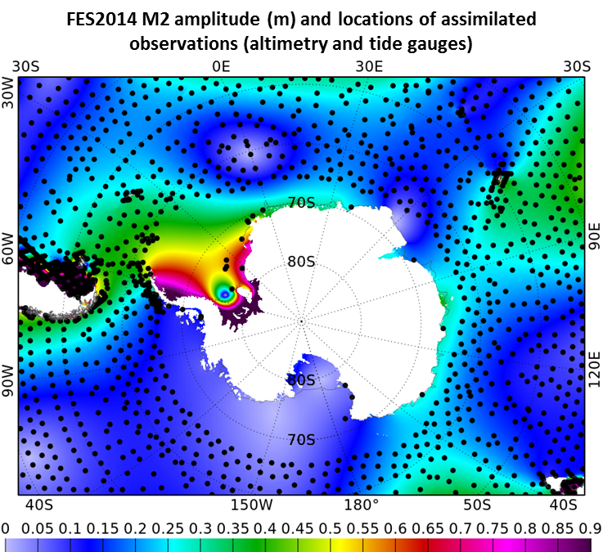
Figure 1: M2 tidal wave amplitude (m) from the FES2014 global tidal atlas in colours. The black dots show the locations of the assimilated observations into FES2014 (TPJ1J2 crossover points, TPJ1J2 alongtrack observations on the shelves and tide gauge stations).

Although several tidal solutions are available in the Southern Ocean, they show large discrepancies, especially in the ice-shelf regions where they can differ from one another by more than 10% of the local tidal range. Figure 2 shows the spatial variability of the amplitude of two main tidal components (M2 and K1) computed over three of the most recent global tidal models. Two of them (FES2014 and GOT4.8) are today the reference models provided by the Space Agencies as ocean tide corrections for the satellite altimetry sea surface height measurements. It appears very clearly that the models strongly differ in the region south of the 66°S limit (black circle in the figure), where the Topex-Jason altimetry mission observations are not available and the quality of the satellite altimetry-derived tidal estimates strongly degraded up to now.

Today, the overall error of the models when compared to tide gauges is still at least in the order of 10 cm (Figure 3), with the most recent version of the TPXO9v3 model, released in October 2020. For the FES2014 reference model and the CATS2008 regional model, the overall error is in the order of 15 cm. And even when the global performance is improved, displaying the vector differences against tide gauge stations on a map clearly highlights the regions where the models still need improvement, particularly the ice-shelf regions (Figure 4).

Finally, the tidal models are provided on regular grids, with a spatial resolution that is not always well adapted to accurately represent the tidal signal close to the coast. For example, the FES2014 global tidal model was computed on an unstructured grid but is distributed on a regular grid of 1/16°, which is more convenient to handle in most cases. However, when the objective is to compute tidal elevations to remove the tidal signal from altimetry coastal observations, the use of such regular grid leads to the discarding of some points that fall out of the grid, whereas they could be kept in the computation when using the unstructured grid.

The second objective of the ALBATROSS project is to improve the knowledge on ocean tides in the Southern Ocean through the implementation of a high-resolution tidal model in the Southern Ocean, based on an unstructured grid and benefitting from data assimilation.

The achievement of this objective will be demonstrated through the capability of the new model to reduce the errors against independent observations, both in the ocean and for the ice shelves.

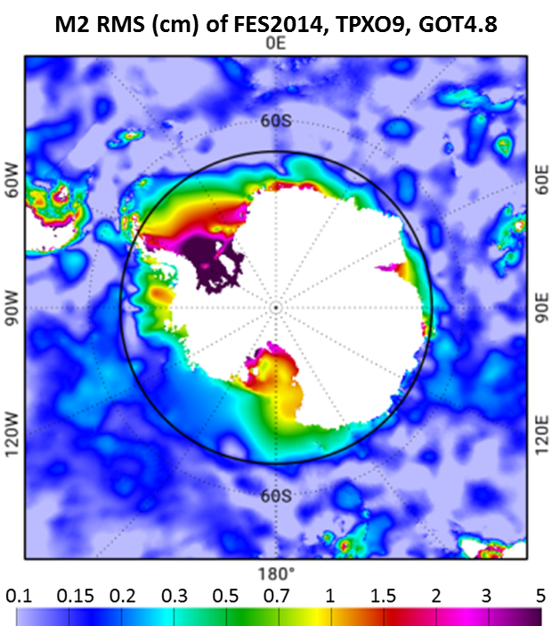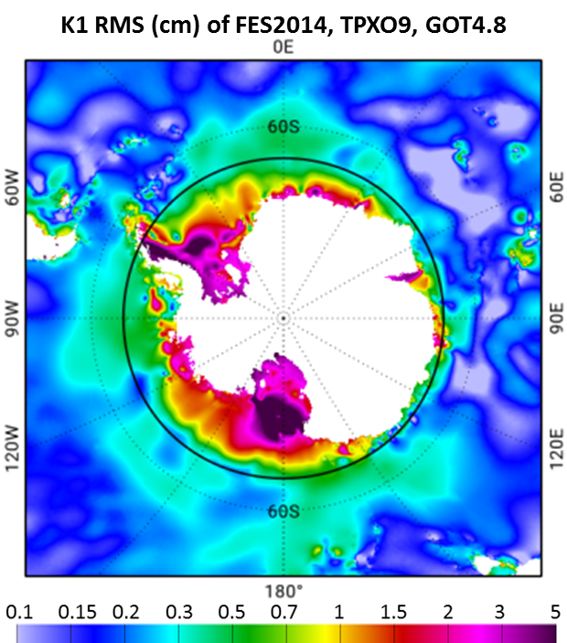
Figure 2: RMS of the amplitude computed from several tidal models (FES2014, TPXO9 and GOT4.8) in the Southern Ocean, for the M2 tidal wave (left) and the K1 tidal wave (right). The black circle shows the 66°S-limit of the Topex-Jason data availability. Adapted from Lyard et al., 2018.

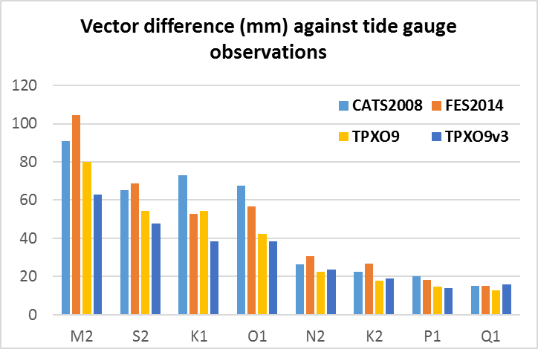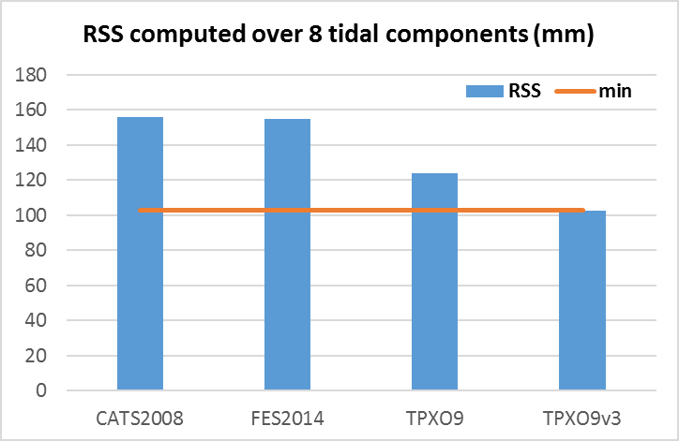
Figure 3: (Left) Vector differences (mm) of global and regional tidal models against tide gauge stations in Antarctica (not assimilated in FES2014) for the main tidal waves. (Right) Root Sum Square (mm) computed over the same eight tidal waves.

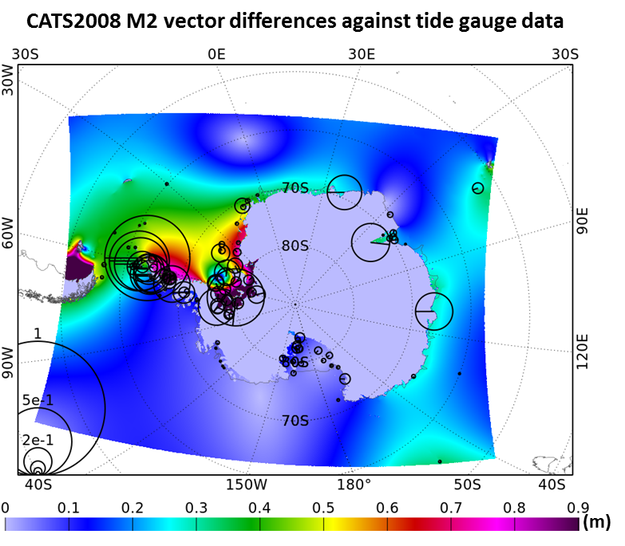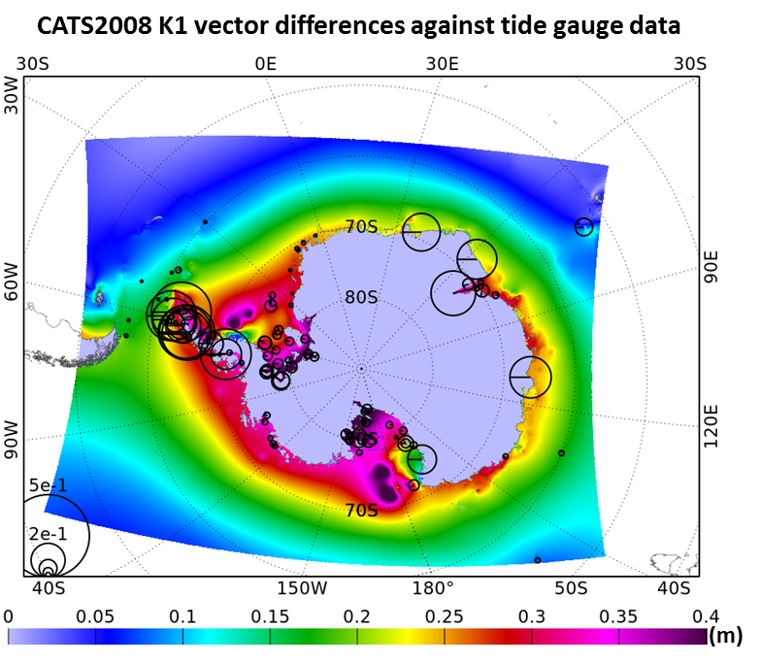
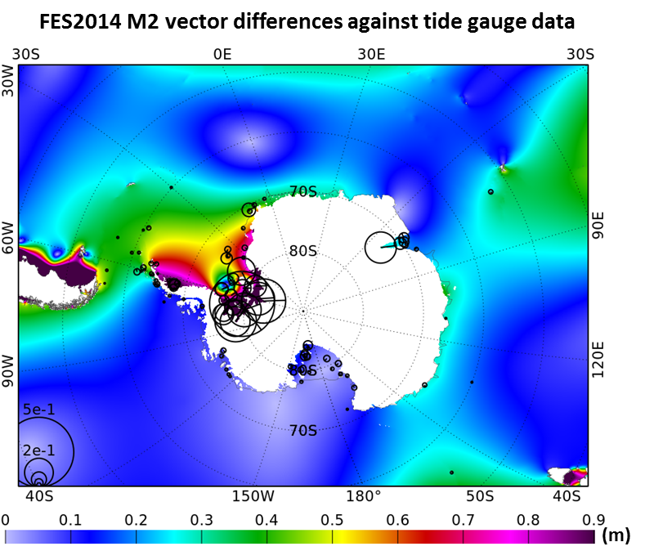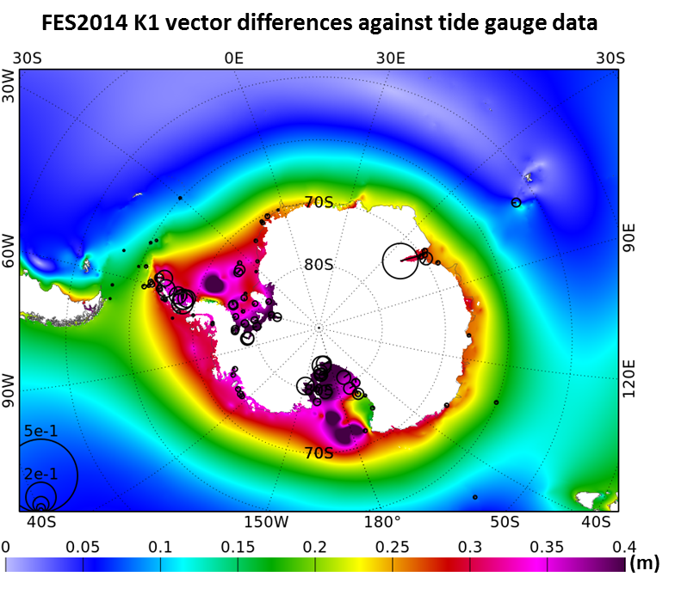
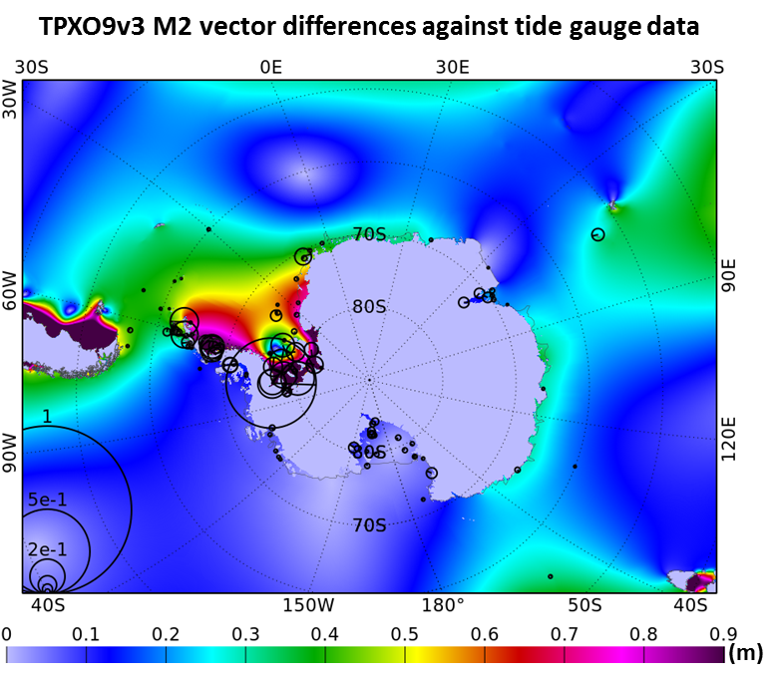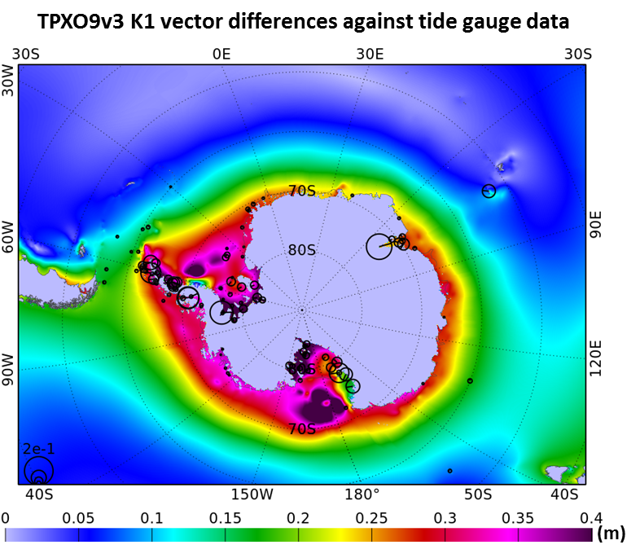
Figure 4: Tidal wave amplitude (in m) for M2 (left) and K1 (right) for three different models (CATS2008, FES2014 and TPXO9v3) as background colours and vector differences against tide gauge data (black circles) in the Southern Ocean.

Today, the main limiting factor to the accuracy of the ocean tide models is the quality of the bathymetry, i.e. the ocean floor topography that is ingested by the models. Indeed, even along the European coasts, huge improvements have been brought to ocean tide models thanks to high resolution and high quality bathymetry datasets (Cancet et al, 2019). In the Southern Ocean, the in situ bathymetry sounding campaigns are rare (Figure 5). The Weddell Sea is particularly poorly resolved and this is important as key region for oceanography and sea ice dynamics (where the thickest and oldest sea ice is found in Antarctica). One must thus mainly rely on satellite observations. Satellite altimetry measurements have been commonly used for decades now to improve the bathymetry in the deep ocean (Smith and Sandwell, 1994) and the geodetic end-of-life orbits of the Jason-1 and Jason-2 missions have strongly contributed to the resolution of smaller bathymetry features, thanks to the denser spatial coverage of the altimeter measurements. However, as mentioned above, this is limited to North of 66°S. In the high latitudes, the dense spatial coverage of the CRYOSAT mission offers a unique opportunity to fill the gaps in the current bathymetry datasets but its use was strongly limited until recently due to the heterogeneity of the datasets in regions covered of sea ice.

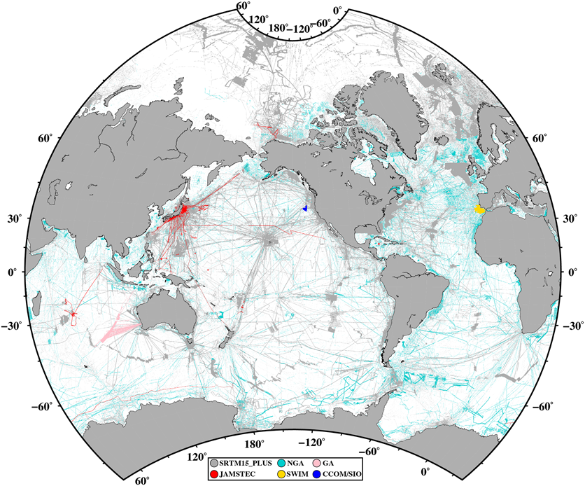
Figure 5: Global data coverage map of shipboard soundings included in SRTM15+V2.0. Extracted from Tozer et al., 2019.

The ocean tides are particularly sensitive to the steep bathymetry gradient features, which can induce internal tides and topography-trapped tidal waves. Because of the presence of sea ice, the satellite altimetry observations are not exploitable everywhere to improve the bathymetry. However, it is possible to use the sea ice surface characteristics as a proxy to improve the location the bathymetry gradients, as the sea ice becomes thinner, smoother and more fragmented in regions of steep bathymetry gradients (REF). This is of particular importance as ‘hot spots’ of enhanced vertical heat fluxes mediated by increased turbulence and tidal activity were observed in the Arctic at location of steep topography (Ripeth et al, 2015). Recent studies (REF) suggest that this mechanism could also contribute to the vertical heat fluxes in the Southern Ocean hence explaining the shelf break surface features observed in Figure 6 but also the intermittent formation of the Maud rise polynya in the ocean at large (See bathymetry figure)

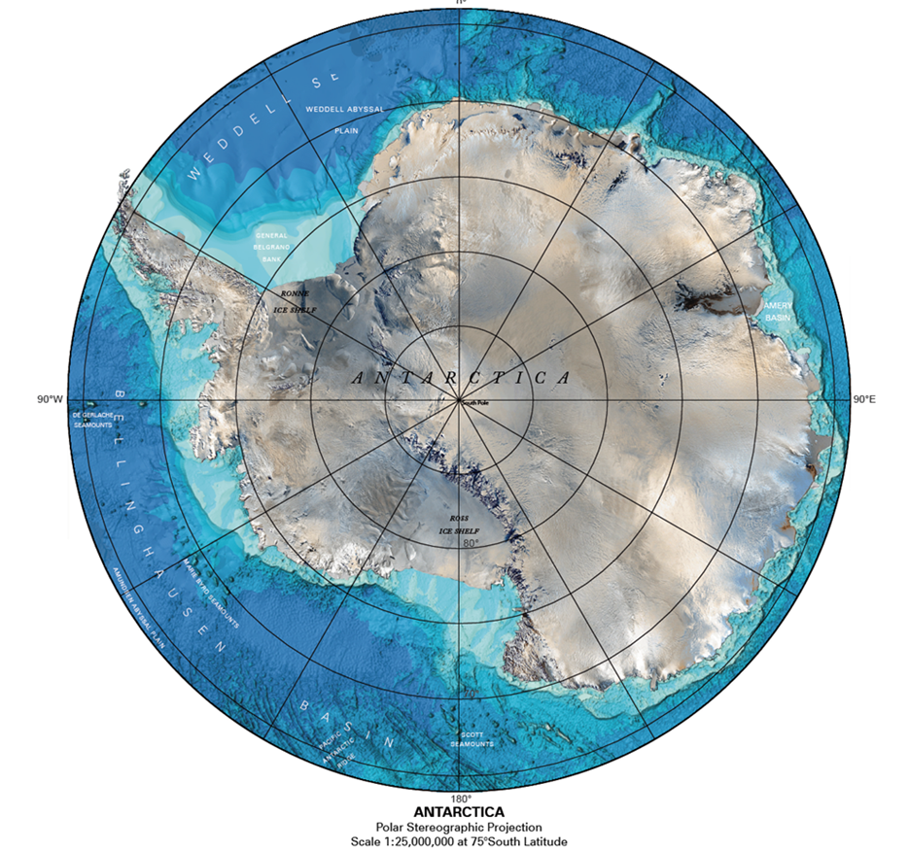
Figure 6: Antarctica and Southern Ocean topography. Extracted from Tozer et al. 2019.

Finally, as highlighted in Figure 4, the models still show the largest errors in the coastal areas with extensive coverage of ice shelves. The bathymetry is poorly known under the shelves and the friction between the ice and the ocean is difficult to model. This is the reason why a specific effort is needed to collect available information and merge the relevant data into the bathymetry used by the hydrodynamic model to simulate the tides.

The third objective of the ALBATROSS project is to improve the knowledge on the bathymetry in the Southern Ocean, with specific focus on the bathymetry under the ice shelves and the bathymetry gradients under the sea ice.

The achievement of this objective will be evaluated through the performance of the tidal model, which is very sensitive to the quality of the bathymetry and will be used as a proxy to validate the new bathymetry product.

The ocean tide information is an important parameter for the computation of various geophysical quantities, such as the sea surface heights measured by the satellite altimetry missions and the sea ice retrievals derived from such measurements, as well as various ice-shelf parameters.

The fourth objective of the ALBATROSS project is to improve satellite altimetry retrievals of sea surface heights and sea ice information thanks to the new tidal model.

The achievement of this objective will be assessed by evaluating the capability of the new tidal model to improve the CRYOSAT sea surface heights and sea ice products from the CRYOSAT+ Antarctica project.

The fifth objective of the ALBATROSS project is to improve the retrievals of ice shelves parameters such as ice-shelf thickness changes and basal melting thanks to the new tidal model.

The achievement of this objective will be assessed by evaluating the capability of the new tidal model to improve estimates of ice-shelf thickness change compared to concurrent tidal models.

  - REQUIREMENTS TO BE ADDRESSED BY THE PROPOSED DEVELOPMENT:
[Identify and discuss the technical requirements to be addressed in order to achieve the specific Scientific/Technical Objectives as outlined in section 1.2 above. Where relevant this should also describe target performance levels to be achieved (eg update frequency, latency, processing times etc). When appropriate the requirements shall be associated to a quantitative value. These quantitative values shall be labelled as committing ones or as being to be considered as a goal. The verification approach for each requirement shall be identified. Provide a justification/ reasoning for such requirements]

In order to achieve the objectives defined in section 1.2 we identify a list of requirements that the project team proposes to meet.

Objectives | Requirements
[Obj. 1] Improve the availability of satellite altimetry-derived tidal estimates in the Southern Ocean | [Req. 1] Produce a satellite altimetry tidal estimate dataset that fills the gap between 66°S and the Antarctic coast using the most recent and relevant satellite altimetry products.
[Obj. 2] Improve the knowledge on ocean tides in the Southern Ocean | [Req. 2] Implement and validate a new regional tidal model around Antarctica with overall error lower than 10 cm (best performance of the current models available in the region, Figure 3). Locally reduce the error, especially in ice-shelf regions, thanks to better knowledge of the bathymetry, high-resolution modelling and data assimilation.
[Obj. 3] Improve the knowledge on bathymetry in the Southern Ocean | [Req. 3] Produce a merged bathymetry based on the best state-of-the-art dataset combined with new satellite altimetry data, information on bathymetry gradient location derived from sea ice roughness and the available information under the ice shelves. This new bathymetry dataset should enable to reduce the errors of the tidal model.  It is however difficult to associate a quantitative value with this requirement (in terms of spatial resolution or vertical error, for example) because the quality of the bathymetry and its intrinsic resolution will strongly vary depending on the region and the quantity of data available.
[Obj. 4] Improve satellite altimetry retrievals of sea surface heights and sea ice information | [Req. 4] Reduce the SSH and sea ice information uncertainties using the new tidal model, compared to concurrent models.
[Obj. 5] Improve the retrievals of ice shelves parameters | [Req. 5] Reduce the uncertainties on ice-shelf parameters using the new tidal model, compared to concurrent models.

  - INNOVATIVE ELEMENTS WITHIN THE PROPOSED DEVELOPMENT:
[Identify what is the nature of the innovative content of the proposal and explain how this represents an improvement on the current state of the art in the domain being targeted.

Describe the expected impact and benefit arising from the proposed development due to the innovative content]

Innovative elements and expected impact of the bathymetry improvement

DTU, UCL, NPI

Innovation and improvement on current state of the art:
Use of CRYOSAT data
Use of sea ice surface characteristics as a proxy for bathymetry gradient location
Combined approach: open ocean, sea ice, ice shelves.
Use of tidal modelling to assess the bathymetry quality.

Expected impact:
Enhance ability to make ocean model (using enhanced bathymetry) also important to interaction between sea ice and ocean

Innovative elements and expected impact of tide modelling and data assimilation

NOVELTIS, Florent, DTU, NPI

Innovation and improvement on current state of the art:
Use of CRYOSAT data
Use of improved bathymetry
Use of high resolution unstructured mesh
Validation on ice shelves

Expected impact:
+ better satellite altimetry observations for the ocean, the sea ice and the ice shelves.
+ better tidal boundary conditions for ocean circulation modelling
+ model config could be run for regional storm surge simulations

Enhance quality of satellite altimetry. Improved tides give better signal to noise of remaining signal.
Benefit to empirical tidal models based on a background solution (GOT, EOT, DTU)

  - Clear synergistic and collaborative content:
[Identify how the proposed activity will bringing together results, data, expertise and knowledge from different projects and team (e.g., funded by ESA, EC or MSs) to attain novel scientific breakthroughs beyond original objectives of the single activities ensuring the result is bigger than the sum of the parts]

The team gathered in our ALBATROSS consortium is rich of expertise in very different fields (geodesy, bathymetry, ocean tides, sea ice and ice shelves, in situ data, satellite observations, modelling) which, put together, aim to build the most possible accurate tidal model in the Southern Ocean. To our knowledge, it is the first time that a team build up with the objective to implement and validate such a model taking into account all these different aspects at once, with specific validation both in the ocean and on the ice shelves. With this approach, we aim to highlight the links between each of these surfaces and the ocean tide processes, and to demonstrate the impact of the available datasets in the construction of the bathymetry and the high-resolution ocean tide model.

The work on the new bathymetry dataset will benefit from the XX projects. Further work on sea ice characteristics informing bathymetry will be done as part of UCL’s contribution by Earth Sciences to the Centre for Polar Observations and Modelling (CPOM) as a UK National Capability Centre. The sea ice roughness prototype product in the Arctic is supported by UK funded PhD studentships (UCL, NERC). CPOM also produces sea ice and ocean data in Antarctica as part of the UK NERC Ocean Regulation of Climate by Heat and Carbon Sequestration and Transports (ORCHESTRA) project. Detailed analysis of ocean models and satellite data in the Southern Ocean has already been achieved at UCL with our project partners at NOCS as part of funded PhD studentships and ongoing collaborations via several UK funded projects (MIZ, PRE-MELT, TEACOSI).

The implementation of the high-resolution model will take profit of the FES2022 global tidal atlas developments, which started in July 2020 and will last until end of 2021. Indeed, NOVELTIS is strongly involved in this project funded by CNES. At the time of the start of the ALBATROSS project, the work to assemble the global bathymetry and generate the global grid for the FES2022 model will be finished, and our high-resolution model around Antarctica will benefit from the lessons learned during the implementation of Fes2022. The tuning of the hydrodynamic model will also take advantage of the study performed by NOVELTIS on the impact of the sea ice on ocean tides in the frame of the ARKTALAS ESA project, for the Arctic Ocean. The discussions within the project between the ocean tide expert, the sea ice expert and the ice shelves expert may lead to new developments in the TUGO-m hydrodynamic model in order to take into account the effect of the ice as precisely as possible.

Altimetry data (CRYOSAT-2 and Sentinel-3) for the tidal modelling will be based on the ESA GPOD altimeter data as recent studies indicate that the SAMOSA+ retracker provides altimetry data seamlessly from the open ocean into the leads within the sea ice. Subsequently the data will be processed and edited for sea ice contamination via the DTU system before used for the tidal prediction.

The code that will be used by NOVELTIS to perform the data assimilation is developed by LEGOS and will be strongly revised in the frame of the FES2022 project. The new version of the code will be more efficient and will be based on new methods to improve the computation time. Given the size of the domain to be considered around Antarctica, this aspect will be of prime importance and will enable us to multiply the assimilation experiments.

The validation of the model will be performed in two ways. The classic method will consist in evaluating the performance of the model by comparing with altimetry and tide gauge observations, and with concurrent models in the region. The other method, much more original, will assess the model under the ice shelves, by comparing with GPS and satellite altimetry measurements along the ice shelves. To do that, the in situ data from the XX project will be used.

The impact assessment of the model will also be the occasion to lean on other projects data and results. First, the SSH and sea ice products from the CRYOSAT+ Antarctic Ocean (CSAO) project will be used to assess the value-added of the new tidal model as tide correction for these altimetry measurements. Second, the data from the XX projects will be used to evaluate the impact of the new tidal model on the ice-shelf research, through the calculation of ice-shelf thickness changes and basal melting.
  - SCIENTIFIC OR ENGINEERING DEVELOPMENT APPROACH
    - Scientific/Technical Steps
[Present and discuss in detail the scientific/technical steps to achieve the objectives and the committing requirements outlined under sections 1.1 to 1.4. This shall include an identification of the main deliverable items to be generated. Note: the steps shall be consistent with those reflected in the Work Logic Diagram in section 1.7.1]

      - WP1: Bathymetry improvement

- WP1.1: Improvement in the deep ocean

First, existing bathymetry models will be evaluated around Antarctica (i.e. GEBCO, R-TOPO, IBCSO, SRTM15+…) to identify a starting model for the gravimetric inversion of satellite altimetry. As for the evaluation of R-Topo-2 bathymetry dataset in the Arctic Ocean (Figure 7, Cancet et al., 2019), NOVELTIS will run the TUGO hydrodynamic model (see WP 2.1 for the implementation of the model) with each bathymetry dataset as input. The performance of each of these tidal simulations will be used as a proxy to identify the most relevant bathymetry dataset. Each simulation will be validated with tide gauge data, as presented in WP 2.4.
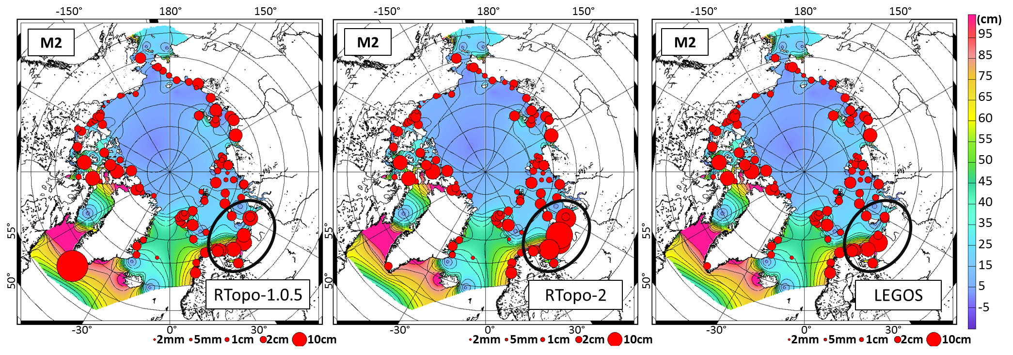
Figure 7: Impact of the choice of bathymetry on the TUGO tidal simulations for the M2 tidal wave in the Arctic Ocean, in terms of vector differences with tide gauge observations (size of red dots). The background colours show the M2 wave amplitude. Extracted from Cancet et al., 2019.

Adaption of the method by Abulaitijiang et al. (2019) will be used, in which gravity field inversion is used to constraint medium wavelength of the pre-selected bathymetry model such that the long and short wavelengths of the pre-selected model is preserved and altimetry only used to improve wavelength. Wavelengths are typically 20-150 km but it depends on sea state, if correlation can be achieved.

Outputs:
Improved bathymetry for regions deeper than 100 meters.
Contributions to MTR report and Final Report.

- WP1.2: Use of sea ice surface characteristics to improve bathymetry gradient location

Sea ice characteristics and bathymetry. This work package stems from the realisation that sea ice is largely controlled by the underlying bathymetry. This link is evidenced in the Arctic at the end of the summer when the sea ice reaches its lowest extent and thickness and follows the basin edges. In Winter months the sea ice edge also closely follows the bathymetry for example in the Fram Strait shelf break or in the Barents Sea where regional topography controls the maximum extent of the ice. In Antarctica, similar observations have been made at the sea ice edge (REF) where rougher ice is attributed to convergent motion linked to a steepening bathymetry change, over the Maud Rise region that controls the formation at irregular intervals (1970s, 2000s) of the open ocean Maud Rise polynya, and strikingly all around the Antarctic shelf break where striking maps of increased lead density (see Figure…) were observed. In the 10-100 metres bathymetry range another process linking bathymetry and sea ice kicks in with the formation of fast ice (ice that is not moving often anchored to the sea floor) and ice bridges between shallow banks in the Ocean (i.e. in the Barents and Kara Seas). This process is well documented (REF) and modelled (REF) but requires high resolution bathymetry information for validation which is often lacking in these remote locations. Detection of the fast ice edge can indirectly be obtained via the location of the coastal polynyas (regions of open water expanses) that form at the edge of the fast ice.

Bridging the 10m to 10km resolution gap with optical imagery. In this work package we will therefore utilise the surface sea ice signatures of the bathymetry of the ocean to identify regions of steepest topography of the ocean floor. This approach has the potential to bridge the gap between existing techniques relying on ship sounding at high resolution (~100m horizontal) and poor sampling (ship tracks are very sparse or even inexistent in part of the SO such as in the Weddell) and satellite-derived gravity measurements with lower resolution (~10km) and high sampling (with limitation over ice covered regions) and offer information about the location of the topography contours in the 100m to 10km range. In addition to analysing existing satellite sea ice products that offer sufficient spatial resolution such as sea ice concentration, lead density, surface albedo (Table XX) we will introduce a novel product of sea ice roughness that has been developed at UCL.

Sea ice roughness from multi-angular imaging spectroradiometry (MISR). In this work package we will build on novel work done in the Arctic as part of a UK funded PhD studentship (Johnson et al, in preparation) where a new sea ice roughness product was developed using a machine learning algorithm using optical imagery from NASA’s MISR trained with airborne elevation data from NASA’s Operation IceBridge (OIB). The method uses the spectral reflectance signature from MISR at different optical frequencies and at different angles together at 500m resolution over the period 2001 to present. The training is achieved by collocating OIB high resolution airborne elevation data at the MISR pixel level to calculate a local MISR sea ice roughness from the standard deviation of the OIB elevations. Training data are available for 2009 to 2019 for March and April flights. Preliminary comparision of the average April roughness map over the 2009 to 2019 period (colour in figure XX) shows good agreement with the 200m resolution GEBCO bathymetry product (contour lines in figure XX). Regions in red indicate rougher, deformed ice while regions in blue indicate smoother, undeformed ice. Polynya regions (blue) and fast ice (white/ref) are therefore clearly identified and the links with the underlying bathymetry exposed.

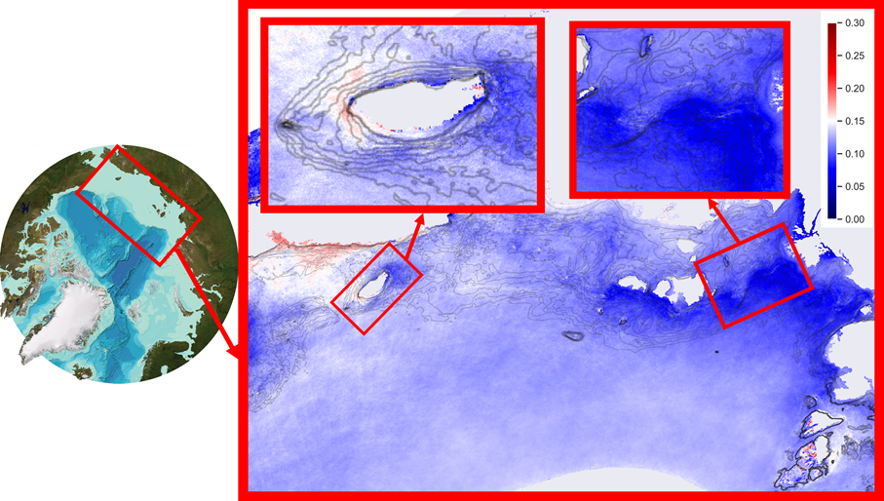
Figure 8: Left: GEBCO pan-Arctic 200m resolution bathymetry product. Right: MISR 500 m resolution sea ice roughness product (in metres from 0 to 0.3m) in the Russian sector overlaid on the bathymetry contour lines (black lines every 10m). Insets: show the bathymetry and roughness around the island of XX and around the Laptev polynya. Credit: Michel Tsamados and Thomas Johnson, UCL.

In this project we propose to expand this methodology to the Antarctic sea ice. The lower latitudes of the Southern Ocean will offer a longer period when the MISR data can be collected (visible light needed). In addition we expect the deeper mixed layer and more dynamically coupled ocean in the Antarctic to result in stronger linkages with the ocean floor even at depths larger than 100s metres. Preliminary results are shown in figure XX and show promise in better resolving the bathymetry in currently very poorly resolved regions in the Weddell, Amundsen, and other sectors. In order to produce a robust sea ice roughness product in Antarctica we will process OIB L1b elevation data for the period 2009 to 2019 and extend our training algorithm to different months of the year corresponding to different insolation. Regional tuning of the algorithm might be attempted if needed (for example in the Weddell) and case studies at the highest 275m MISR resolution tested.

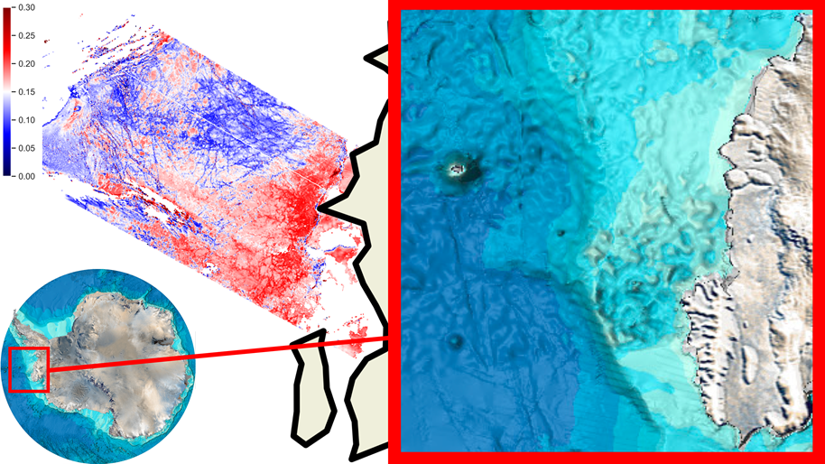
Figure 9: Bottom Left: GEBCO pan-Antarctic 200m resolution bathymetry product. Top Left: MISR 500 m resolution sea ice roughness product (in metres from 0 to 0.3m) in the Amundsen sector overlaid. Inset: shows a zoomed in version of the GEBCO bathymetry in the Amundsen sector. Credit: Michel Tsamados and Thomas Johnson, UCL.

Outputs: We will review the linkages between bathymetry and sea ice characteristics. We will compile the existing satellite datasets from optical imagery. We will further develop in the Southern Ocean a novel sea ice roughness product from NASA’s multi-angular imaging spectroradiometry (MISR) instrument. This work package will constitute the basis for a publication.

Outputs:

- WP1.3: Data collection to improve bathymetry knowledge under the ice shelves

Knowledge of ice shelf bathymetry is limited to scattered observation campaigns with autonomous underwater vehicles, seismic surveys on the ice and airborne gravity from which bathymetry can be inverted. We will combine these available datasets with coarser models/interpolations and updated maps of grounding line locations to derive an optimized ice shelf bathymetry grid to be integrated with the open-ocean bathymetry in WP1.4. To further resolve shallow bathymetry areas under and nearby ice shelves, we will implement local constraints from ice-shelf pinning points and grounded icebergs visible in high-resolution satellite imagery and elevation models. We will check the compiled bathymetry dataset against independent estimates of ice-shelf draft from hydrostatic inversion of ice-shelf freeboard measurements using satellite altimetry (CRYOSAT and ICESat-2). In case of discrepancies, i.e. bathymetry shallower than estimated draft, the causes for this will be investigated and used to make improvements in either dataset as appropriate. Finally, these two datasets will be differenced to derive a consistent grid of water column thickness under the ice shelves.

Outputs:
Ice shelf mask with consistent bathymetry, ice draft and water column thickness.
Contributions to MTR report and Final Report.

- WP1.4: Integration of the bathymetry datasets

The final bathymetry dataset will be produced by integrating the bathymetry datasets collected in the ice-shelf regions (WP1.3) into the
improved bathymetry generated in WP1.1. Merging is the process of combining different Digital Elevation Models (DEM) with each other, or DEMs with punctual information such as soundings. An interpolation method is used to this end and some smoothing is applied to correctly connect the different sources of data at their edges and avoid discontinuities.
The tools that will be used by NOVELTIS to merge the bathymetry datasets have already been successfully applied in previous projects, for example to generate the bathymetry datasets used to produce the FES2014 global tidal atlas and regional bathymetry datasets in the Arctic Ocean (ESA CP4O project), in the North-East Atlantic Ocean or around Australia (BATHY CNES project).

A visual quality checking is performed after the integration of each dataset, in order to identify and reject possible spurious data (Figure 8).
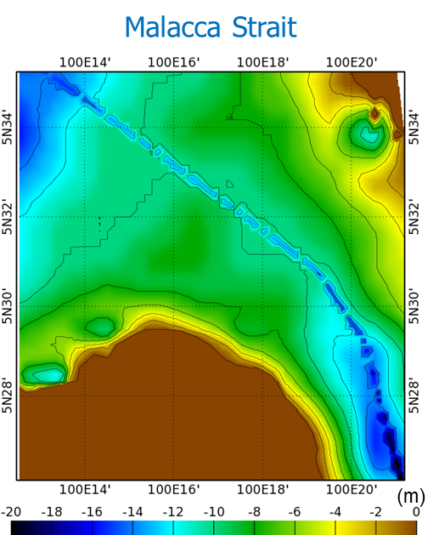
Figure 10: Example of spurious bathymetry sounding data evidenced after merging into a bathymetry dataset in the Malacca Strait.
Finally, the sea ice surface characteristics computed by UCL in WP1.3 will be superimposed to the bathymetry dataset to verify the location of the steep bathymetry gradients in the regions covered by sea ice. This information will help understand possible lower performance of the tidal model in some regions (WP2.1) and will be useful to select the more relevant bathymetry datasets amongst the various global sources, which will be locally patched in the problematic regions.
The WP1.4 task will thus be iterative with the tidal modelling task WP2.1.

Outputs:
Bathymetry dataset to be ingested by the hydrodynamic model.
Contributions to MTR report and Final Report.

      - WP2: High resolution tidal modelling and assimilation

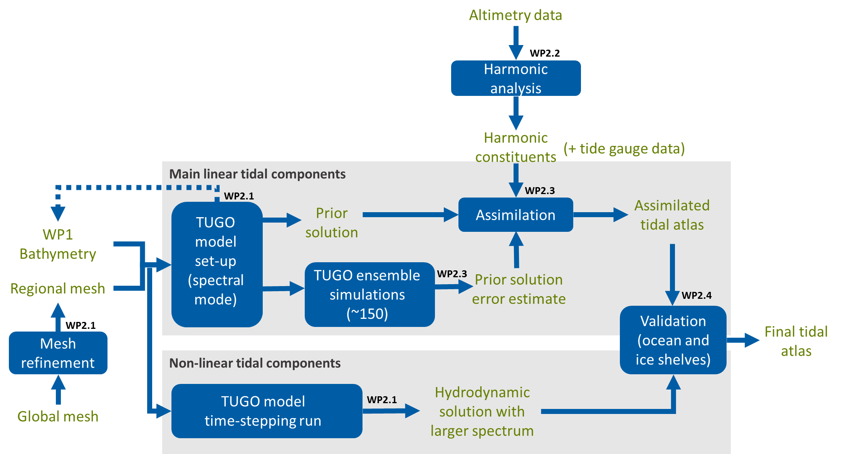
Figure 11: Schematic diagram of the implementation of the regional tidal model with data assimilation in WP2

- WP2.1: Implementation of the model configuration

The implementation of the tidal model configuration will consist of several steps presented in Figure 9. First, starting from the global unstructured mesh of either FES2014 or FES2022 (depending on the results that will be obtained in the region with the FES2022 configuration), NOVELTIS will extract a regional extent of this mesh in the Southern Ocean and will increase the resolution in the most relevant regions. For example, the resolution of the FES2014 unstructured mesh ranges between 12 km at the coast under the ice shelf and 60 km in the free water in the Weddell Sea, which may be too coarse to accurately represent the tidal signal in the region (Figure 10).
The increase in the mesh resolution will be a trade-off between the number of elements in the grid (which is directly linked with the computation time – and even more importantly in the data assimilation process) and the relevant resolution needed to benefit from the improvements in the bathymetry and to avoid residual defaults. A model run will also be made with the extract from the global mesh without any increase in the resolution, to quantify the amelioration brought by the new regional mesh.
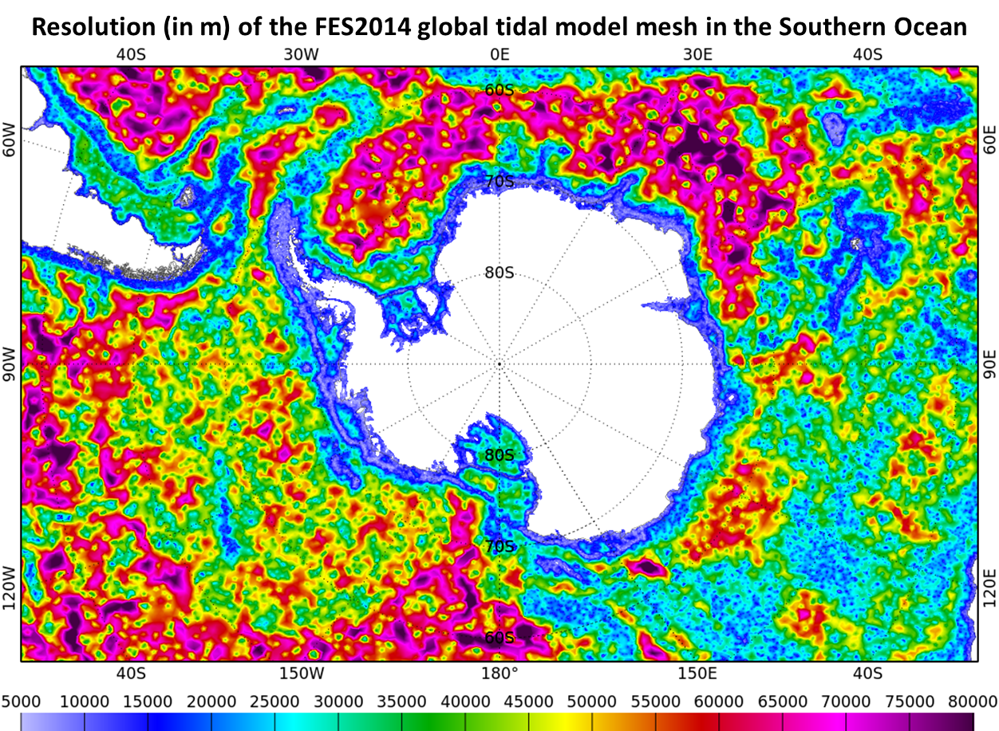
Figure 12: Resolution (in m) of the unstructured mesh grid of the FES2014 global tidal model in the Southern Ocean.
Second, in association with the regional mesh, the bathymetry generated in WP1 will be used to feed the TUGO hydrodynamic model. The open boundary conditions will come from the FES2014 global tidal model. The regional model parameters will be set up (mainly the bottom friction coefficient and the wave drag, which represents the energy transfer from the barotropic mode to the baroclinic mode) by varying their values until the best solution is obtained.
All these simulations will be performed with the spectral mode of the TUGO hydrodynamic model, which directly solves the tidal waves in the frequency domain. This mode is particularly well adapted to simulated the main linear tidal components (M2, K1, O1, S2, etc.) and is much faster than the time-stepping mode, which gives the possibility to run a large number of tuning tests.
The best solution will be identified thanks to the comparison with tide gauge observations available along the coast. Some validation tests will also be performed in the ice-shelf regions as presented in the description of WP2.4.
As the simulations may highlight some degradations due to the bathymetry in some regions, an iterative work will be done with WP1 to modify the bathymetry in these regions and check if it improves the model.
Finally, a time-stepping run will be made over a period of one year to simulate the non-linear and long-period components that could not be computed in spectral mode. This will enrich the spectrum of the final tidal atlas and will bring some innovative content compared to the concurrent regional model CATS2008 and the most recent global model TPXO9v3, which are distributed with a limited number of tidal components.

Ouputs:
Hydrodynamic simulation of the barotropic tides in the Southern Ocean.
Contributions to MTR report and Final Report.

- WP2.2: Altimetry data processing for assimilation

Altimetric data for the tidal modelling will be based on the ESA GPOD altimeter data and analysed via the DTU quality checking, processing, sea-ice editing. As editing and quality checking is done relative to the FES2014 ocean tide model, the extraction of the tidal signal will be derived relative to the FES2014 ocean tide model. Altimetry will be analysed using the response method extended with the orthotide formalism [e.g. Andersen, 1999] in order to isolate remaining tidal signal. In order to achieve adequate temporal sampling from Cryosat-2 we will take advantage of the investigation performed by Zaron, 2019. It should be noted that satellite altimetry observes the elastic ocean tide (sum of ocean and loading tides). As we are working relative to the FES2014 ocean tide model, the experience from previous modelling indicates that this approximation is adequate on the centimetre level. Individual error estimate, computed at each point during the response analysis of the altimetry sea surface height time series, is assumed to give less weight to less accurate observations (e.g., within the sea ice) in the data assimilation process, resulting in a more accurate tidal atlas.

Outputs:
Tidal harmonic constituents derived from altimetry observations
Contributions to MTR report and Final Report.

- WP2.3: Data assimilation

The data assimilation process enables to minimize the distance between the prior non-assimilated hydrodynamic simulation and the observations, taking into account their respective errors. The assimilated solutions are thus optimal in the least squares sense as they are coherent with both the observations and the physical structures described by the hydrodynamic model. To perform the data assimilation, NOVELTIS will use the SpenOI assimilation code developed by LEGOS and already used for the assimilation in FES2014 and all the regional tidal models implemented by NOVELTIS (Cancet et al., 2017). The software is based on the ensemble Kalman Filter.

To estimate the error of the prior non-assimilated hydrodynamic solution, an ensemble of simulations will be run, where the model parameters (bottom friction, wave drag and bathymetry) will be varied in the regions where the model is particularly sensitive to the effect of these parameters. The map of energy dissipation in the model due to each of these parameters will be used to define the regions of the perturbations. We expect to produce about 150 simulations with different perturbations.

Then, we will proceed to the data assimilation using the altimetry tidal estimates computed by DTU in WP2.2 and tide gauge observations to constrain the model where necessary. This will be an iterative process where the assimilated observations will be added step by step. Part of the observations will be kept for the validation purpose.

Outputs:
Optimal assimilated tidal atlas in the Southern Ocean.
Contributions to the Final Report.

- WP2.4: Tidal atlas validation

Ocean
Classical validation of tidal models in the ocean is performed by computing the vector difference (Figure 3 and Figure 4) between the maps of the model tidal constituents (amplitude and phase lag for each tidal wave) and the tidal harmonic constituents extracted from observations (altimetry and tide gauge time series).

For the tide gauge observations, we will use the database of Antarctic tidal estimates recomputed very recently by Howard et al. (2020) (Figure 11).

For the altimetry observations, we will use the CRYOSAT estimates computed in WP2.2, when available to the project. In the regions north of 66°N, we will use the tidal harmonic constituents derived from the Topex/Jason-1/Jason-2 long term series and computed for the FES2014 project.

The TUGO hydrodynamic simulations and the assimilated solutions will also be compared with the other available models in the region, including the FES2014 and FES2022 hydrodynamic solutions, which will be directly comparable with the hydrodynamic simulations computed in WP2.1.

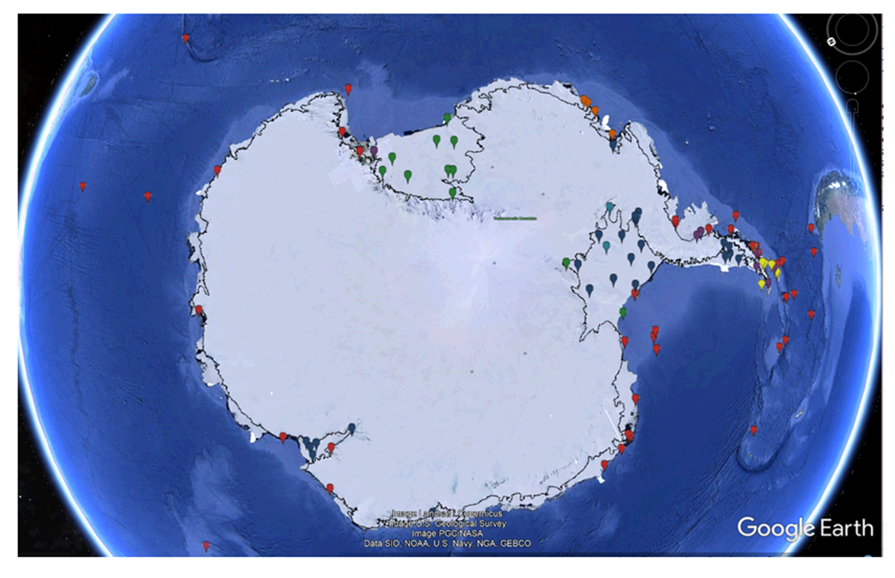
Figure 13: Location of the Antarctic tide gauge stations in the database of Howard et al., 2020. Image from https://www.esr.org/data-products/antarctic_tg_database/

Ice shelves
Ice shelves rise and fall with tides and provide relatively stable reference surfaces for validation of tide models. We will perform local and regional validation of the tidal atlas based on available time series of surface elevation from GPS stations and repeated satellite altimetry profiles from CRYOSAT and ICESat-2 over selected areas. We will focus the validation effort to the region between Filchner-Ronne ice shelf and Dronning Maud Land in East Antarctica (60°W to 30°E) where the tidal range is relatively large (Figure 1), where several GPS time series of ice-shelf height are available, and where suitable ice-shelf reference surfaces that are flat and relatively stable can be found. The most precise validation will be with respect to the GPS records (cm-level), whereas the altimetry comparisons will give a spatial overview of how well the tidal atlas performs (<10 cm level). To maximize the precision of the validation with ice-shelf altimetry, we will exclude areas near grounding zones where tidal amplitudes might be dampened by incomplete ice flexure, as well as areas with fractured or rough surface conditions where altimetry elevation retrievals will be less precise and more impacted by ice advection between satellite overpasses. We will also seek to reduce impacts from surface melting, snowfall and snowdrift by avoiding periods with extreme weather conditions and by checking if surface elevations have been stable over nearby grounded ice during the same periods of time.

      - WP3: Impact assessment

- WP3.1.: Impact on CRYOSAT+ Antarctica SSH and sea ice products

Table 1: Radar error analysis. Adapted from CRISTAL mission error analysis document.
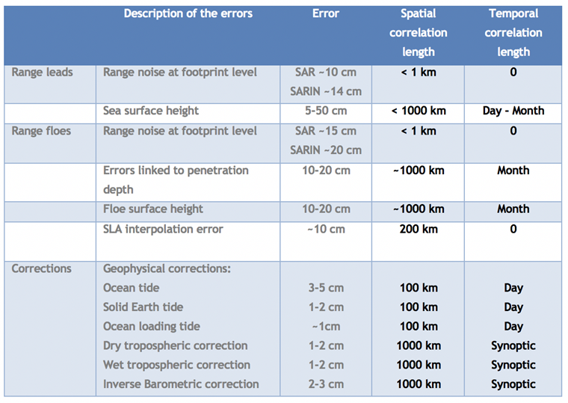

Polar altimetry processing steps. Radar altimetry (Quartly et al, 2019) of the polar oceans is complicated by the presence of sea ice and requires specific processing steps for the surface identification (sea ice, leads and open ocean), the application of a different retracking algorithm for each surface type and mode of operation, and the instrumental, atmospheric, oceanic and other geophysical corrections. Figure XX summarizes the key variables that are required to retrieve the sea surface and ice floe elevations following respectively the two equations below:

$$E=h_{ellip}-D_{radar}-h_{geoid}-∆h$$
and

$$F=h_{ellip}-D_{radar}-{MSS}_{interp}-∆h$$

where $E$ is the sea surface elevation, $F$ the flow elevation, $h_{ellip}$ the geoid position, $D_{radar}$ the distance between the satellite and the surface, ${MSS}_{interp}$ the interpolated mean sea surface at the floe locations, and $∆h$ the perturbation of the sea surface due to wind forcing, tides, and other transient effects.

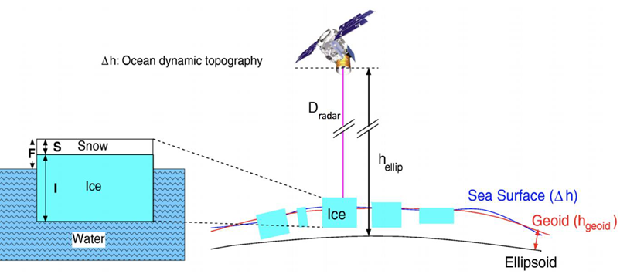
Figure 14: Schematic illustrating the principle of radar altimetry over the sea ice covered regions.

Contribution of tides to the overall error budget. Each of the steps presented above introduce specific errors that are the subject of an intense research activity in order to bring the uncertainties to a minimum for future radar altimetry satellite missions (i.e. CRISTAL) and produce the next generation altimetry products (ESA’s CSAO for CS2, mission performance analysis for Sentinel-3 A/B). Note that with the launch of ICESat-2 in 2018, radar altimetry is now complemented by laser altimetry at high latitudes. The impact analysis proposed in this work package for CS2 sea ice and sea level products can also be adapted to laser altimetry. The table XX below summarizes the errors and corresponding spatial and temporal correlation lengths with tidal induced errors correlated over 1day and 200km. We see that tide errors and the associated interpolated sea-level anomaly (SLA) errors remain one of the dominant terms to the error budget of both sea ice freeboard and sea level heights. Armitage et al (2018) quantified the errors on the SLA and showed that the tidal error contribution becomes the dominant term over continental shelf regions where tides magnitude is the largest. Tilling et al. (2017) and Lawrence et al., (2018), found that the error on monthly-gridded CS-2 freeboard is dominated by the uncertainty on the interpolated sea-level anomaly (SLA), calculated from the SLAs of waveforms identified as leads and therefore also affected by tidal aliasing.

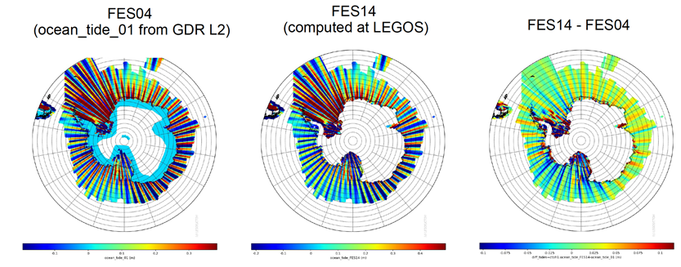
Figure 15: Differences in the model FES04 and FES14. Credit Sara Fleury and Florent Garnier (LEGOS) as part of the CSAO project.
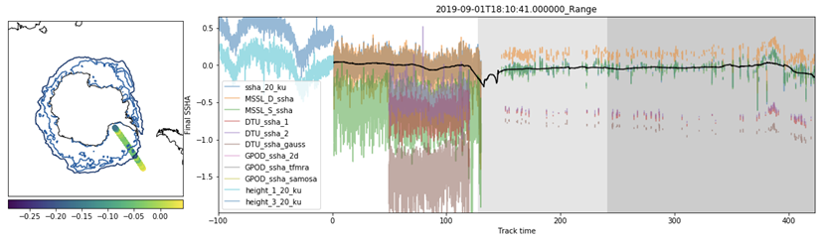
Figure 16: Output of the CSAO comparison analysis between different radar altimetry solution showing the role of the different tides in the results. Credit Harry Heorton and Michel Tsamados.

Testing new tidal models in the CS2 processing chain. To assess the improvement of our new tidal model on the CryoSat-2 freeboard and ocean elevation products we will follow the procedure developed as part of CSAO (Tsamados, PI of this project) where we compared the FES14 and FES04 (CryoSat2 L2 handbook) tide models as shown on figure XX. Average over one month differences of up to 10cm are found close to certain bands when aliasing between altimeter tracks and tides is maximum. While the impact of tides is found to be negligible on sea ice freeboard retrievals (mm or less) it significantly affects all oceanographic altimetry products (cm level or more on continental shelf regions). The impact of the tide model along-track can be seen on the Figure XX …We see that the impact of tides is particularly important closer to the coasts where variability of the sea surface height anomaly is increased due to the shallower bathymetry and stronger tidal signal. A better resolution of the sea surface height close to the Antarctic coastal region and on the continental shelves is important to resolve the coastal currents that control the transport of heat to the ice shelves (Figure XX and Dotto et al, 2020).
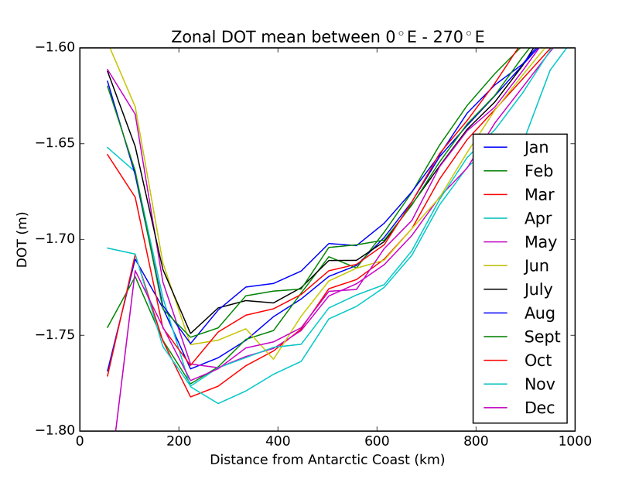
Figure 17: 2010-2016 average zonal dynamic ocean topography (DOT) close to the coast of Antarctica for all months of the year. The strong seasonal variability near the coast and the reversal of the sign of the slope indicates changes in the corresponding geostrophic coastal currents. At present, uncertainty in the DOT is too large to unambiguously resolve those coastal currents and requires reduction of the tidal signal uncertainty as provided by this project. Credit: Jack Hooley and Michel Tsamados.

Outputs: Updated along-track sea surface height altimetry retrieval with reduced uncertainty. Improved derived gridded products of sea level anomaly (SLA), dynamic ocean topography (DOT), eddy kinetic energy (EKE), geostrophic current, etc.

- WP3.2.: Impact on ice shelves

Estimation of ice-shelf thickness change and basal melting from satellite altimetry is challenging because the signal of change in surface height is only about one tenth of the actual change in ice thickness because of the hydrostatic compensation of floating ice in ocean water. Removal of the tidal signal in ice-shelf height retrievals is therefore essential for deriving precise estimates of ice-shelf thickness change and related basal melting; two key parameters for assessing the stability of the Antarctic ice sheet and the Southern Ocean circulation. In this WP task, we will quantify the impact that the new tidal atlas has on estimates of ice-shelf thickness change (and basal melting) by performing parallel computations with different tidal models, as well as without any corrections. We will estimate thickness change rates by least-squares fitting of repeated ICESat-2/CRYOSAT measurements and assume that the residuals of the fit will reduce when tidal corrections improve. This principle holds true even in cases of no actual change in ice shelf thickness. These results will be used along with the new tidal atlas itself to assess the impact it will have on future monitoring and research of Antarctic ice shelves, including the vulnerability to tide-induced ice-dynamical changes.
      - WP4: Scientific roadmap and Commercial evaluation

- WP4.1.: Scientific roadmap

We will provide a Scientific Roadmap that will describe the potential areas of improvement of the bathymetry, sea ice roughness and tidal model developed and implemented within the ALBATROSS project. This task will be led by UCL but all the partners will contribute to the roadmap, as they are all experts in different fields. The scientific roadmap will also benefit from the feedback of the external experts who will be involved in collaborations with the project and with whom sample products will be shared. We have already obtained the formal agreement of several renowned scientists and Polar projects to collaborate with the project team to test the potentials of the ALBATROSS products (see their letters of support in ANNEX 3). Interactions with these other Polar projects and research groups will help us evaluate the quality and the relevance of the ALBATROSS outputs as well as their added value.
Outputs:
Scientific roadmap report

- WP4.2.: Commercial evaluation

This activity will be led by NOVELTIS and will consist in elaborating an exploitation plan of the project outcomes for maximizing short and mid-terms exploitation opportunities, for commercial purposes in the “Space Market” but also in other fields linked with navigation, insurances and Polar exploration. NOVELTIS will build this analysis on its long-term experience in tidal data distribution through the TIPS web-service (opened in 2014) for tidal elevations and currents predictions, the TIDEA service for tidal energy assessment (opened in 2017) and the eNovOcean met-ocean web-platform launched in November 2020 (www.enovocean.com).
This commercial evaluation will describe the areas of improvement of the outputs of the ALBATROSS project, their maturity and the potential necessary level of funding to reach a marketable level.

Outputs:

Commercial evaluation report

      - WP5: Communication and Promotion

A tailored web-portal will be developed to provide information about the project (objectives, team, news, publications), to communicate about the outcomes of the project towards the various interested communities (climate, modelling, remote sensing, ocean, sea ice, ice shelves) and to distribute sample products.
The strong involvement of the project partners in various fields of the Polar research, through international and national projects and numerous groups of experts such as the OSTST (Ocean Surface Topography Science Team) and CPOM (Centre for Polar Observation and Modelling) will help promote the outcomes of the project. The outputs of the ALBATROSS project will be regularly presented and promoted within international scientific conferences, which will be opportunities to enlarge the end-users panel and to collect users’ requirements for new ocean colour products and identify priority ocean colour research.
The main outcomes and events of the project will be advertised on social networks (LinkedIn) and in ESA webstories.

Outputs:
Project web page
Communication Package

    - Implementation aspects
[Present a first iteration of the concept and the baseline design/approach. The baseline design covers for instance the system architecture and a functional decomposition presented in block diagrams, providing also internal and external interfaces. Discuss the current state of the art and the trade-offs that need to be taken into account and show the overall logic of the work being proposed including any key review and decision points. Discuss how the work performed will be validated (e.g. test plan and test approach) and how achievement of the objectives will be proven/ demonstrated]

      - Concept and baseline design

      - Current state of the art and trade-offs

The current state of the art has been exposed in the previous sections and is summarised in the table below.
State of the art | Trade off, limitations
Starting bathymetry datasets:  The datasets have been identified and have already been used by the consortium (GEBCO, RTopo, IBCSO, SRTM15+) | N/A
Bathymetry with satellite altimetry:  The methodology and the tools to process the altimetry data and produce the bathymetry field are completely mastered by DTU. | Limitations may come from the lack of coherency between gravity field and bathymetry.
Sea ice roughness
Bathymetry data fusion:  The suite of tools used to merge, homogenise, visualize and quality-check the bathymetry datasets are completely mastered by NOVELTIS. | The merging tools are flexible enough to process gridded bathymetry as well as soundings.
Numerical ocean tide modelling and data assimilation.  The methodology and the tools to develop accurate tide models with data assimilation and to validate them is completely mastered (TUGO hydrodynamic code and SpenOI assimilation code). | Some specific developments in the TUGO hydrodynamic model may be needed to deal with the sea ice and ice shelves aspects. Florent Lyard, who is the TUGO expert, will adapt the code where necessary and possible.
Satellite altimetry tidal retrievals:  All state of the art ocean tide models heavily rely on satellite altimetry from the Jason sequel of satellites as an integral part. At high latitudes outside the Jason coverage (66 parallel) Cryosat-2 has demonstrated huge potential when the data are carefully processed according to the subsycle (Zaron, 2019; Cancet et al., 2019) | Some issues are still existing with minor constituents due to the near sun-syncronous nature of Cryosat-2. This we can remedy using the response techniques making it an improvement to the work by Zaron (2019).

      - Validation approach

The validation approach has been detailed in the technical description of the work packages and is summarised in the table below. We anticipate that the in situ bathymetry data to validate the improved merged bathymetry will be very rare (and they will be preferably integrated into the improved bathymetry).
Items to be validated | Methods
Validation of the bathymetry | - Available multi-beam surveys (mainly in the Drake Passage region) will be used to compare with the open ocean bathymetry.  - The merged bathymetry will be quality-checked by visual inspection.  - The Seabed 2030 Nippon global bathymetry foundation gradually releases more and more bathymetric surveys as they become available in the preparation of the global 2030 bathymetry, and we can likely use some of these for quality control.  - The final validation criterion will be provided by the performance of the tide model implemented with the improved bathymetry, compared to the initial bathymetry.
Validation of the tidal model | - The protocol to validate the tidal model in the ocean is mature and consists in comparing the tidal harmonic constituents of the model with tide gauge and altimetry data for the mail tidal components (M2, K1, O1, S2…). During the data assimilation work, some tide gauge stations will be selected to build an independent validation database. The performance of the model will be compared to the performance of the other tidal models in the region.  - On the ice shelves, the local and regional validation of the tidal atlas will be based on available time series of surface elevation from GPS stations and repeated satellite altimetry profiles from CRYOSAT and ICESat-2 over selected areas.

      - Assessment of the objectives
It will be straightforward to assess whether the objectives have been met or not thanks to the requirements defined in section 1.3.

Objectives | Assessment criteria
[Obj. 1] Improve the availability of satellite altimetry-derived tidal estimates in the Southern Ocean | The new satellite altimetry tidal estimate dataset fills the gap between 66°S and the Antarctic coast and is consistent with other observations (satellite altimetry north of 66°S, tide gauges at the coast).
[Obj. 2] Improve the knowledge on ocean tides in the Southern Ocean | The overall error of the new regional tidal model around Antarctica is lower than 10 cm. The error is also locally reduced, especially in ice-shelf regions.
[Obj. 3] Improve the knowledge on bathymetry in the Southern Ocean | The new bathymetry dataset enables to reduce the errors of the tidal model compared to the other available bathymetry datasets. In particularly we seek corporation with Seabed 2030 for validation and usage towards this next generation global bathymetry.
[Obj. 4] Improve satellite altimetry retrievals of sea surface heights and sea ice information | The SSH and sea ice information uncertainties are reduced using the new tidal model, compared to concurrent models.
[Obj. 5] Improve the retrievals of ice shelves parameters | The uncertainties on ice-shelf parameters are reduced using the new tidal model, compared to concurrent models.

  - SCIENTIFIC/TECHNICAL FEASIBILITY, PROBLEM AREAS AND DEVELOPMENT RISK:
[Provide evidence as to the feasibility of meeting the objectives and requirements identified in sections 1.2 to 1.4. Identify, present and discuss the main technical problem areas and key development risks that may be expected during the execution of the activity in order to address the requirements and target performance levels identified in sections 1.2 to 1.4. Propose mitigation and preventative actions to reduce the likelihood and potential impact of such risks/problems and discuss credible alternative design or implementation solutions to avoid identified potential technical problems becoming showstoppers]

    - Feasibility of meeting the objectives and requirements

Although the proposed developments are innovative, they build on solid bases, which are the scientific background, the previous projects, the expertise and the tools brought by the consortium. The feasibility of meeting the objectives and requirements has been detailed in the previous section and is summarized in the table below.
Objectives / requirements | Feasibility
Improve the availability of satellite altimetry-derived tidal estimates south of 66°S in the Southern Ocean | DTU has been involved for years in altimetry data processing to produce tidal estimates, in particular in the frame of the generation of the DTU10 and DTU16 empirical tidal atlases. In the high latitudes, DTU already processed CRYOSAT data in the Arctic Ocean for data assimilation into the Arctide2017 tidal model implemented by NOVELTIS in the frame of the CP4O ESA project. The processing of the altimetry data will be done through the ESA GPOD service.
Improve the knowledge on ocean tides in the Southern Ocean | NOVELTIS has more than 10 years of continuous experience in tidal modelling and has already implemented several tidal models with data assimilation at the global scale (FES2012, FES2014, FES2022) and at regional scales (North East Atlantic, Mediterranean Sea, Arctic Ocean, Australia). All the tools for the generation of unstructured mesh grids, the tidal simulation, the data assimilation and the model validation are mature and mastered by NOVELTIS.
Improve the knowledge on bathymetry in the Southern Ocean | DTU has a long experience in the generation of gravity field and bathymetry datasets based on satellite altimetry. Similar work was performed recently in the Arctic Ocean, using CRYOSAT data.  UCL  NPI  The bathymetry merging tool used by NOVELTIS is flexible and can process gridded bathymetry datasets as well as vector information such as ship-soundings or punctual measurements. It allows to merge/calibrate/smooth and visualise the bathymetric data.
Improve satellite altimetry retrievals of sea surface heights and sea ice information | Previous projects including CSAO have shown that there is room for improvement in these parameters by reducing the error of the tidal models used as correction for the satellite altimetry observations.  The previous tidal modelling projects carried out by NOVELTIS have all enabled to improve the tidal solution in the considered area, thanks to the combination of improved bathymetry, high-resolution modelling and data assimilation.
Improve the retrievals of ice shelves parameters | NPI  Some previous tidal modelling experiments performed by LEGOS under the Mertz ice shelf have shown the capability of the TUGO hydrodynamic model to improve the tidal knowledge in these specific regions.

    - Potential problem areas, development risks and mitigation actions
      - Identification of potential problem areas and development risks

ALL: As suggested by Ole, can you each identify the risks linked with your activities in each task and provide solutions in the next section ?

Work Package | Task | Risk | Likelihood | Impact | Criticality
WP1 | WP1.1 | Lack of coherency between gravity and bathymetry | Medium in some regions. | Limits region where gravity inversion can be performed | low
 | WP1.2
 | WP1.3
 | WP1.4 | Lack of coherency between the bathymetry datasets | Probable in some regions | Limits the quality of the bathymetry | medium
WP2 | WP2.1 | Incompatibility between the high-resolution mesh and the bathymetry quality | Probable in shallow regions | Limits the quality of the tidal model | medium
 | WP2.2
 | WP2.3
 | WP2.4 | Doubts on the quality of in situ tide gauge data for the validation of the tide model | Probable | Limits the validation in some regions | High
WP3 | WP3.1
 | WP3.2

      - Proposed solutions to the identified risks

Work Package | Task | Risk | Description of the solution  Anticipation / prevention / mitigation
WP1 | WP1.1 | Lack of coherency between gravity and bathymetry | We can mitigate this by limiting the wavelength bands where we perform gravity field inversion.
 | WP1.2
 | WP1.3
 | WP1.4 | Lack of coherency between the bathymetry datasets | We can mitigate by smoothing locally the bathymetry and by deciding not to integrate the most incoherent datasets.
WP2 | WP2.1 | Incompatibility between the high-resolution mesh and the bathymetry quality | We can mitigate by lowering the resolution of the mesh and smoothing the bathymetry locally to limit the sensitivity of the model to the bathymetry defaults.
 | WP2.2 | The quality (signal to noise) of GPOD retracked satellite will be poorer than expected. altimetry | The use of the response technique with Cryosat-2 and Sentinel.3 data should limit the effect of unfortunate signal to noise and assist to resolve even minor constituents in the region.
 | WP2.3
 | WP2.4 | Doubts on the quality of in situ tide gauge data for the validation of the tide model | NOVELTIS has solid expertise in tidal analysis of tide gauge observations and has tools which allow to detect and disregard data of poor quality. Tidal harmonics derived from satellite altimetry will also provide an independent quality dataset for validation.
WP3 | WP3.1
 | WP3.2

  - APPLICATION OF DEVELOPMENTS RESULTING FROM THE PROPOSED ACTIVITY
[Present the justification and reasoning for the objectives and evidence to show that such objectives meet the criteria of the call as outlined in the Cover Letter of the ITT. In addition, provide evidence to demonstrate the expected scientific, operational or commercial uptake of the output capabilities.
This shall include an initial roadmap for wider exploitation and uptake of the outputs to be generated.

This shall also include a demonstration of the interest of potential users/ customers. Letters of sypport/engagement from users/customers/stakeholders should be attached to the end of this document.

Bathymetry

Even the best bathymetry models have errors over 1000 meters (Watts et al., 2020) and the publication “Bathymetry from Space (Oceanography, 2004, Vol 17) highlight that more than 50000 undersea mountains larger than 1 km still remains uncarted even using altimetry. Global inititatives are paramount to map bathymetry of the worlds ocean. The SeaBed 2030; GEBCO, IBCAO and IBCSO (international bathymetry chart of the Southern Ocean) are all such intiatives. The model derived in the Albatross project will be of huge importance to such initatives and the region surrounding Antarctica remains one of the poorest surveyed data with marine vessels.

Tide model

Florent, UCL, DTU, NPI

  - MECHANISM FOR COMMUNICATING/PROMOTING OUTPUTS OF THE PROPOSED ACTIVITY
The ALBATROSS project team will ensure the promotion of the Southern Ocean bathymetry and tidal atlas.

A tailored web-portal will be developed to provide information about the project (objectives, team, news, publications) and to communicate about the outcomes of the project towards the various interested communities (climate, modelling, remote sensing, ocean, sea ice, ice shelves).

The results of the project will be presented in targeted symposiums and workshops. As the partners are all members of various consortia for different National, European and International projects for Polar Science, they will have the possibility to promote the outputs of this Polar Science Cluster project within the meetings of these other projects in order to foster possible collaborations. The strong involvement of the project partners in groups of experts such as the OSTST (Ocean Surface Topography Science Team) and CPOM (Centre for Polar Observation and Modelling) will also help promote the outcomes of the project.

The main outcomes and events of the project will be advertised on social networks (LinkedIn) and in ESA webstories. The project members have already produced such kind of communication materials, for example in the framework of the CP4O ESA project, to present their work on the Arctic Ocean tide modelling (https://www.esa.int/Applications/Observing_the_Earth/CryoSat/Modelling_tides_in_the_Arctic_Ocean).

  - TECHNICAL IMPLEMENTATION / PROGRAMME OF WORK
    - Proposed Work Logic
[Insert a flow chart showing the logical flow of work from step to step, with reviews, dependencies, and critical path clearly shown. Note that this shall be consistent with section 1.5, the WBS and the schedule]

Figure XXX below depicts the different components of each task, as well as their interconnections.
- The first work package will concern bathymetry improvement. It will consist in processing satellite altimetry data to retrieve the deep ocean floor topography, processing satellite optical images to generate a sea-ice thickness product, which will be used as a proxy to explore the location of the bathymetry gradient, and finally collecting existing datasets and information useful to improve the bathymetry knowledge under the ice shelves. Then, all the useful information will be merged into a new bathymetry dataset that will be used to feed the hydrodynamic model.
- The second work package will consist in implementing the hydrodynamic tidal model, based on the bathymetry built in the first work package and on an unstructured high-resolution grid. Due to the sensitivity of the model to the bathymetry quality, the tuning of the model may highlight some default in the bathymetry, which will be corrected in an iterative process between WP1 and WP2. This second work package also includes the processing of altimetry data to retrieve the tidal estimates used for the validation of the model and the data assimilation. The data assimilation of tidal constituents derived from altimetry and tide gauge observations will be performed in this WP, as well as the validation of the model, both by comparing with altimetry and tide gauges, with respects to other available tidal models, but also by considering satellite altimetry and GPS validation data over some ice shelves.
- The impact assessment of the tidal model will be undertaken in the third work package, considering ocean, sea ice and ice shelves products. The new tidal model will be used to take out the tidal signal from the CRYOSAT SSH and sea ice products and an assessment of the accuracy of these new products will be performed. For the ice shelves, the impact on ice shelf research will be analysed in terms of improved calculations of ice-shelf thickness changes and basal melting, and discussion on vulnerability to tide-induced ice-dynamical changes.
- The fourth work package will be dedicated to the definition of a scientific roadmap with recommendations for further work and studies that could come out of this project. A commercial evaluation of the space market potential of the project outputs will also be performed within this work package.
- Finally, the fifth work package will be devoted to developing a dedicated web site and multi-media content, as well as publishing the results and promoting the outcomes of the project to the international research communities, through the participation of the team members to targeted symposia/workshops.
A work package (WP0) will also be dedicated to the project management and reporting to ensure the coordination and the success of the project activities.
    - Contents of the proposed work
      - Work Breakdown Structure (WBS)
The activities are divided into 5 technical work packages and one management work package. The subtasks of each work package are specified in Figure 1, as well as the involved partners and the lead person.
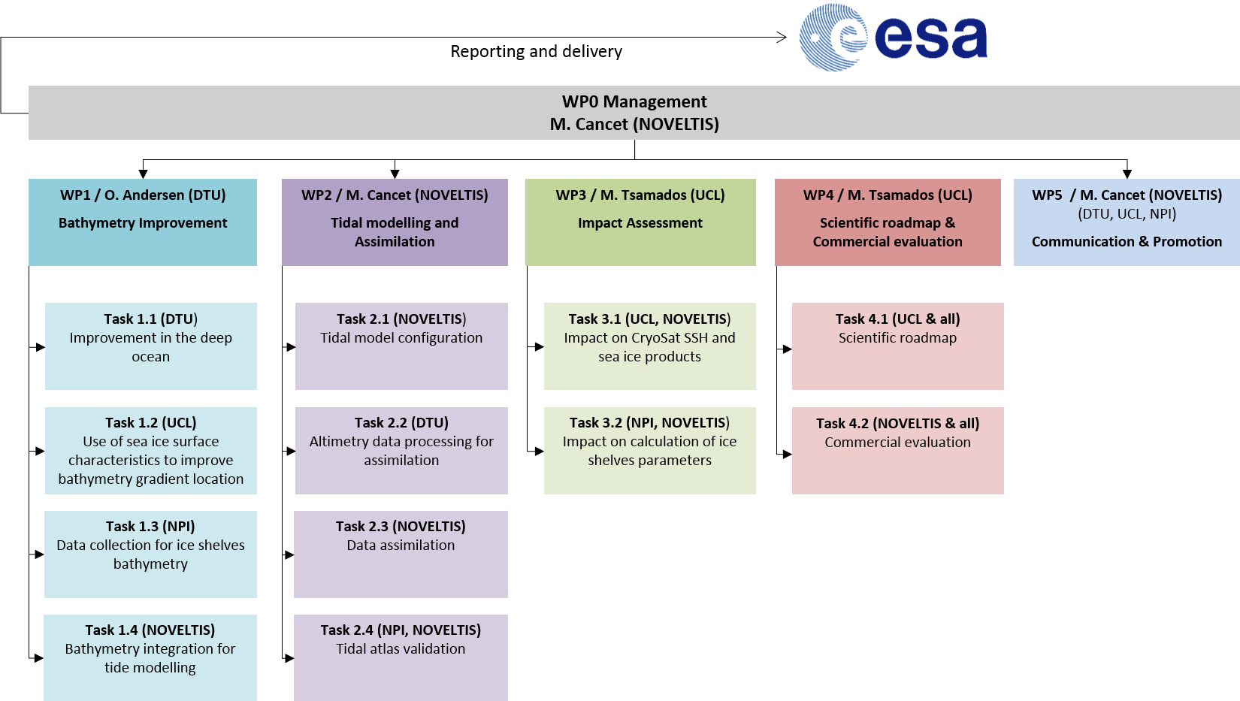
Figure 17: Work Breakdown Structure of the study
      - Work Package Description (WPD)
[Individual WPD shall be established per work package identified in the WBS, describing the following:
      - responsible company
      - beginning and end date of each work package
      - person responsible for the work package
      - description of the activities in the work package, sufficient to understand clearly the scope and depth of the work being performed.
      - inputs to the work package
      - outputs of the work package
      - the outputs to the work packages are to be identified (e.g. TN1 etc.) and shall be included in the List of Deliverables.
With respect to the standard requirements for management, reporting, meetings and deliverables (Appendix 1 to the Draft Contract), please include a dedicated work package for Management and Reporting. All management tasks, such as meetings, progress reports and final documentation shall be carried out under this work package.
For reference see ESA PSS-A20 form, available at http://emits.sso.esa.int/ under Reference Documentation / Administrative Documents / PSS Forms / Issue 5.]

WP 0 | Management
WP Manager: | Mathilde CANCET (NOVELTIS)
Contributors: | Mathilde CANCET (NOVELTIS)
Start event: | Successful negotiation meeting | Starting date: | T0
Duration: | 24 months (project duration) | Ending date: | T0 + 24 months
Inputs
- SOW, contract, authorisation to proceed
- NOVELTIS management procedures
- NOV-FE-1176-PR-001
Tasks
The work package covers the management of the study. It can be split into the following subtasks:
- Ensure resource availability and control the progress of the tasks.
- Inform ESA on the progress (progress reports).
- Organize the meetings with ESA and the partners (agenda, presentation, minutes...).
- Maintain the document list and the action item list.
- Update the task schedule.
Outputs
- Minutes of meeting, Reference Document list, Action list, Schedule updates.
- Mid-Term Review Report (MTRR)
- Final Report (FR).
- Monthly Progress Reports (PR).
- Executive Summary (ES).
- Contract Closure Documentation (CCD).

WP 1 | Bathymetry improvement
WP Manager: | Ole ANDERSEN (DTU)
Contributors: | Ole ANDERSEN (DTU)  Adili ABULAITIJIANG (DTU)  Michel TSAMADOS (UCL)  Harry HEORTON (UCL)  Geir MOHOLDT (NPI)  Etienne SAHUC (NOVELTIS)  Mathilde CANCET (NOVELTIS)
Start event: | Kick-off meeting | Starting date: | T0
Duration: | 6 months | Ending date: | T0 + 6 months
Inputs
- SOW
- Literature
- Satellite altimetry data processed with GPOD (Cryosat-2 SAR and SARin, S3A/B SAR)
Tasks
- Task 1.1: Improvement of the deep ocean bathymetry
- Evaluation of existing bathymetry models around Antarctica (e.g. GEBCO, R-TOPO, IBCSO, SRTM15+)
- Improvement of the deep ocean bathymetry using gravity inversion of satellite altimetry following Abulaitijiang, Sandwell and Andersen (2019)
- Task 1.2: Use of sea ice surface characteristics to improve the bathymetry gradient location
- Task 1.3: Collection and combination of the best available grounding line, bathymetry and ice shelf thickness (for water column thickness) datasets
- Task 1.4: Integration of bathymetry datasets
- Fusion of bathymetry datasets from Task 1.1 and Task 1.3
- Use of information from Task 1.2 to select the most relevant bathymetry datasets
Outputs
- Scientific paper NT1
- Mid-Term Review Report (MTRR)
- Final Report (FR)

WP 2 | Tidal modelling and Assimilation
WP Manager: | Mathilde CANCET (NOVELTIS)
Contributors: | Etienne SAHUC (NOVELTIS)  Mathilde CANCET (NOVELTIS)  Florent LYARD (NOVELTIS)  Ole ANDERSEN (DTU)  Adili ABULAITIJIANG (DTU)  Geir MOHOLDT (NPI)
Start event: | Kick-off meeting | Starting date: | T0
Duration: | 15 months | Ending date: | T0 + 15 months
Inputs
- SOW
- Literature
- WP1 bathymetry dataset
- Satellite altimetry data
- Tide gauge data
Tasks
- Task 2.1: Tidal model configuration:
- Implementation of the unstructured high-resolution grid
- Tuning of the hydrodynamic model, comparison to in situ and altimetry data
- Evaluation of the impact of the new bathymetry and local update if necessary
- Task 2.2: Altimetry data processing
- Editing (sea-ice) and quality checking of Cryosat-2 and Sentinel-3 altimetry.
- Optimizing box sizes for tidal estimation based on sub-cycles and repeat periods of satellite altimetry.
- Estimation of harmonic constituents and associated accuracies from satellite altimetry
- Task 2.3: Data assimilation
- Generation of hydrodynamic ensemble simulations
- Selection of data and assimilation into the model
- Task 2.4: Model validation
- Comparison to in situ and altimetry data, with regards to other tide models
- Validation over ice shelves using altimetry (ICESat-2, CryoSat-2) and GPS records
Outputs
- Mid-Term Review Report (MTRR)
- Final Report (FR)

WP 3 | Impact Assessment
WP Manager: | Michel TSAMADOS (UCL)
Contributors: | Michel TSAMADOS (UCL)  Harry HEORTON (UCL)  Geir MOHOLDT (NPI)  Etienne SAHUC (NOVELTIS)
Start event: | End of WP1 and WP2 | Starting date: | T0 + 15
Duration: | 6 months | Ending date: | T0 + 21 months
Inputs
- SOW
- Literature
- CRYOSAT+ Antarctica sea surface heights and sea ice products
Tasks
- Task 3.1: Impact on CRYOSAT SSH and sea ice products
- Computation of ocean tide elevations along the altimeter tracks from the new tidal model

- Task 3.2: Impact on ice shelves parameters determination (ice-shelf thickness changes, basal melting)
- Computation of ocean tide elevations along the ice shelves from the new tidal model
- Study of the impact on ice shelf research in terms of improved calculations of ice-shelf thickness changes and basal melting, discussion on vulnerability to tide-induced ice-dynamical changes.
Outputs
- Final report (FR)
- Input for the Scientific Roadmap and the Commercial Evaluation

WP 4 | Scientific roadmap and Commercial evaluation
WP Manager: | Michel TSAMADOS (UCL)
Contributors: | Michel TSAMADOS (UCL)  Harry HEORTON (UCL)  Mathilde CANCET (NOVELTIS)  Florent LYARD (NOVELTIS)  Ole ANDERSEN (DTU)  Adili ABULAITIJIANG (DTU)  Geir MOHOLDT (NPI)
Start event: | End of WP3 | Starting date: | T0 + 21 months
Duration: | 3 months | Ending date: | T0 + 24 months
Inputs
- SOW
- Literature
- Outputs of WP2
- Outputs of WP3
Tasks
- Task 4.1: Scientific Roadmap:
  - Identification of the remaining scientific and technical challenges to be addressed to improve the quality of the products;
  - Discussion with large European initiatives on the possible use and maturation of the products;
  - Recommendations to reduce uncertainty on the products.
- Task 4.2: Commercial Evaluation
  - Analysis of the potential of the outputs of the products (bathymetry, tide model) in the space market;
  - Recommendations in terms of additional work and level of funding to reach a marketable level.
Outputs
- Scientific roadmap document
- Commercial evaluation document

WP 5 | Communication and Promotion
WP Manager: | Mathilde CANCET (NOVELTIS)
Contributors: | Mathilde CANCET (NOVELTIS)  Florent LYARD (NOVELTIS)  Michel TSAMADOS (UCL)  Harry HEORTON (UCL)  Ole ANDERSEN (DTU)  Adili ABULAITIJIANG (DTU)  Geir MOHOLDT (NPI)
Start event: | Kick-off meeting | Starting date: | T0
Duration: | 24 months (project duration) | Ending date: | T0 + 24 months
Inputs
- SOW
- Results from WP1, WP2, WP3 and WP4
Tasks
- Implementation of the project web-page
- Communication on project news and results on the social networks
- Presentation of the project objectives and results in scientific conferences and other projects meetings
- Publication of the main results
Outputs
- Project web-page including data samples
- Communication package (news, web stories)
- List of publications and communications about the project

  - BACKGROUND OF THE BIDDER(S)
    - NOVELTIS
NOVELTIS is a French independent private company created in 1998 and based in Toulouse, France. The NOVELTIS team is composed of 39 people including 35 PhD and engineers highly qualified in physics, mathematics and computer sciences (2020), who perform innovative scientific engineering studies and implement customized end-user solutions in the fields of Space, the Environment and Sustainable Development. Our scientists and engineer develop high-tech solutions that involve top-level skills in environmental and physical sciences, in domains covering the atmosphere, oceans and land surfaces. Our staff is expert in modelling simulations, processing of observation data and measurements, information systems, impact assessments, decision support systems...
In this context and as a key point of the company’s strategy, NOVELTIS has generated and strengthened numerous partnerships with French, European and International space research laboratories.

NOVELTIS has a long experience in the management of international multi-partner Project teams within different ESA and European frameworks. To date, NOVELTIS has been or is prime contractor of more than thirty ESA scientific studies.

We present below a list of recent reference projects related to our expertise relevant to this proposal, focusing on Ocean Tide modelling, Bathymetry data processing, and Polar Science fostering.

- Global ocean tide models FES2012, FES2014 and FES2022
In collaboration with LEGOS and CLS, NOVELTIS implemented the global ocean tide models FES2012 and FES2014 for the French Space Agency (CNES). Thanks to its high level of accuracy, FES2014 is today one of the two reference tidal models provided in the radar altimetry products that are distributed by the Space Agencies. NOVELTIS performed the hydrodynamic simulations and the ensemble assimilation. In 2020-2022, NOVELTIS is involved in the implementation of the new global FES2022 global model.

- BathyCNES: bathymetry improvement and regional tidal modelling
Since 2017, NOVELTIS has been working for CNES on the local improvement of the bathymetry using the available datasets (DEMs and soundings), in regions where the ocean tide models lack accuracy. High-resolution regional ocean tide models with data assimilation are then implemented in these regions (North East Atlantic, Mediterranean Sea, Arctic Ocean and Australia).

- High-resolution tidal modelling in the Kerguelen Islands
A calval site for the satellite altimetry missions is implemented at the Kerguelen Islands, in the Southern Ocean, in the frame of the FOAM project (From Ocean to inland waters Altimetry Monitoring), led by OBSPM. In order to provide the most accurate tidal corrections for the altimetry and the tide gauge measurements, NOVELTIS and LIENSs are carrying out parallel experiments of tidal modelling using two different models (TUGO-m and SCHISM respectively).

- CRYOSAT+ FOR OCEANS (CP4O)
The aim of the CP4O ESA project was first to develop and evaluate new ocean products from CryoSat-2 data, focusing on the additional capabilities offered by the SAR mode. In this framework, NOVELTIS provided regional ocean tide corrections over the North-East Atlantic CryoSat-2 SAR region. Further work was carried out to develop improved geophysical corrections. In the frame of CCNs to this project, NOVELTIS implemented the Arctide2017 regional tidal atlas in the Arctic Ocean, in collaboration with LEGOS and DTU Space.

- Arktalas
In the Arktalas ESA project (2019-2021), NOVELTIS performs sensitivity analyses of the tidal model to the sea ice cover in the Arctic Ocean. NOVELTIS will also perform an analysis of the impacts of the future satellite missions in understanding the changes in the Arctic Ocean, in collaboration with NERSC.

- FDR4ALT & CRYOTEMPO
In the FDR4ALT and CRYOTEMPO ESA projects, which started in 2019 and 2020 respectively, NOVELTIS will provide ocean tide corrections along the ERS1-2 and Envisat (and CryoSat respectively) altimeter tracks for the generation of the Polar Ocean products in the Arctic Ocean (using the Arctide2017 ocean tide model) as well as in the Mediterranean Sea and in the North-East Atlantic Ocean, using the regional ocean tide models developed in the frame of the BATHY CNES project.

- TidEA (Tidal Energy Assessment) webservice
In the frame of the first Copernicus Marine Service (CMEMS) User Uptake Contracts, NOVELTIS has been selected to promote its global service TidEA dedicated to Tidal Energy Assessment (http://www.tidea.io/). Based on the high resolution and high accuracy tidal models implemented by NOVELTIS, TidEA is a unique, operational service that provides indicators of tidal energy potential to the marine renewable energy community, for a first level of tidal energy assessment.

- Demonstrator for the optimization of bathymetric models development by data fusion
Shom, the French Hydrographic Services, produces digital models of bathymetry from measurements that are often heterogeneous and characterized by different accuracies, resolutions and ages. In order to ease the data selection process, a long and laborious work which currently only leans on the expertise of the Shom agents, NOVELTIS is developing a software that aims to facilitate the choice of data sources, the fusion of selected data in bathymetry datasets and the estimation of uncertainty by grid node.

- POLAR POD met-ocean study for design structure and route optimization
In 2018, NOVELTIS was solicited by SHIP-ST and the French explorer Jean Louis Etienne to provide weather-ocean parameters statistical analyses for the design of the structure of the Polar Pod inhabited oceanographic platform, which aims at drifting around Antarctica. NOVELTIS also proposed Polar Pod drift route options based on calculations of the icing potential of the structure and the statistics on the presence of floating ice on the road.

- Drafting of an operational summary about sea ice
In order to help the French Navy operational personnel to better understand and prepare the consequences of the presence of sea ice within the perimeter of their naval, submarine and naval-air operations, NOVELTIS was mandated in 2016 to produce summary files that enable to identify, understand, characterise, anticipate and control the processes governing ice encountered at sea. Composed of summary texts and explanatory diagrams relating the regional fundamental phenomena and mechanisms, this practical, didactic and comprehensible tool can be used quickly by non-specialized personnel in operation.
    - DTU Space
The Technical University of Denmark (DTU) is recognized internationally as a leading university in the areas of technical and natural sciences, renowned for our business-oriented approach and our focus on sustainability. DTU is the largest technical university in Denmark with about 8000 bachelor- and master students, about 1300 Ph.D. students, about 4000 staff including 1800 scientific staff, and with an annual income of about 1 billion Euro. DTU benchmarks with the best universities in the world.
DTU is furthermore a leading polar research organisation, with more than 100 polar scientists and contribute to world leading Arctic and Antarctic research on especially Earth Observation of sea- and land ice from space, oceanography and marine living resources, Arctic infrastructures and Arctic sustainable energy systems.
The National Space Institute (DTU Space) was formed at DTU in 2007, as a large merge of specific entities of universities and research institutions in Denmark conducting space related research, some of which roots dates back to the beginning of the space age in 1962. The merger has brought together most space related activities in Denmark, now forming the DTU Space department conducting research in remote sensing of the cryosphere, geodesy, astrophysics, solar system physics, space instrumentation and space technology with a staff of about 160 persons including Postdocs and Ph.D. students.
DTU Space has more than 30 years of experience in sensor development and remote sensing applications and has currently contributed with instruments to more than 70 space missions.

Date | Project | Customer
2016 - 2019 | GOCE ++ | ESA
2015 - 2019 | CP40 | ESA
2015 – 2018 | FRM4ALT | ESA
2013 - 2017 | Blue Siros (ESA Artes) | ESA
2019 - 2019 | Baltic + | ESA
2019 - 2019 | Antarctica + | ESA
2016 - 2018 | ArcFLux | ESA
2011 - 2022 | EGM 2020 Altimetry | NGA
2012 - 2018 | ESA Icesheets | ESA
2012 - 2015 | Ice2Sea | EU
2019 - 2021 | Global Seas (ESA Artes) | ESA
2009 - 2011 | Sea Level budget Closure | ESA
2008 - 2009 | Sea Level CCI | ESA
2008-2011 | INTAROS | EU
2008-2012 | LOTUS | EU
2006-2009 | MonarchA | EU

    - NPI
The Norwegian Polar Institute (NPI) was established in 1928 and is a directorate under the Ministry of Climate and Environment. The institute’s activities are focused on environmental management needs in the polar regions of Svalbard and Antarctica. NPI leads and participates in many monitoring and research programs within biodiversity, pollutants, climate and cryosphere sciences. Topographic and geologic mapping are also important tasks. The institute has organized Antarctic research expeditions regularly since 1976 and is operating the year-round Troll research station in Dronning Maud Land, East Antarctica. Three under ice-shelf moorings have been operated on Fimbulisen since 2010 and form the longest continuous record of ocean properties within an ice-shelf cavity in Antarctica. Extensive GPS and radar measurements of ice-shelf thickness and basal melting have also been carried out and will be available to the project. NPI has currently around 10 researchers working on topics related to glaciology and oceanography in Antarctica. The usage of remote sensing for environmental monitoring and research is increasing and NPI has recently developed several popular web-map/GIS products such as toposvalbard.no for Svalbard and the SCAR-endorsed Quantarctica GIS package for Antarctica. NPI has also been involved in the ESA CryoSat-2 cal-val program, CryoVEx, over many years through dedicated field measurements and research activities on Austfonna ice cap, Svalbard. Two ongoing research projects in Antarctica are of special relevance to this proposal; the Indo-Norwegian project MADICE (Mass balance, dynamics, and climate of the central Dronning Maud Land coast) and the recently started project iMelt (Ocean-ice shelf Interaction and channelized Melting in Dronning Maud Land) which have several associated PhD/postdoc researchers in addition to permanent research staff.
    - UCL
University College London (UCL) is among the world’s top universities for academic research and teaching. UCL’s contribution calls upon the combined expertise of the UK’s largest space engineering and space research group at the Mullard Space Science Laboratory (MSSL) and the Cryospheric science expertise of the Centre for Polar Observation and Modelling (CPOM) within UCL’s Department of Earth Sciences, a world leading research centre who both provided the original proposal for CryoSat and played a leading role in the design and testing of the CryoSat ground segment.
The Centre for Polar Observation and Modelling at UCL, a NERC funded Centre of Excellence, focuses on observation, modelling and fundamental physical processes which control polar climate. Current activities are concentrated on the determination of land and marine ice fluxes using space-borne SAR and altimetry from ERS, ENVISAT and CRYOSAT. The group pioneered the determination of sea ice thickness from space and currently has both National and EU funded programmes to use this data to improve the representation of sea ice in both regional and global coupled models.
CPOM has long-standing expertise in creating satellite observations and numerical models of the polar-regions. We have led the development and exploitation of satellite radar altimetry for studying sea ice and land ice for 26 years, and we have led the development of ice sheet and sea ice models for 18 and 14 years, respectively.
Our expertise in satellite observations is recognised by international space agencies, and we conceived and continue to advise ESA on the CryoSat-2 mission. In providing the skills to observe, monitor, and predict the long-term behaviour of Earth’s ice cover, CPOM delivers, for the UK, a National Capability that is internationally outstanding. Continuity of our expert technical staff underpins our ability to do this work, and the scientific discoveries that emerge from it.
CPOM plays an active role in the Polar Science community. We work closely with organisations collecting in situ observations that are required to verify our satellite measurements and to support their interpretation. We use, for example, ice cores to evaluate surface mass balance and firn densification models, and direct measurements of sea ice to verify our satellite retrievals. These data are sourced either through collaborative partnerships with, for example BAS, NOC, and the Centre for Remote Sensing of Ice Sheets, or through funded projects. We engage closely with, and often lead, efforts to interpret the wider importance of the satellite datasets and models we produce, including the IPCC, the ESA Climate Change Initiative, the World Climate Research Programme, and IMBIE. We have a long-standing collaboration with the MO which includes joint sea ice and land ice modelling programmes and the use of our satellite observations to evaluate and develop climate models. In future, we will explore the assimilation of Cryosat data into near real time sea ice thickness products. We have a close relationship with space agencies, providing the scientific leadership of CryoSat, and scientific advice to numerous other missions. Our technical expertise in satellite geodesy is supported by long-standing collaborations with international experts in satellite orbits, geophysical corrections, and instrument design. In receiving NERC-support for National Capability science, CPOM has a responsibility to engage with, and provide for, the wider scientific community. We chair, for example, the Joint Sea Ice Modelling Programme, which coordinates UKESM development for sea ice across the MO, CPOM, NOC, and BAS. Our programme of work provides a natural bridge between the activities of BAS and NOC, and we will support annual scientific forums to ensure that our collective efforts are brought to bear on the scientific challenges we aim to address. We will also serve the wider scientific community through provision of key climate-quality datasets and numerical models relating to land and sea ice. UCL CPOM and MSSL scientists have also been members of ERS, ENVISAT and CryoSat Commissioning Working Groups concerned with the calibration of the RA instruments.
  - RESOURCES
[Identify the facilities (including s/w tools) required to perform the proposed work. Submit a brief description of the intended facilities to be used, making it clear how the rights to use those facilities has been secured for this activity (e.g. own facilities, to be bought, to be constructed, sub-contracted, rented…)].
……………

    - NOVELTIS
NOVELTIS will use a set of in-house processing tools for merging, homogenising, visualising and checking bathymetric information from diverse origin (mono and multi-beam, grids…) adapted for large areas and for high-resolution bathymetry. These tools have already been used and validated, for example for the processing of bathymetry datasets prior to the implementation of tidal models in the frame of the FES2014 and BATHY CNES projects. For tidal modelling, the numerical model TUGO-m developed by LEGOS will be used. For data assimilation, the SpenOI code developed by LEGOS will be used. NOVELTIS will also use a set of in-house tools to produce validation metrics of tide models with respect to observations such as tide gauges and satellite altimetry. These tools and numerical model are both installed and ready to use on our local HPC cluster.
    - DTU Space

    - NPI
NPI is a large governmental institute with all needed facilities available for the proposed work, including computer hard- and software (e.g. SNAP, ArcGIS/QGIS, Matlab/Python), as well as access to High Performance Computing through the Norwegian Uninett-Sigma-2 infrastructure. All data planned to be used over ice shelves are freely available, e.g. GPS records, local/regional bathymetry, grounding line products, ICESat-2 altimetry, and high-resolution imagery and elevation models (Sentinel-1/2, REMA).

    - UCL

