Cyclone Helen:
Tropical Cyclone Helen swirled just off the northern coast of Australia on January 4, 2008. The storm struck in a fairly sparsely settled part of Australia: the only major city, Darwin, is 130 km from Channel Point, where the Category 2 storm ultimately came ashore. Winds peaked around 120 km/hour late on January 4.
The Moderate Resolution Imaging Spectroradiometer (MODIS) on NASA’s Aqua satellite acquired this photo-like image (Figure 1) at 2:20 p.m. local time (4:50 UTC) on January 4, 2008. The storm had an indistinct spiral structure and a poorly defined eye, an indication that it was not a powerful storm. The long arms reach across Arnhem Land, the large peninsula that juts up in Australia’s Northern Territory between the Gulf of Carpentaria and Timor Sea (Figure 2). While not a strong storm as cyclones go, Helen did bring heavy rains to the area during the already soggy northern Australian monsoon season—known locally as “The Wet.”
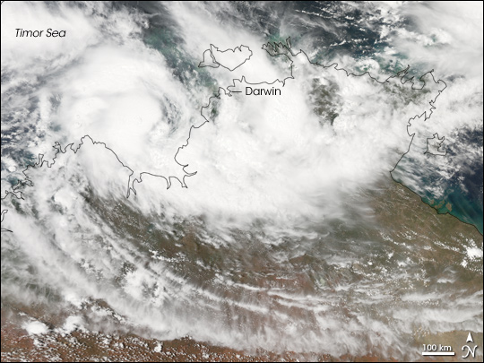
Figure 1. Satellite acquired image of Helen at 2:20 p.m. local time (4:50 UTC) on January 4, 2008.

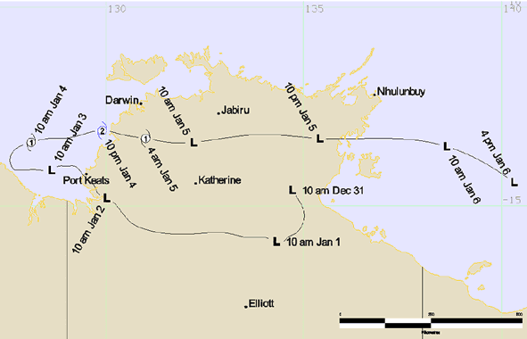
Figure 2. The track of Helen
Four Altimetric ground tracks/passes have been selected during the period of the cyclone Helen (Figure 3). The mean sea level (since 1992) and standard deviation have been computed at each along-track point. For each pass a point, where the SLA reaches the maximum during the cyclone Helen, is chosen. The SLA time series is plotted. In addition, the along-track SLA profiles have been analysed for four tracks.
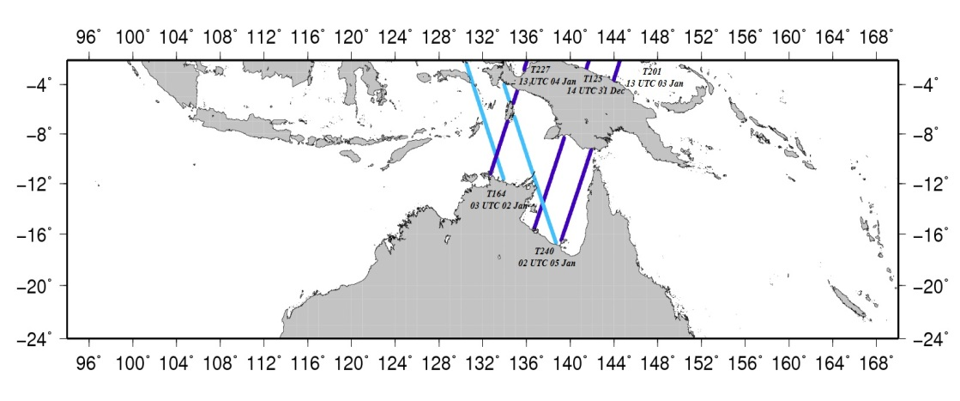
Figure 3. Selected altimetric ground tracks during the cyclone Helen period.

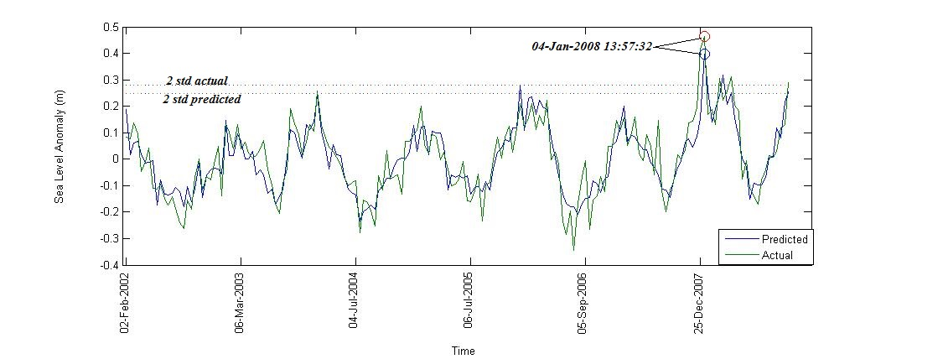
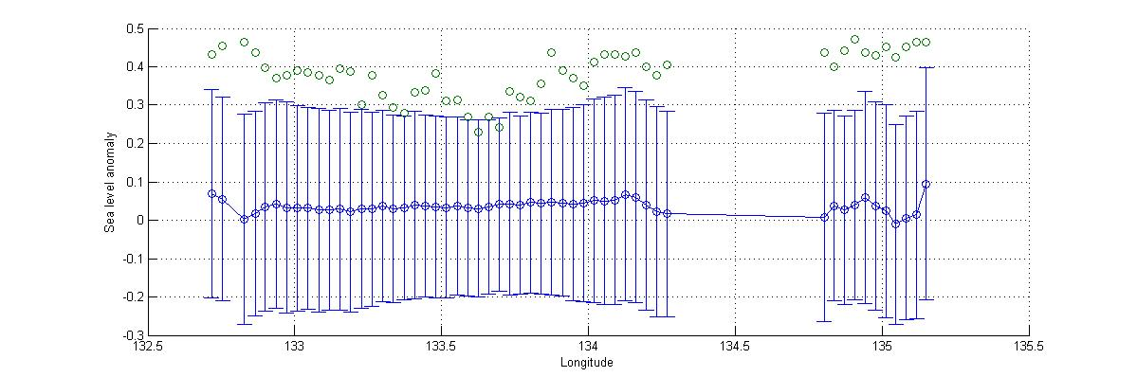
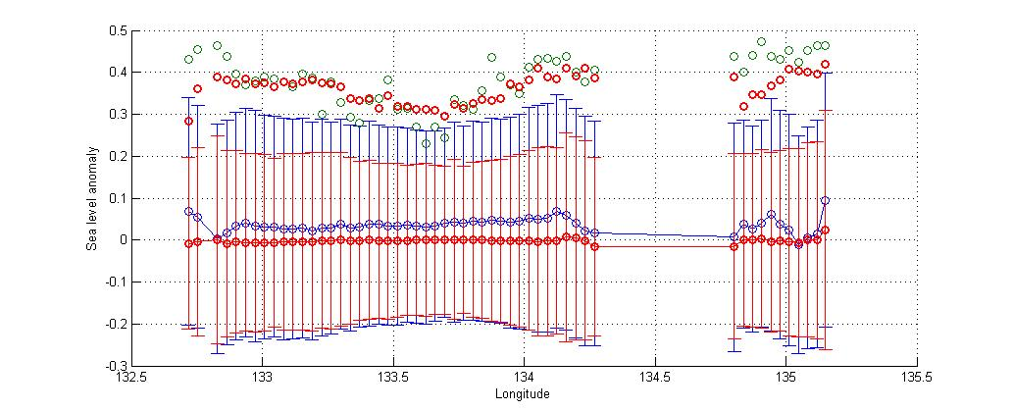
Figure 4. (Top): The measured (green) and predicted by the multi regression method (blue) SLA time series for a normal point (10.894°S, 132.8284°E) along track 227. The 2 times standard deviations (both related to measured and predicted) are shown as horizontal lines, suggesting that they both capture the sea level variations caused by the cyclone Helen. (Middle): Along-track SLAs (green) with respect to the mean sea level (blue circle) and 2 times stds (blue bar) during the cyclone Helen around UTC13:00 on 4 Jan 2008, indicating that SLAs are > 2σ. (Bottom): The same as mid Figure, but adding predicted sea level (red circle) and 2σ (red bar) into the figure. It shows that both measured and predicted SLAs are > 2σ. (units in m).

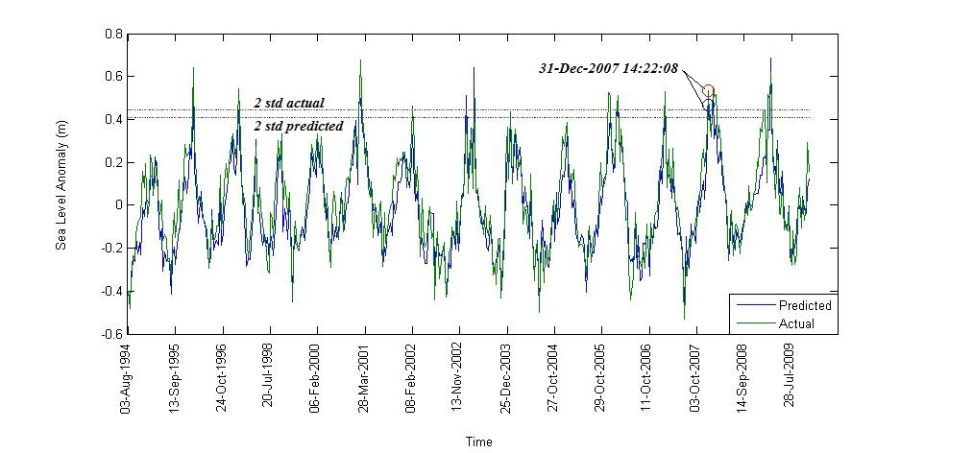

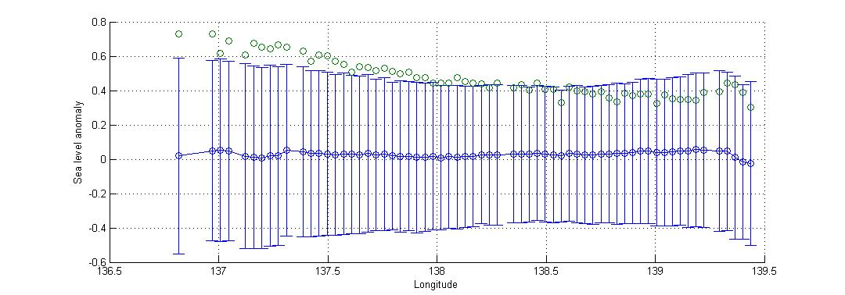
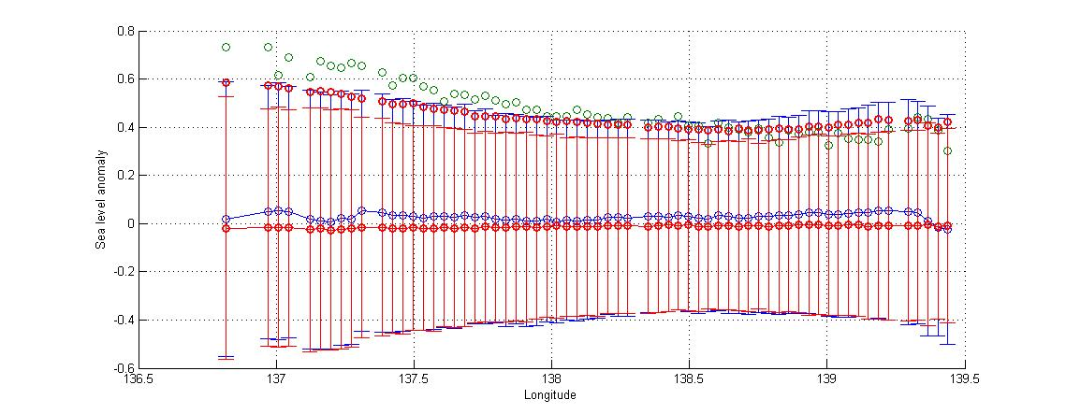
Figure 5. (Top): The measured (green) and predicted by the multi regression method (blue) SLA time series for a normal point (13.0462°S, 137.6838°E) along track 125. The 2 times standard deviations (both related to measured and predicted) are shown as horizontal lines, suggesting that they both capture the sea level variations caused by the cyclone Helen. (Middle): Along-track SLAs (green) with respect to the mean sea level (blue circle) and 2 times stds (blue bar) during the cyclone Helen around 14:22:08 on 31 December 2007, indicating that SLAs are > 2σ. (Bottom): The same as mid Figure, but adding predicted sea level (red circle) and 2σ (red bar) into the figure. It shows that both measured and predicted SLAs are > 2σ (units in m).

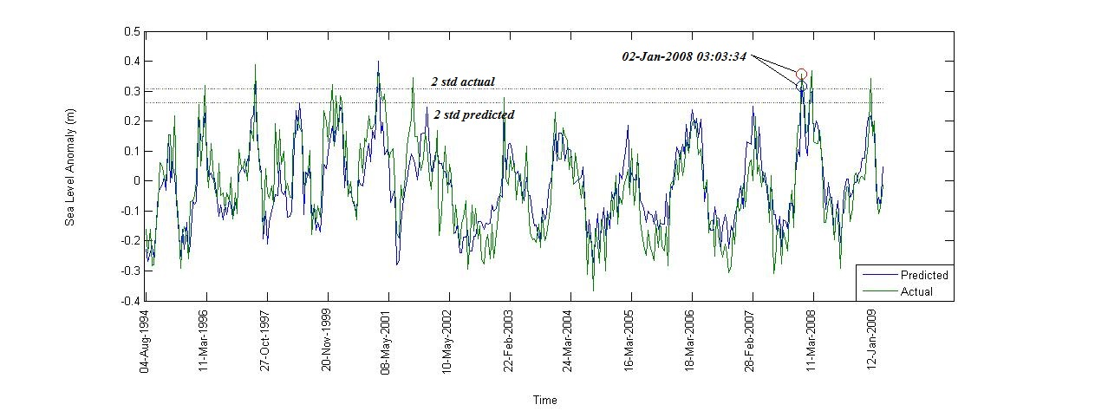
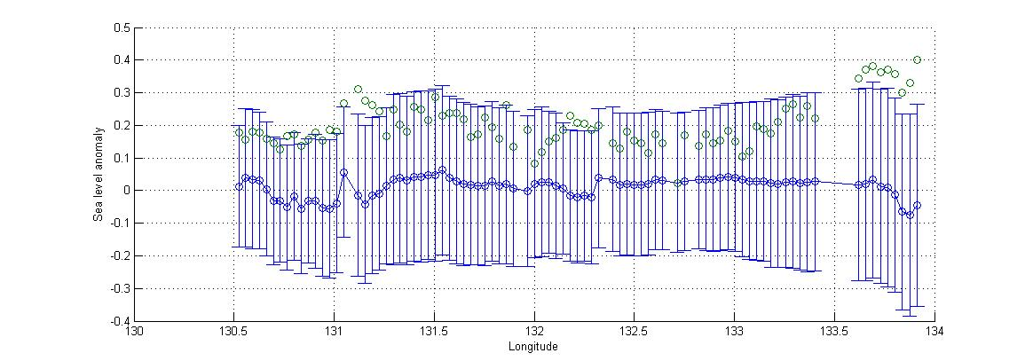
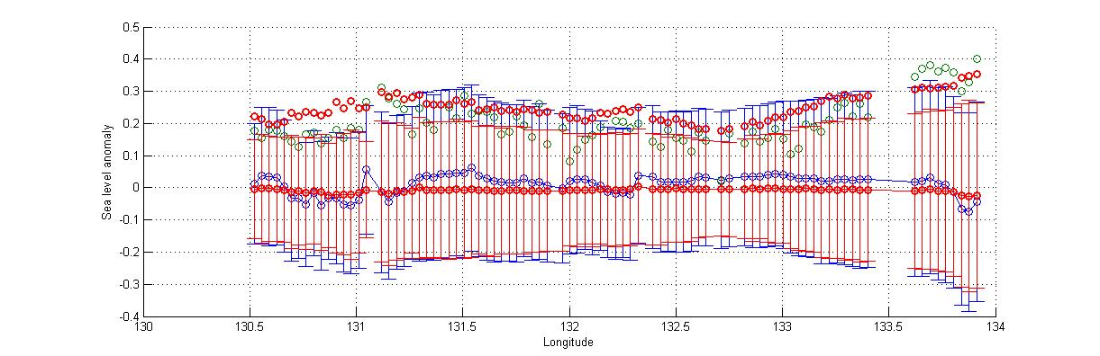
Figure 6. (Top): The measured (green) and predicted by the multi regression method (blue) SLA time series for a normal point (11.3330°S, 133.8016°E) along track 164. The 2 times standard deviations (both related to measured and predicted) are shown as horizontal lines, suggesting that they both capture the sea level variations caused by the cyclone Helen. (Middle): Along-track SLAs (green) with respect to the mean sea level (blue circle) and 2 times stds (blue bar) during the cyclone Helen around 03:03:34 2 January 2008, indicating that SLAs are > 2σ. (Bottom): The same as mid Figure, but adding predicted sea level (red circle) and 2σ (red bar) into the figure. Most part of this track did not pass through the cyclone with SLAs < 2σ. Altimeter still caught the cyclone-caused sea level signal when it approached the coastline near longitude 134°, with both measured and predicted SLAs are > 2σ (units in m).

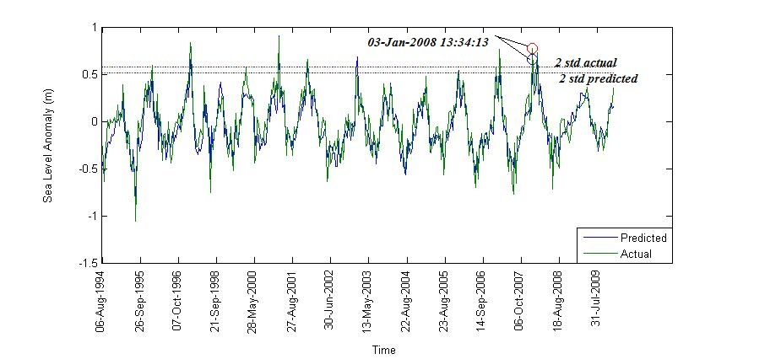
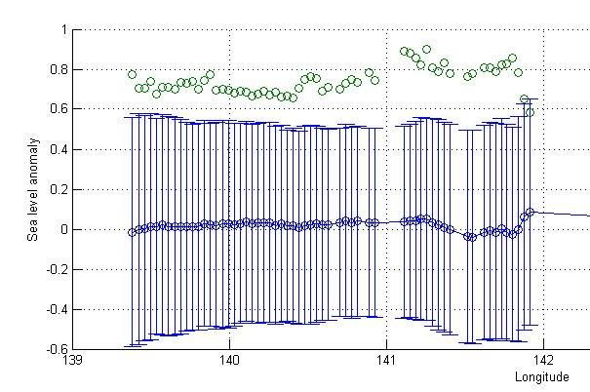
Figure 6. (Top): The measured (green) and predicted by the multi regression method (blue) SLA time series for a normal point (15.9655°S, 139.3838°E) along track 201. The 2 times standard deviations (both related to measured and predicted) are shown as horizontal lines, suggesting that they both capture the sea level variations caused by the cyclone Helen. (Middle): Along-track SLAs (green) with respect to the mean sea level (blue circle) and 2 times stds (blue bar) during the cyclone Helen around 13:34:13 on 3 January 2008, indicating that SLAs are > 2σ. (Bottom): The same as mid Figure, but adding predicted sea level (red circle) and 2σ (red bar) into the figure. It shows that both measured and predicted SLAs are > 2σ (units in m).
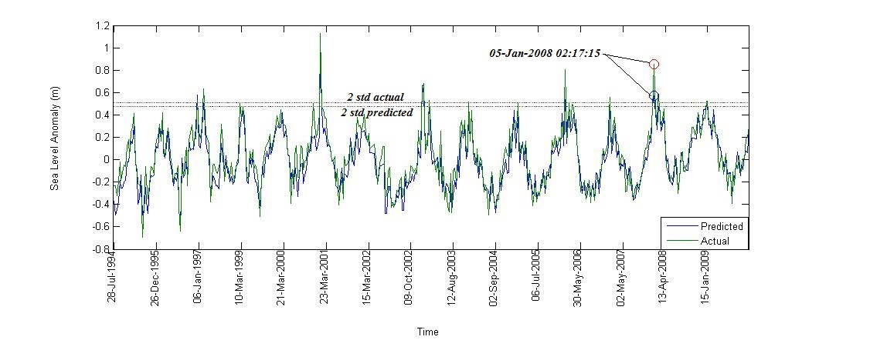
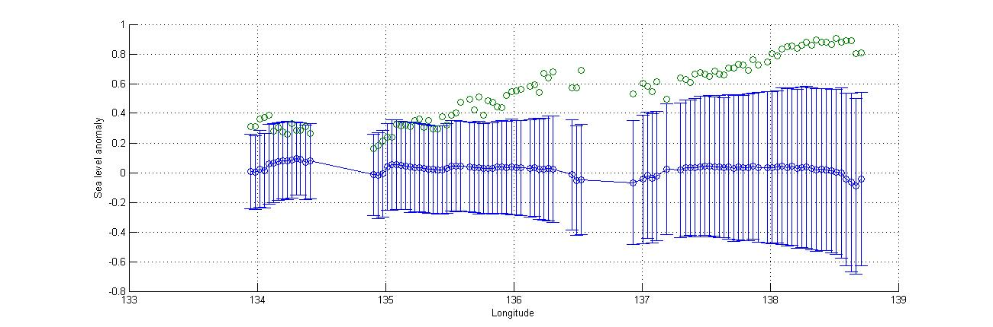
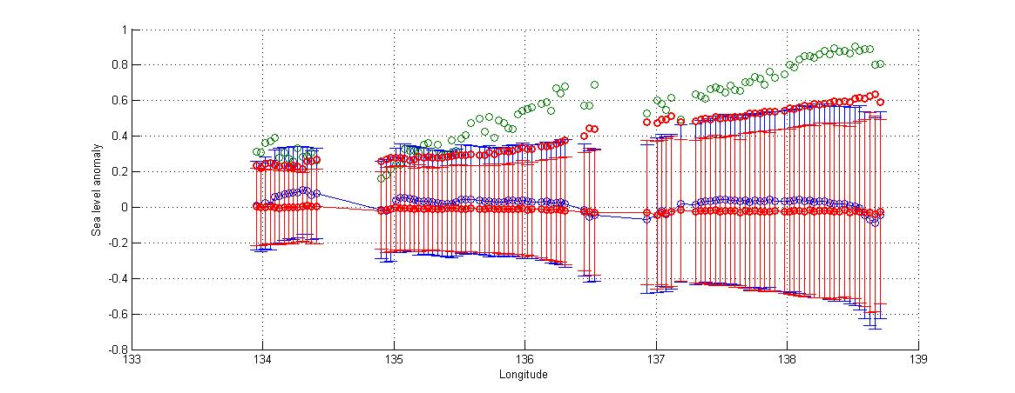
Figure 7. (Top): The measured (green) and predicted by the multi regression method (blue) SLA time series for a normal point (15.3322°S, 138.1704°E) along track 240. The 2 times standard deviations (both related to measured and predicted) are shown as horizontal lines, suggesting that they both capture the sea level variations caused by the cyclone Helen. (Middle): Along-track SLAs (green) with respect to the mean sea level (blue circle) and 2 times stds (blue bar) during the cyclone Helen around 02:17:15 on 5 January 2008, indicating that SLAs are > 2σ. (Bottom): The same as mid Figure, but adding predicted sea level (red circle) and 2σ (red bar) into the figure. It shows that both measured and predicted SLAs are > 2σ (units in m)

