Evaluation of the updated FAMOS17 MSS and geoid with existing MDT Models
In the Baltic Sea

1. INTRODUCTION
The Mean Dynamic Topography (MDT) is a fundamental surface for a large number of oceanographic applications and it is a representation of the ocean’s mean circulation. The MDT can be derived with two different approaches, namely ocean and geodetic approach [Ophaug et al., 2015]. The ocean approach is based on numerical ocean models, while the geodetic MDT is the result of the difference between the Mean Sea Surface (MSS) and an accurate geoid model.

Satellite derived mean sea surface (MSS) and geoid heights must both be given relative to same reference ellipsoid and the same tide system. In appendix B the transformations we apply in FAMOS to convert between different reference ellipsoids and different tide systems are described. Consequently, the MDT may be derived through a purely geometrical approach based on the simple equation
MDT=MSS-N (1).
The accuracy of a geodetic MDT is related to the accuracy of the geoid model and the accuracy of the mean sea surface (MSS).
In this investigation we use this equation as a mean of checking the updates achieved in FAMOS in terms of improved MSS (FAMOS DTU16MDT) and improved gravimetric Geoid (FAMOS 17 geoid) to investigate if this improvement is reflected through an improvement in the determination of the geodetic MDT determination which can be achieved by forming the difference between the FAMOS enhanced MSS and Geoid models.
Each MDT, geoid and MSS in this investigation are provided with a certain spatial resolution and time coverage. However, a consistent comparison requires same MDT characteristics [Ophaug et al., 2015], therefore all the models have been resampled with a spatial resolution of 1/30×1/30 degrees.

Model | Resolution (°) | Time Span | Approach
DTU16MSS | 1/60 × 1/60 | - | Geodetic
FAMOS17Geoid | 1/120 × 1/60 | - | Geodetic
EGM08 | 1/4 × 1/4 | - | Geodetic
DTU13MDT | 1/60 × 1/60 | 1996-2012 | Geodetic
HIROMB | 1/20 × 1/20 | 1989-2013 | Ocean

Table 1: Summary of the various models used in this work.

2. MODEL DESCRIPTION
In this section a short description of the models evaluated in this study is given.

2.1 DTU16 Mean sea surface (DTU16MSS)
The DTU16MSS is the new mean sea surface derived for the FAMOS project during 2016 and 2018 using new altimetric SAR data. The models use here is DTU16MSS_TideFree_WGS84_Noib_Baltic.xyz.zip for the Baltic region on a 1 minute resolution. Spatial extend is 53 N to 67 N and 8.00833333 W to 31.0083333333E.
The model is based on a new updated collection of SAR altimetry from the recent Cryosat-2 satellite used to update the previous model DTU13 which was the baseline for the computation of the DTU13MDT model described on section 2.3
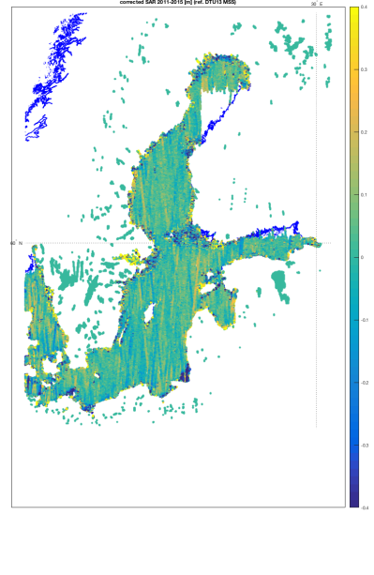
Figure 2.2 The Cryosat-2 SAR altimetry data available for computation of the DTU16MSS. The values are given relative to the previous DTU15MSS. Large differences can be seen along the coast and within the regions with many island “skærgården”.

2.2 FAMOS17Geoid
The FAMOS (interim) gravimetric quasigeoid computations (from now on called FAMOS17 geoid) is provided by Jonas Aagren and correspond to the grid called.
Famos_grav_w0nkg15_zerotide_lm4a.gri and the model is given in the zero tide system.

2.3 EGM08 Geoid
This is the baseline geoid which is the Earth Geopotential Model 2008 derived at the National Geospatial Agency in US. This geoid is normally taken as the starting point for computing geoid improvement.
EGM08 is a global model that refers to the Topex/Poseidon ellipsoid and the mean tide system. Consequent the transformations described in Appendix A and B are used to transfer this model into the WGS84 ellipsoid and zero tide system is applied.
The model used in this investigation is the transformed version given in the zero tide system relative to the WGS84 ellipsoid.

2.4 DTU13 Mean dynamic topography (DTU13MDT)
This model is used in the following as it represent the state of the art MDT modelling prior to the FAMOS project.
The DTU13MDT is obtained from the combination of the DTU13MSS Mean Sea Surface model (derived from 20 years of altimetry data – from 1993 to 2013) and the geoid model EGM2008 [Andersen and Knudsen, 2009]. The resolution available for DTU13 is of 1, 2, 5, or 12 minutes. Figure 2.3 shows the DTU13MDT at 1 minute resolution over the Baltic. Higher values are registered in the Gulf of Bothnia, while lower values are found westward, towards the Atlantic Ocean.

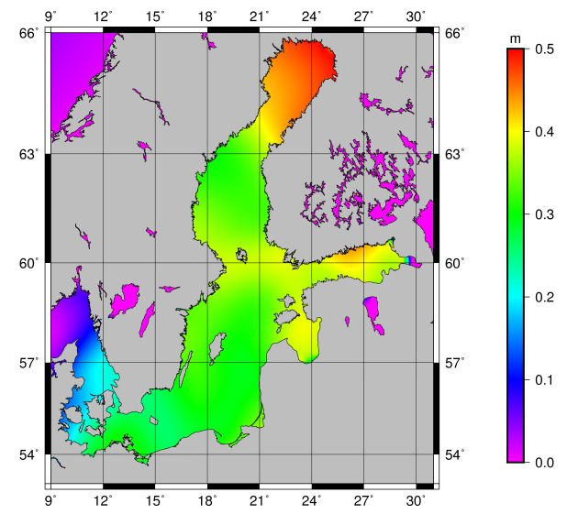
Figure 2.3: DTU13MDT in the Baltic
Upon forming the MDT for the DTU13 as the difference between the MSS and the Geoid we ensure that the same reference system and tide system is used which means that the MDT difference will be in-sensitive to the choice of reference and tide system.

2.5 HIROMB
The High-Resolution Operational Model for the Baltic (HIROMB) is a regional circulation model produced in 2014 by the Swedish Meteorological and Hydrological Institute (SMHI). HIROMB is based on both data assimilation from in situ-data and meteorological and hydrological models. The Copernicus catalogue provides this model with a resolution of 3 nautical miles, (approximately 1/20×1/20 degree) and for the time period 1989-2013 [Axell, 2015]. The model was evaluated as part of the FAMOS project and found to be the most accurate oceanographic MDT for the Baltic Sea and the model is shown in Figure 2.4

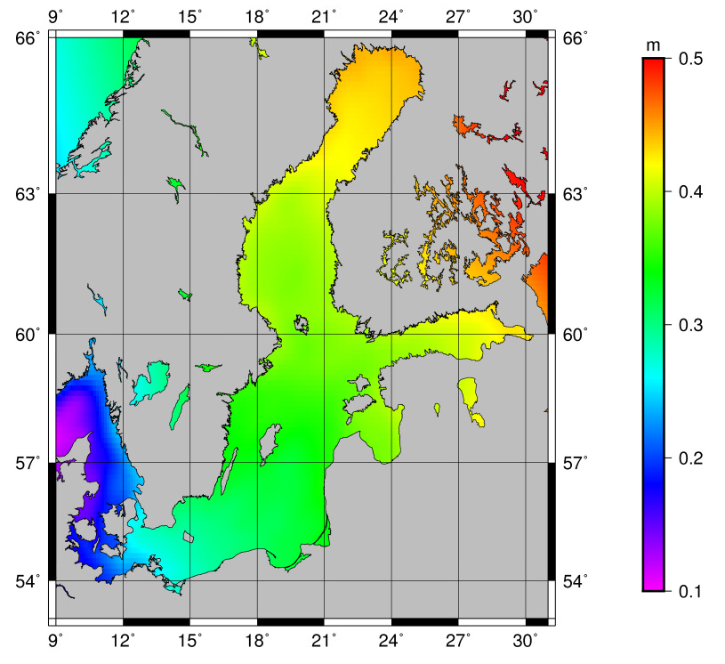
Figure 2.4: HIROMB model in the Baltic
YS2V3 model in the Baltic

3. FAMOS Developments

3.1 FAMOS geoid improvement
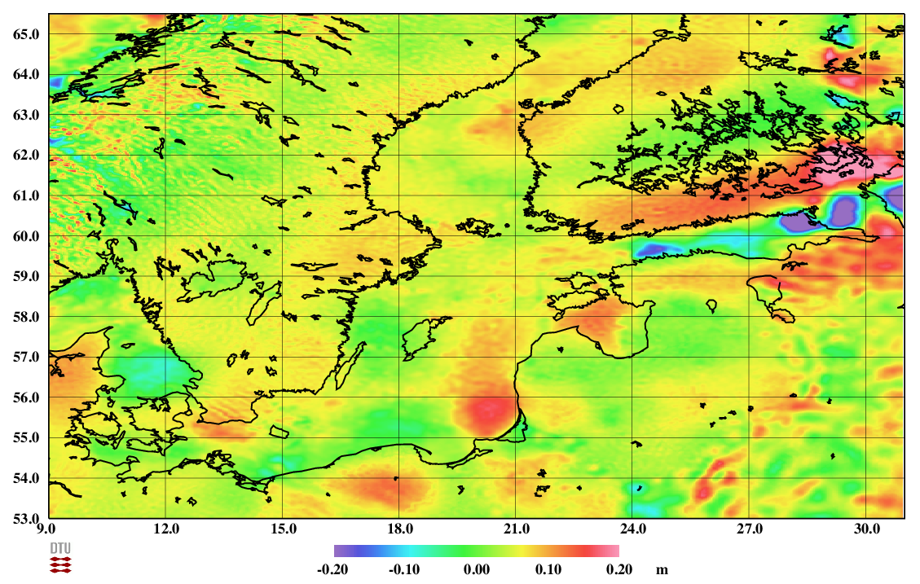
Figure 3.1. The difference between the FAMOS17 and the EGM08 geoid models.

The difference between the FAMOS17 and the EGM08 geoid models is given in Figure 3.1. The difference highlights the regions where the gravity observations within the FAMOS project has been improving the local geoid determination in the Baltic Sea.
On average the improvement over the Baltic is 3.9 cm with a negative anomaly decreasing the geoid with -20 cm in the eastern part of the Gulf of Finland. There are three regions with positive geoid anomalies exceeding 10 cm in the Gulf of Riga, the southern eastern part of the Baltic close to Lithuania and in the southwestern part of the Baltic south of Sweden between the island of Bornholm and Sealand in Denmark at 55N.

3.2. FAMOS MSS improvement.

The improvement in Mean sea surface determination within FAMOS for the Baltic Sea will be smaller than the improvement in geoid determination as the reference period is the identical 20 years period for the pre FAMOS DTU13MSS and the FAMOS DTU16MSS.
The improvement comes from the fact that that ESA recently launched the Cryosat-2 satellite which is providing observations with higher precision compared to previous for the Baltic. This turns into improvement of the final scales of the MSS in the Baltic Sea. Figure 3.2 illustrate the improvement in MSS determination from DTU13MSS to DTU16MSS.
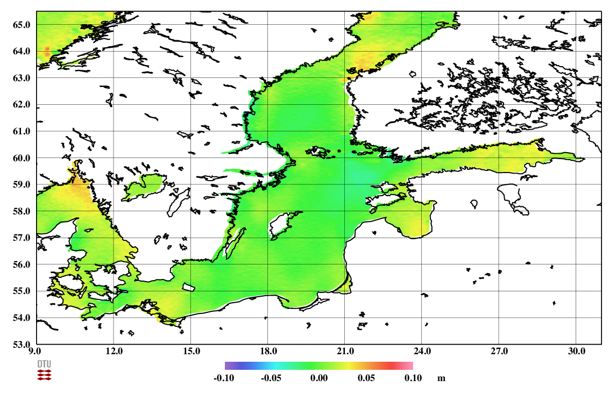
Figure 3.2 Improvement in MSS determination in the Baltic with FAMOS illustrated via the difference between the FAMOS MSS (DTU16MSS) and the pre FAMOS MSS (DTU13MSS).

3.3. FAMOS MDT improvement.

Section 3.1 and section 3.2 presented in the improvement in the determination of the Baltic Geoid and the Baltic MSS. It is obvious that the largest improvement is seen in the geoid determination with the inclusion of the marine gravity observations performed in FAMOS.
In this section we are forming the equation
MDT=MSS-N (1).
We have computed a pre FAMOS MDT using
MDT (Pre FAMOS) = DTU13MSS – EGM08 geoid
And a FAMOS MDT using:
MDT (FAMOS) = DTU16MSS – FAMOS 17 geoid.
The pre FAMOS MDT is shown in Figure 3.3 and the FAMOS MDT is shown in Figure 3.4
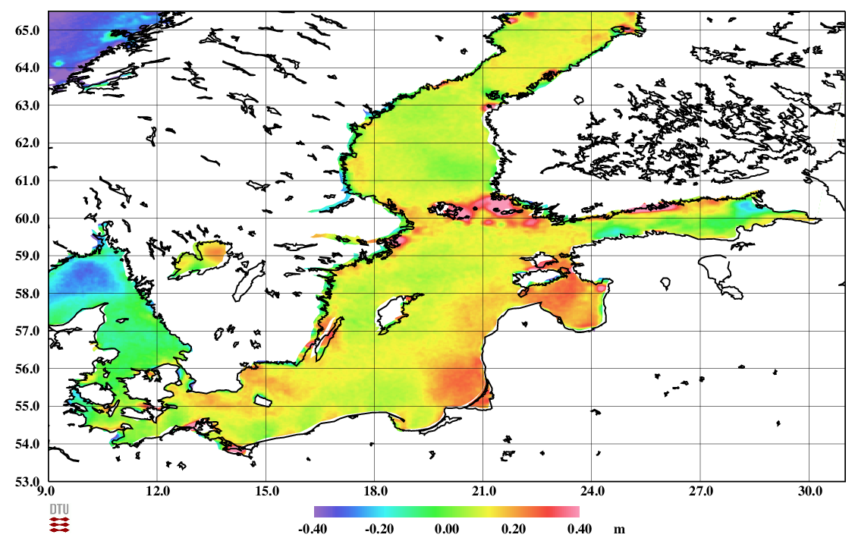
Figure 3.3. “Pre FAMOS Baltic MDT” computed as the difference between the FAMOS DTU16 MSS and the EGM08 geoid models.

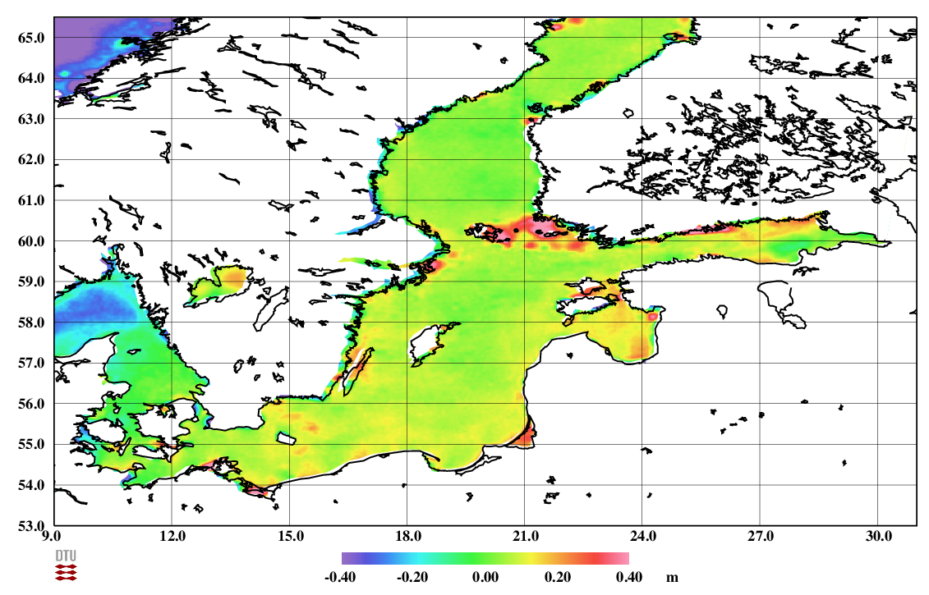
Figure 3.4. “FAMOS Baltic MDT” computed as the difference between the FAMOS DTU16 MSS and the EGM08 geoid models.

Figure 3.4 and 3.3 illustrate the huge improvement in geodetic MDT determination in the Baltic Sea achieved through the FAMOS project.
In the Gulf of Riga, the southern eastern part of the Baltic Sea close to Lithuania and in the southwestern part of the Baltic south of Sweden between the island of Bornholm and Sealand in Denmark at 55N the inclusion of FAMOS gravimetric data in the computation of the interim FAMOS geoid has resulted in a huge improvement in the MDT.
The geodetic determined MDT is now much more physical realistic and much more similar to the oceanographic MDT HIROMB in Figure 2.4.
The large anomalies seen in Figure 3.3 are equal to the pre FAMOS MDT errors illustrated in the pre FAMOS MDT in Figure 2.3
The largest un-physical difference in Figure 3.4 is obviously seen in and within the Aaland islands between Finland and Sweden within the latitude bands of 60N to 61N. This un-physical difference is clearly related to the MSS determination which is difficult due to the huge amount of islands in the region.
Initially we expected a large improvement in the MSS in this region using the Cryosat-2 SAR altimetry, but we have found that the improvement is not yet fully seen because we have not been able to include the repeated SAR altimetry from the Sentinel-3A satellites (we only have only been able to use un-repeated sparse data from Cryosat-2 as illustrated in Figure 2.2).
We similarly se un-physical differences in Figure 3.4 along the southern part of Finland in the Gulf of Finland. The inclusion of the gravity observations within FAMOS data has improved the determination of the geoid but there are still regions seens where the geoid appears to result in un-physical MDT fearures.
A close inspection of the geoid improvement in Figure 3.4 also illustrate some high frequency geoid signals appearing around the island of Bornholm as a consequence of the FAMOS gravity surveys as these regions has intensely surveyes in the FAMOS project.

4. Summary and conclusions

It has been demonstrated that particularly the gravity improvement within the FAMOS project lead to a huge improvement in the ability to determine geodetic MDT for the FAMOS project in the Baltic Sea.
Very large improvement in the geoid appears in the Gulf of Riga, the southern eastern part of the Baltic Sea close to Lithuania and in the southwestern part of the Baltic south of Sweden between the island of Bornholm and Sealand in Denmark at 55N. The large improvement in geoid determination within the FAMOS project is seen from computing the geodetic MDT
By computing the MDT as the MSS-geoid using the improved FAMOS quantities has also revealed some problems which should lead to further improvement in both the FAMOS MSS and the FAMOS geoid models
The largest un-physical difference in Figure 3.4 is obviously seen in and within the Aalands islands between Finland and Sweden. This un-physical difference is clearly related to the MSS determination which is difficult due to the huge amount of islands in the region. Initially we expected a large improvement in the MSS in this region using the Cryosat-2 SAR altimetry, but we expect that the improvement is not yet seen because we have not been able to include the repeated SAR altimetry from the Sentinel-3A satellites which we consequently recommend for the next phase of FAMOS.
We similarly se un-physical differences in Figure 3.4 along the southern part of Finland in the Gulf of Finland. The inclusion of the gravity observations within FAMOS data has improved the determination of the geoid where we recommend that further gravimetric data should be recorded in the next phase of the FAMOS project.
A close inspection of the geoid improvement in Figure 3.4 also illustrate smaller but distinct high frequency geoid signals appearing around the island of Bornholm as a consequence of the FAMOS gravitymetric surveys as these regions has been intensely surveyed in the FAMOS project.
We assume that these high frequency geoid signals are due to voids in the FAMOS gravimetric campaigns and recommend that there are further surveys are conducted to improve the geoid within the next phase of FAMOS.

Appendix A Reference ellipsoid.
Both altimetric mean sea surface heights and geoid heights are given relative to a reference ellipsoid, which corresponds to a theoretical shape of the Earth. The characteristics of different, currently used, reference ellipsoids are given Table 1. Before subtracting a geoid from a MSSH, both fields have to be expressed relative to the same reference ellipsoid. If not, the impact on the resulting MDT is large: Figure 1 shows the height differences between the GRIM and Topex ellipsoids on a global grid.
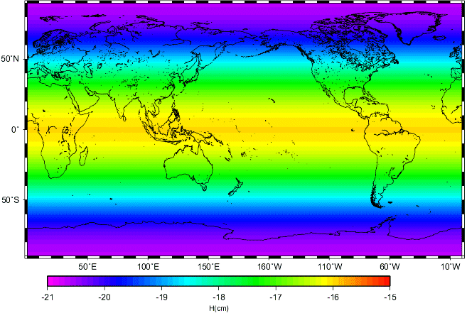
Figure 1: Height difference between the TOPEX and the GRIM ellipsoids.
Ellipsoid name | a (m) | 1/f | Gm (m3/s)
“GRIM” | 6378136.46 | 298.25765 | 398600.4369e9
“TOPEX” | 6378136.3 | 298.257 | 398600.4415e9
“GRS80” | 6378137. | 298.257222101 | 398600.5e9
“WGS84” | 6378137. | 298.257223563 | 398600.5e9
WGS84 rev 1 | 6378137. | 298.257223563 | 398600.4418e9
Table 1: The different reference ellipsoids and their characteristics (semi grand axe a, flattening 1/f and coefficient Gm)

Altimetric Mean Sea Surfaces are most commonly computed relative to the TOPEX ellipsoid.

The selection of a particular reference ellipsoid is not critical when computing geodetic MDT models. The important criterion is, that the MSS and the geoid must be defined in the same system if these are to be used jointly to compute a Mean Dynamic Topography (MDT).
This means that before computing the ocean MDT by subtracting the GOCE geoid from an altimetric Mean Sea Surface, the user must check that the MSS is defined in the same system.

Appendix B. Tide systems

Geoid heights (and mean sea surface heights) also differ depending on what tidal system is implemented to deal with the permanent tide effects. In the MEAN TIDE system, the effects of the permanent tides are included in the definition of the geoid. In the ZERO TIDE system, the effects of the permanent tides are removed from the gravity field definition. In the TIDE FREE or NON-TIDAL system, not only the effects of the permanent tides are removed but the response of the Earth to that absence is also taken into account.
Altimetric mean sea surfaces are usually expressed in the MEAN TIDE system. The GRACE GGM02 geoids from the CSR are defined relative to the ZERO TIDE system. The GRACE EIGEN geoids from the GFZ are defined relative to the TIDE FREE system. When computing an ocean mean dynamic topography, the MSSH and the geoid first have to be computed in the same system. If not, the impact on the resulting MDT is large: for instance, Figure 2 shows the difference between the TIDE FREE and the MEAN TIDE reference systems.
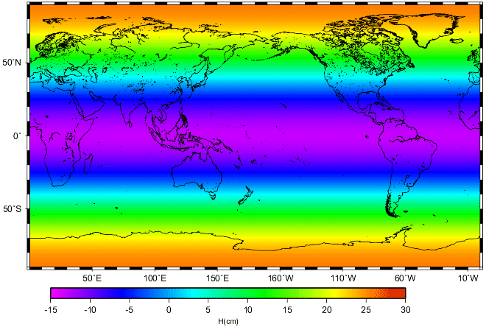
Figure 2: Height difference between the TIDE FREE and the MEAN TIDE reference systems

