**Recommendations for the use of GNSS-R observations for evaluation of altimetric mean sea surface models in the Baltic**

Date 20 December 2018.

Report and data prepared for

FAMOS

Prepared by

Ole Baltazar Andersen

DTU space.

Elektrovej bldg 328.

Office 104.

2800 Kongens Lyngby , Denmark

Mail: [oa@space.dtu.dk](mailto:oa@space.dtu.dk)

Contents

1. Preface 2

2. Summary 3

3. Consistency issues. 6

3.1. The Reference Ellipsoid 6

3.2. Tide System 7

4. Baltic 8

5. References 11

# Preface

The title of this Milestone 12F was to prepare a report with recommendations concerning the use of GNSS measurements on ships for evaluation of altimetric derived mean sea surface models.

The deliverable was supposed to use the raw GPS data from the Deliverable 11D and 12B which was cancelled. Hence No raw GNSS data were collected during 2017 as it was not possible to allocate resources for post processing during 2017.

We have been forced to change this Deliverable to a study on fix mounted GNSS measurements for evaluation of altimetric derived mean sea surface model. Here we will use GNSS reflectrometry from land stations. This is in principle equally important for an independent evaluate the altimetric sea level variations and the derived mean sea surface models.

# Summary

In this work we present the first usage of GNSS observations for validation of the FAMOS Mean Sea surface

Today there are a number of published reports which document how a standard geodetic quality GPS receiver situated at the coast with an unobstructed view of the sea can be used to act as an accidental tide gauge (Larson et al- 2013a,b) because the GPS reflections off the sea surface can be analysed separately to the direct signal as illustrated in Figure 1.

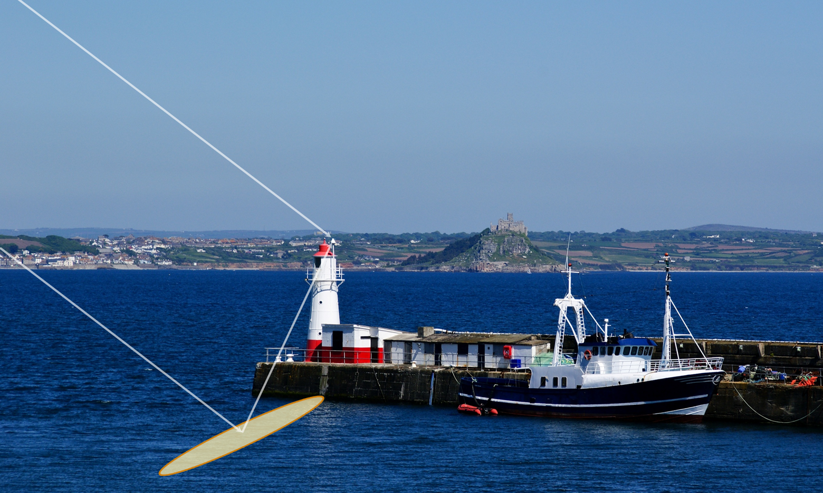

*Figure 1. The direct and reflected GNSS signal for a GNSS receiver on a pier.*

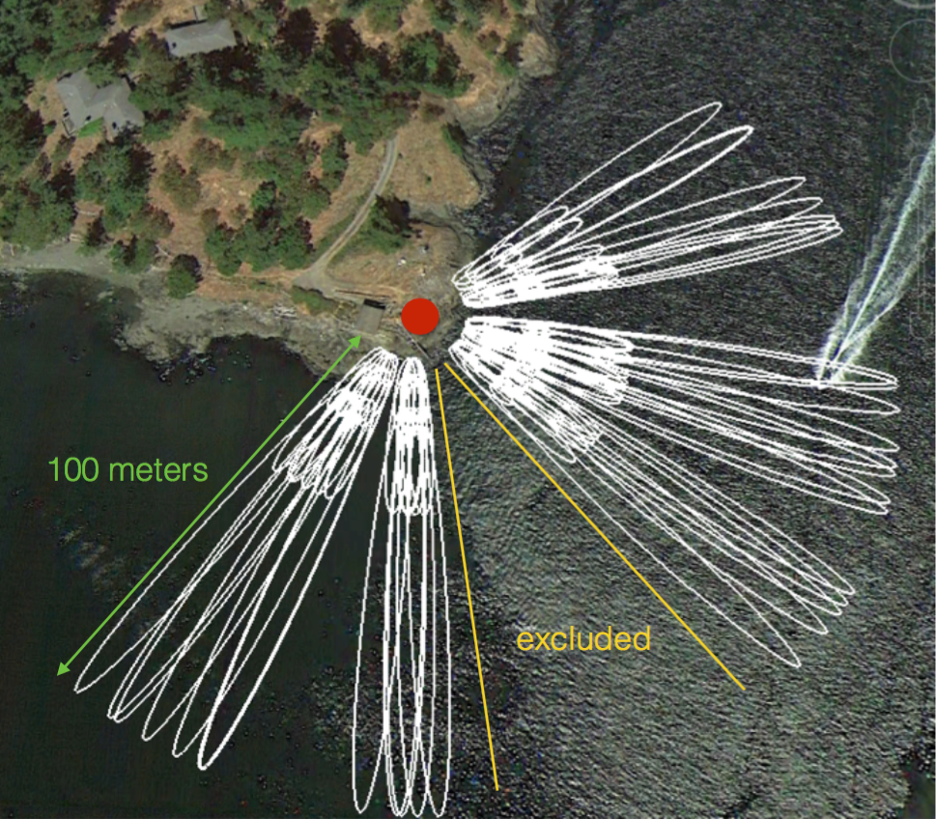

*Figure 2. The Fresnel zones for the reflected GNSS signal for a GNSS receiver on a pier.*

Interference pattern between direct and reflected signals causes changes in the signal to noise ratio

In the absence of multipath SNR values smoothly rise from ~35 dB to ~52 dB and determined by the satellite transmitted power and the antenna gain pattern



Where A is amplitude, l is GPS carrier wavelength, q is satellite elevation angle and f is phase offset

# Consistency issues.

The MSS and/or sea level observations from GNSS must be given relative to a consistent tide system and with respect to a consistent reference ellipsoid and the period of the observations must be consistent.

We used the mean tide system and the TOPEX ellipsoid, with a semi major axis of 6,378,136.3 m and an inverse flattening of 298.257. Other ellipsoids or tide systems can be used through transformation. GNSS measurements, that are initially consistent with the WGS84 reference frame, are usually aligned with the International Terrestrial Reference Frame (ITRF) for Earth science applications that require a high degree of accuracy (IERS, 2010). Thus, the GNSS ellipsoidal heights were here transformed to the most up-to-date ITRF realization at the time of the study (the ITRF08 (Altamimi et. al, 2011), which is associated with the GRS80 ellipsoid. The same was applied to the FAMOS mean sea surface with height given in Figure 3.

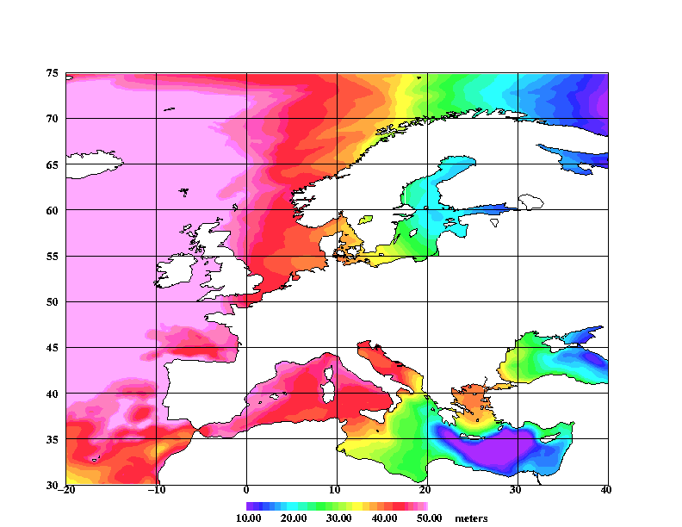

*Figure 3 Mean Sea Surface model relative to GRS80/WGS84 for the greater FAMOS European Region*

## The Reference Ellipsoid

The DTU18MSS is given relative to the GRS80 / WGS reference Ellipsoid is the currently best fitting mathematical model used to describe the shape of the Earth.

Se documentation at <http://en.wikipedia.org/wiki/GRS_80>

## Tide System

The FAMOS Mean sea surface is given in the Tide free or NON-TIDAL system to be consistent with GPS observations.

Geoid heights (and mean sea surface heights) differ depending on what tidal system is implemented to deal with the permanent tide effects. In the **MEAN TIDE** system, the effects of the permanent tides are included in the definition of the geoid. In the **ZERO TIDE** system, the effects of the permanent tides are removed from the gravity field definition. In the **TIDE FREE or NON-TIDAL** system, not only the effects of the permanent tides are removed but the response of the Earth to that absence is also taken into account.. GPS is processed in the NON-TIDAL system.

In the Baltic Sea this corrections is on average 14 cm which was corrected for as shown in Figure 4.

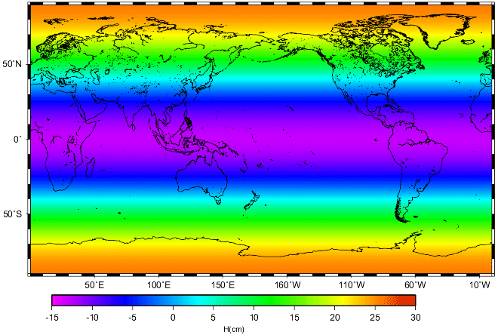

*Figure 4. Difference between the Mean Tide and Non Tide system.*

# FAMOS Baltic GNSS vs satellite altimetry comparison

Here we compare 2 years of GNSS reflectrometer data with Satellite Altimetry from the Sentinel-3A mission (Samosa retracker) since the launch of the satellite in 2016. In the following the altimetric heights are given relative to the FAMOS mean sea surface.

The Processing of the GNSS data is very time consuming and was done in collaboration between the National Oceanographic Center in Liverpool and DTU Space.

The Satellite altimetry from the Sentinel-3 satellite was processed using the standard range and geophysical corrections (Andersen and Scharroo, 2011).

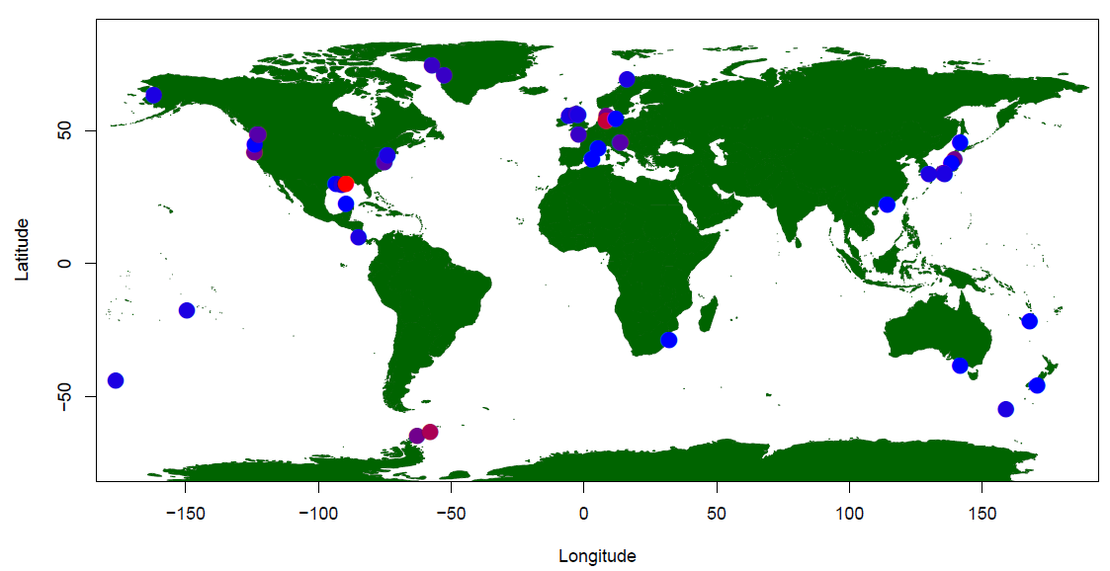

*Figure 5. GNSS stations which can act as an accidental tide gauge and hence be used to confirm the satlellite altimetric observations of the sea surface height.*

The GNSS stations processed for reflectometric observations of sea level which and be used as an accidental tide gauge observing sea level and sea level variations is shown in Figure 5. Figure 6 shows the Sentinel 3A ground tracks in the Baltic illustrating that the Gedser stations in southern Denmark is very good site to compare satellite altimetry observations with GNSS-R observations. In figure 7 a close up of the satellite track and the Gedser GPS monument used for the comparison (The Ge

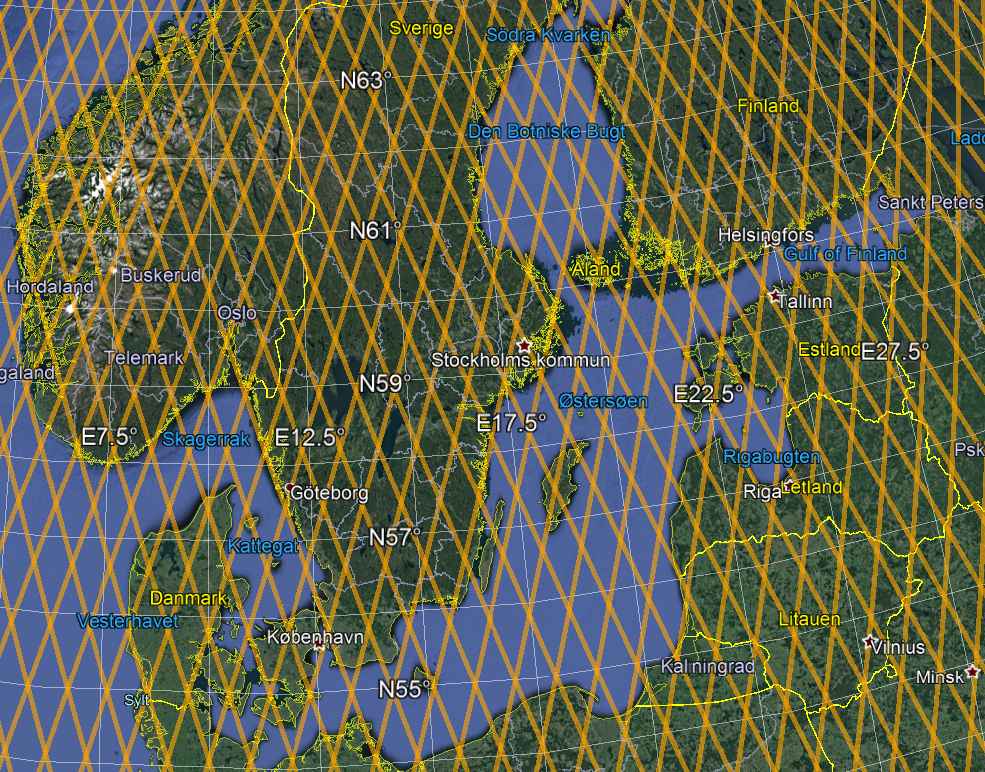

*Figure 6. Sentinel 3A ground tracks in the Baltic illustrating that the Gedser stations in southern Denmark is very good site to compare satellite altimetry observations with GNSS-R observations*

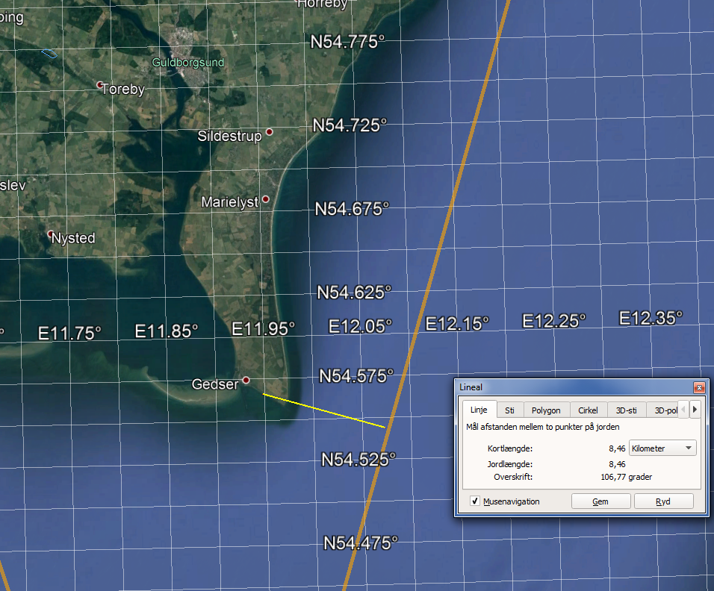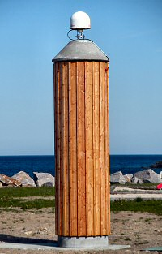

## 

*Figure 7 The tide gauge in Gedser in Southern Denmark and the distance to the Sentinel-3A satellite track and data in the MSS which is was compared with (the picture of the GPS monument is actually from Tejn as no picture was available for the Gedser tide gauge.*

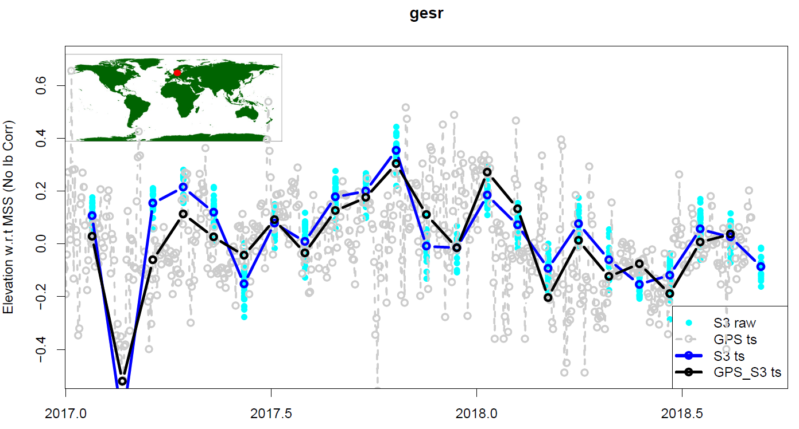

*Figure 8. The data from Sentinel-3A in a 20 km box surrounding the tide gauge at Gedser (cyan observations) and the track-wise averaged values (dark blue observations) as well as the raw GNSS_R solutions (grey) and the edited GNSS (black)*

The data from Sentinel-3A in a 20 km box surrounding the tide gauge at Gedser (cyan observations) and the track-wise averaged values (dark blue observations)The elevation variations over the two years are shown and reaches up to 40 cm. In Grey and black the aw GNSS_R solutions (grey) and the edited GNSS (black) as shown.

# Summary

The comparison between the altimetric mean sea surface for FAMOS and the sea level variations around this mean sea surface was compared with GNSS reflectometry observations and the Gedser permanent GNSS facility and yielded very consistent result which is very promising for future extensions of such investigations and for the use of GNSS observations onboard ships.