Water level extremes
From mean sea surface.

Date 19 November 2018.

Report and data prepared for
FAMOS

Prepared by
Ole Baltazar Andersen and Carsten Ludwigsen
DTU space.
Elektrovej bldg 328. 2800 Kongens Lyngby , Denmark
Mail: oa@space.dtu.dk

Contents
1. Summary 2
1.1. Vertical referencing and tide system. 2
1.2. The DTU16MSS and its error 4
1.3. Inverse barometer and/or dynamic atmosphere correction. 5
2. Monthly and longer scale sea level variability 6
3. Sub monthly extreme sea level 8
3.1. Cryosat-2 SAR versus conventional altimetry. 10
3.2. Comparison with 30 years altimetry. 11
4. The DTU altimetry illustrator. 13
4.1 Software 13

Summary
This short note uses the DTU16 Mean sea surface as a vertical Offshore Reference Frame in order to investigate the water level extremes during the 1993-2018 period. The DTU16MSS is described in previous FAMOS reports.

For reference, it should be noted, that the DTU16Mean Sea Surface is identical to the DTU16LAT (DTU16 Lowest Astronomical Tide) inside the Baltic Sea. This is because the Baltic is considered tide free and hence the Lowest Astronomical Tide is zero The scematice and relationship between different reference surfaces used in offshore navigation is shown in Figure 1.0

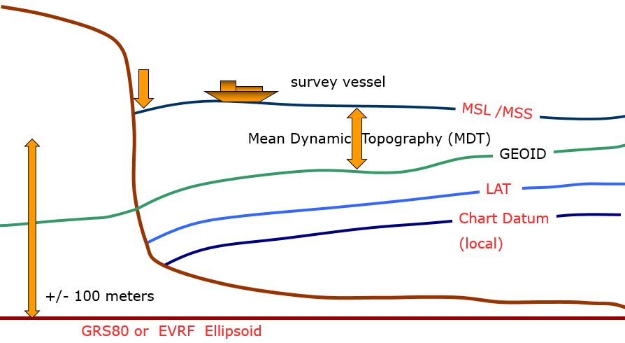
Figure 1.0: Sketch of the DTU16 MSS relative to the GRS80 ellipsoid

Vertical referencing and tide system.

For absolute comparison between altimetric sea surface level and GNSS references sea level from tide gauges and satellite altimetry it is important that the altimetric sea level and tide gauges measured sea level are given in the same reference Frame. Figure 1.1 illustrate how the tide gauge measurements should be converted to ellipsoidal heights if such a comparison should be possible.
The figure also illustrate that the tide gauge observations are always RELATIVE to the ground as the tide gauge is fixed to the ground whereas the satellite altimeter measures ABSOLUTE sea level as it is not fixed to the ground.

In the Baltic relative sea level changes due to the Post glacial rebound from the last ice-age. This is considered as a linear effect so in terms of temporal correlation it does not contribute to the correlation. However it contributes to any absolute comparison which must be carried out to the same epoch.

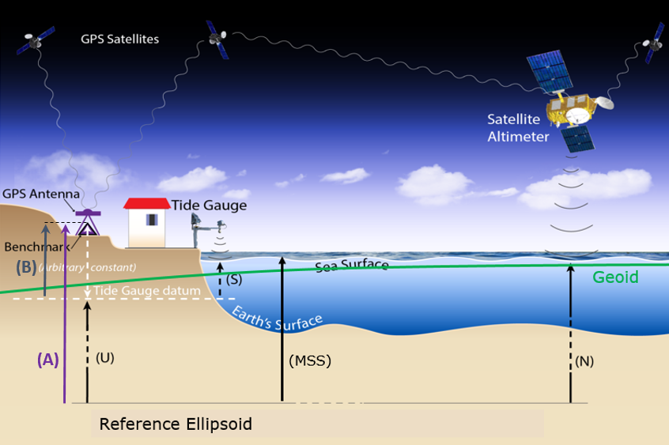
Figure 1.1 Satellite and tide gauge observations of the ellipsoidal Mean Sea Surface (MSS) or (S) and the Geoid (N) relative to the reference ellipsoid. The figure is modified from Thierry Guyot (LIENSs).

For absolute comparison we must consider that the DTU16MSS has been computed relatively to reference ellipsoid WGS84/GRS80 in the non-tidal tide system (correspondent to tide system used for GPS processing). In the Baltic there is only very small differences to the European EVR2007 realisation of the vertical reference height

For absolute comparison with GNSS references sea level at tide gauges it must also be considered that the DTU16 Mean sea surface is given in the Tide free or NON-TIDAL system to be consistent with GPS observations. Geoid heights (and mean sea surface heights) differ depending on what tidal system is implemented to deal with the permanent tide effects. In the MEAN TIDE system, the effects of the permanent tides are included in the definition of the geoid. In the ZERO TIDE system, the effects of the permanent tides are removed from the gravity field definition. In the TIDE FREE or NON-TIDAL system, not only the effects of the permanent tides are removed but the response of the Earth to that absence is also taken into account.. GPS is processed in the NON-TIDAL system.

There are standard formulas to correct for this differences which can be readily applied. The DTU16MSS prepared for the FAMOS project comes in both mean tide versions and Non Tidal versions for usage.

The DTU16MSS and its error

The DTU16 MSS used in this investigation for the vertical referencing is illustrated in figure 1.2.1 and its error is shown in Figure 1.2.2. The Error is used to illustrate that the vertical reference is less accurate very close to the coast where tide gauges are located. Hence it is frequently an advantage to use altimetric observations at a distance of 10-20 km from the coast.
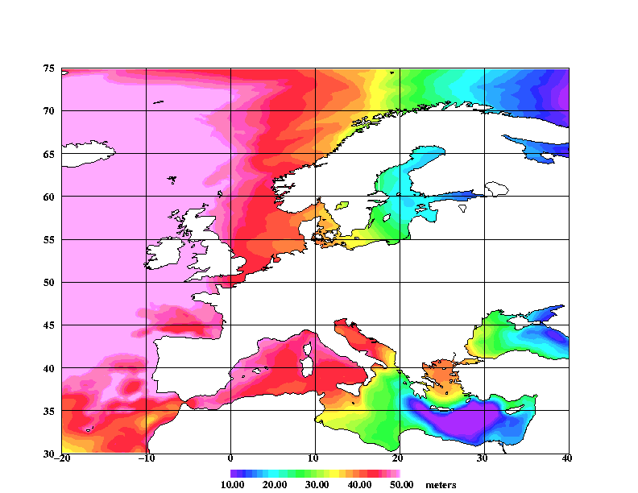
Figure 1.2.1 The DTU16 Mean Sea Surface model relative to GRS80/WGS84 for the greater FAMOS European Region. IIlustration taken from DTU16MSS FAMOS report
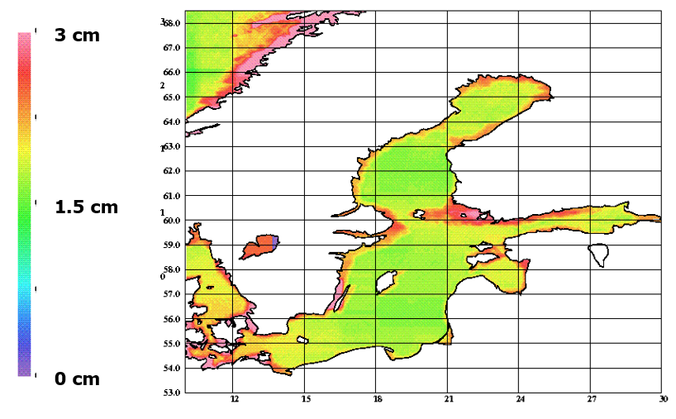
Figure 1.2.2 The interpolation error of the DTU16MSS in the FAMOS region to highlight that the error increases in close proximity to the shore..

Inverse barometer and/or dynamic atmosphere correction.

Tide gauges measures the physical sea level. Frequently satellite altimetry has the inverse barometer or dynamic atmospheric correction applied in order to account for the atmospheric effect on sea level.
In order to compare the two quantities and to make these compatible we can apply an inverse barometer correction to the tide gauges and in this way make the resulting time series compatible with satellite altimetry. We could alternatively avoid applying the correction for the atmosphere
For the monhly and longer scale sea level variability study in chapter 2 we decided to apply this Dynamic Atmosphere correction to the tide gauge data before comparing with the tide gauges.
The Dynamic Atmosphere correction is determined either from the ERA-Interim reanalysis product (http://www.ecmwf.int/en/elibrary/8174-era-interim-archive-version-20), monthly mean sea level pressure on a ¼ degree grid, interpolated to tide gauge locations, or the Dynamic Atmosphere Correction (DAC), which is a barotropic ocean model forced by atmospheric pressure and wind stress from the same meteorological analysis, reverting to simple inverse barometer correction at periods longer than 20 days.
Although this does not mean that monthly mean values in the DAC are precisely equivalent to the simple IB correction, we find that they are extremely similar with both DAC and IB analyses explaining very similar fractions of the variance of the tide gauge data. For this reason, we will focus only on the DAC-corrected product, which is also the product used to correct the altimetry data.
For the sub monthly extreme sea level in Chapter 3 we decided NOT to apply the Dynamic Atmosphere correction to the satellite altimetry. This is because a large part of the physical sea level signal seen at shorter periods will be explained by the atmospheric pressure variations as well as the signal modelled in the Dynamic Atmosphere signal

Monthly and longer scale sea level variability
The relationship between tide gauges and altimetry are considered using all tide gauges in the Permanent Service for Mean Sea Level (PSMSL) Revised Local Reference (RLR) dataset (http://www.psmsl.org). We identify all tide gauges (a total of 1007 sites) with data overlapping the precise satellite altimetry period 1993 to present (in practice to the end of 2015).
For each tide gauge we seek the altimeter record (from the AVISO gridded absolute dynamic topography) within 300 km which, when supplemented by a trend, annual and semiannual cycle, explains the largest fraction of variance in the tide gauge record. All subsequent diagnostics are shown with DAC correction applied, seasonal cycle removed, and a trend added to the altimetry to make it match the tide gauge trend. Plotting the tide gauge and altimetry data together gives a good feel for the variability and its representativeness of the open ocean.

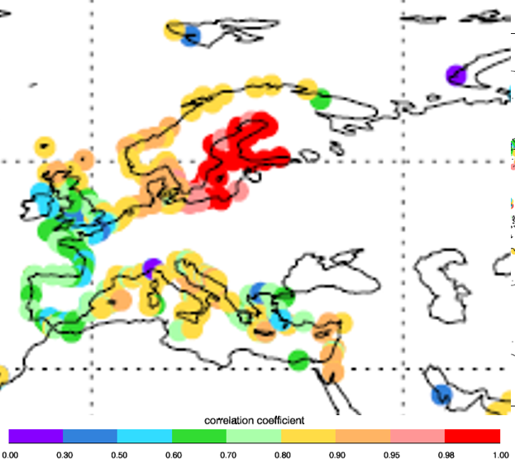
Figure 2.1: Percent variance of tide gauge data explained by satellite altimetry

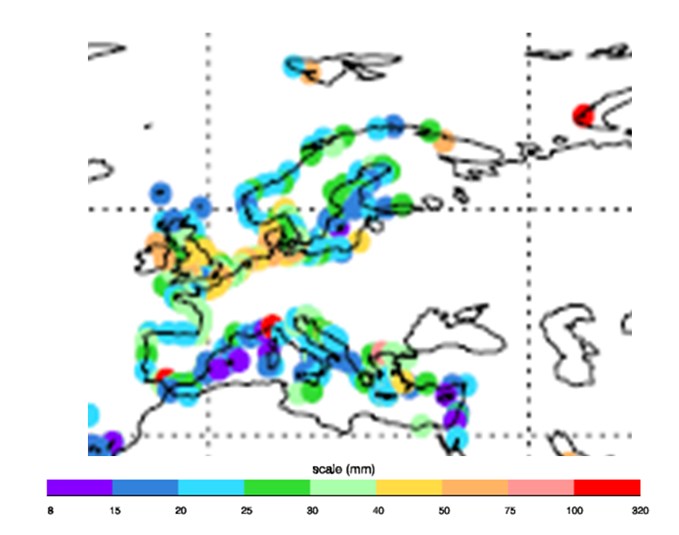
Figure 2.2: Residual standard deviation at each tide gauge after DAC correction, seasonal cycle, trend and open ocean (altimetry) signal have been accounted for.
He most striking features worth highlighting is the very high variance explained in the Baltic results in a residual standard deviation of less than 40 mm despite the high initial variance in this region
This means that on scales longer than 1 month most of the sea level variance is adequate explained from satellite altimetry. This includes extremes in the Baltic.

Sub monthly extreme sea level
For the sub monthly extreme sea level in Chapter 3 we decided NOT to apply the Dynamic Atmosphere correction to the satellite altimetry. This is because a large part of the physical sea level signal seen at shorter periods will be explained by the atmospheric pressure variations as well as the signal modelled in the Dynamic Atmosphere signal
The location of the Stockholm tide gauge is shown in Figure 3.1 as well as the box with satellite altimetry used for the comparison with the tide gauge in Stockholm. Please notice now far from the open Baltic that the Stockholm tide gaue is placed

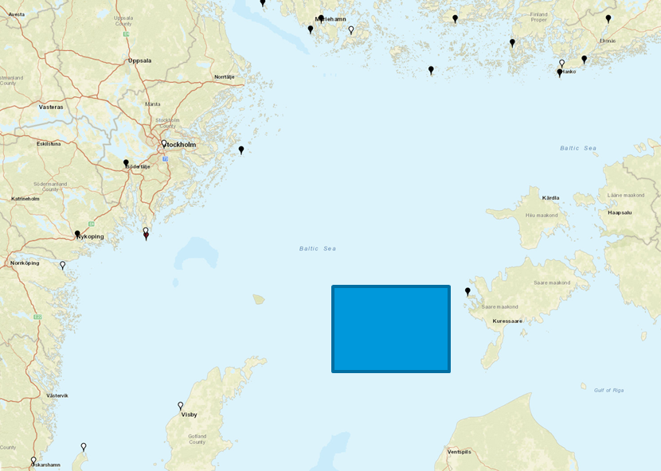
Figure 3.1 The location of the Stockholm tide gauge some 50-60 km from the nearest open water where conventional satellite altimetry is available. The box with satellite altimetry in section 3.2 is used for the comparison with the tide gauge in Stockholm.
Daily sea level variations from the Stokholm tide gauge is shown in figure 3.2. The standard deviation of the sea level at the gauge is close to 20 cm (19.8 cm).
Defining sea level extremes as sea level higher than 2 x the standard deviation or 40 cm yields 19 incidents of extreme sea level since 1993.
The highest recovered sea level was in may 2007 where sea level reached 77 cm above heighest sea level.

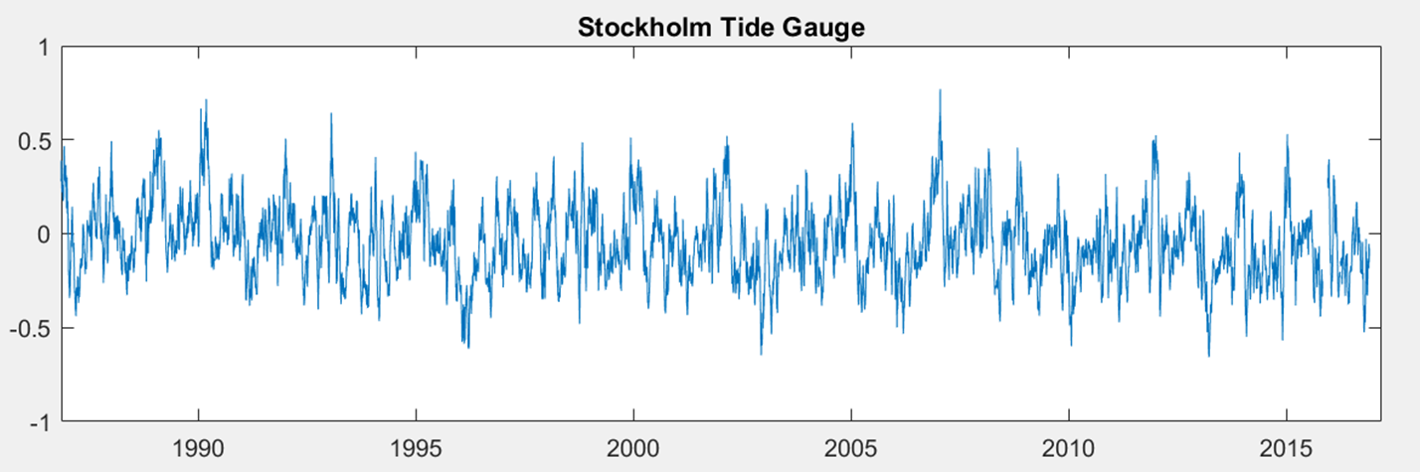
Figure 3.2 Tide measured sea level at the Stockholm tide gauge at daily interval for last 30 years corresponding to the altimetry tide era

Two investigations are in the following made between the satellite altimetry and tide gauge information.
In the first investigation is performed to investigate the importance of SAR altimetry processing which became available with Cryosat-2 and which is now available on-board Sentinel 3A and Sentinel 3B. The clear advantage of this processing is that footprint on the sea surface is far less and hence for coastal regions the change of it being contaminated with land is far less. Figure 3.3. illustrate the situation.
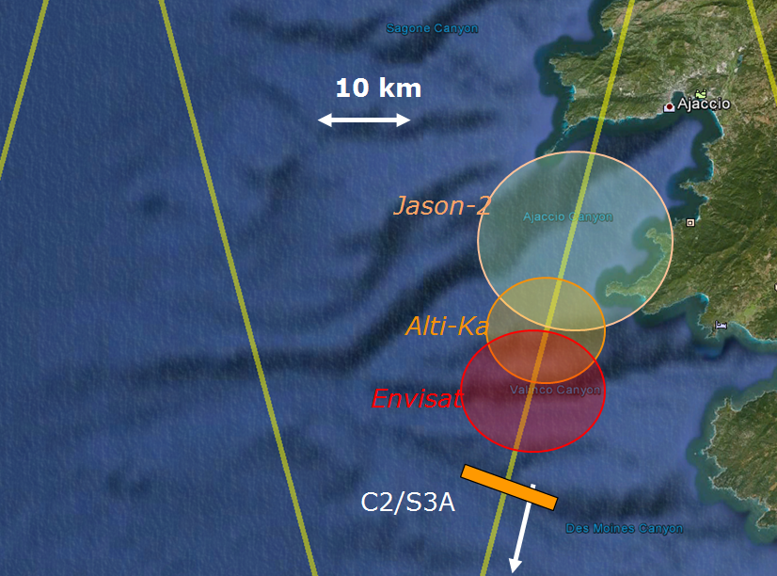
Figure 3.3 The circular footprint of conventional satellite altimetry (Jaons, Envisat, ERS, AltiKA and TOPEX) and the rectangular footprint of SAR processed altimetry from Cryosat-2 and the Sentinel-3 satellites.
The second investiagation is performed with satellite altimetry from ALL available satellites since 1988 highlighting that all sea level extremems can be captured using satellite altimetry in the Baltic Sea.

Cryosat-2 SAR versus conventional altimetry.

The following investigation present at comparison with the Stockholm tide gauge between Cryosat-2 with and without the SAR processing applied. As Figure 3.4 illustrate then with the SAR processing (left) figure far more data close to the Stockholm tide gauge is present. This should in principle lead to a better mapping of the sea level. In the right panel Cryosat-2 processed like conventional altimetry with a circular footprint and edited accordingly so that the footprint is not contaminated by land.

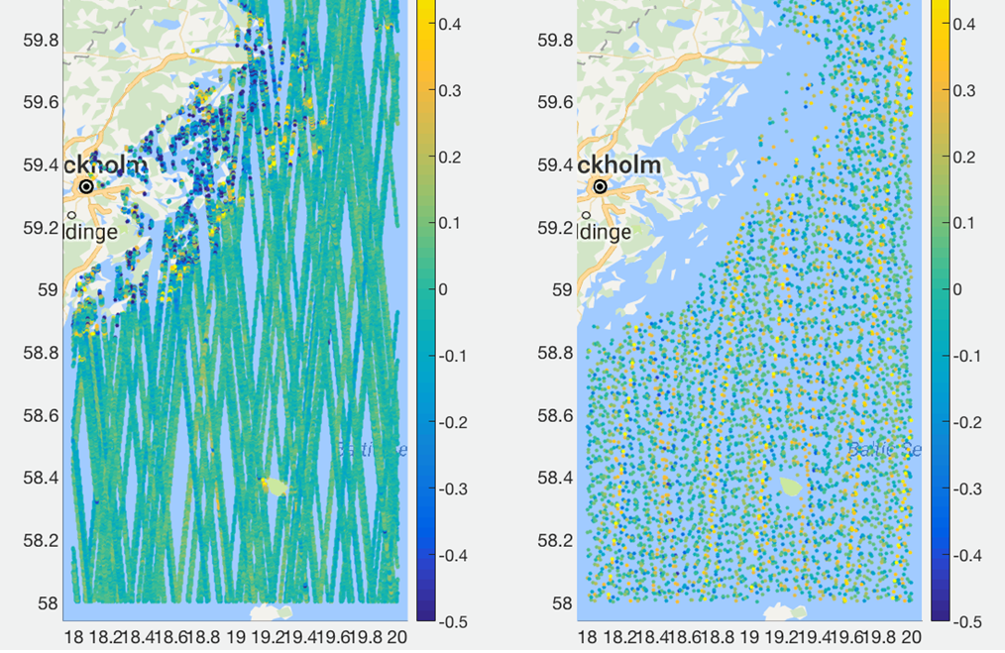
Figure 3.4 Satellite altimetry from Cryosat-2 available as 20 Hz from the ESA GPOD service (left) and as RADS 1 Hz edited data (right)

The comparison between the Tide gauge (blue), Cryosat-2 processed like conventional satellites is shown in red and as SAR altimetry is shown in yellow in Figure 3.5.
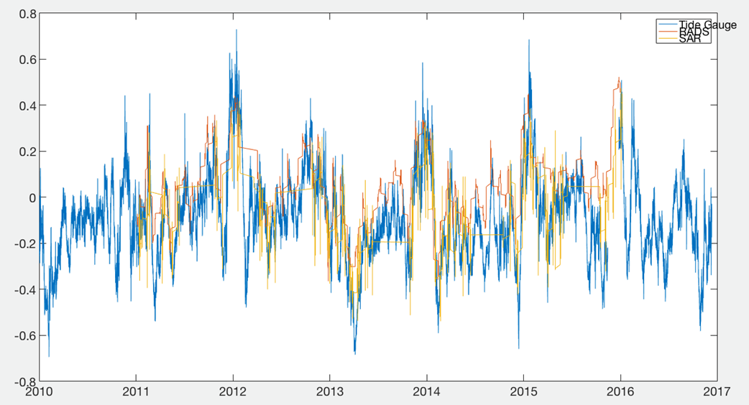
Figure 3.5. Sea surface height (meters) from Cryosat-2 20 Hz SAR altimetry (yellow)and 1 Hz edited conventional altimetry (red) for the Stockholm tide gauge (blue).
The conculsion is currently in-conclusive. This is because that the Cryosat-2 data is very sparsely sampled in time close to the Stockhold tide gauge.
Furthermore it was found from a close inspection of Figure 3.4 the the SAR processed data were available at 20 Hz where as the conventional data where available as 1 hz. In the latter the 1hz is computed as an averageing of 20 observations of 20Hz which lowers the noise on sea elvel by 1/sqrt(20) biasing the results towards the 1 Hz data.

Comparison with 30 years altimetry.

In the following we used the DTU altimetry illustrator which was developed in the FAMOS project to plot and visualize satellite altimetry in a region of the Baltic Sea. The illustrator is described in detail in section 4 below. The illustrator contains all Baltic satellite altimetry covering the 1986-2016 period from a total of 11 satellites (GEOSAT, GEOSAT FO, ERS-1, ERS-2, Envisat, Saral, TOPEX/POSEIDON, Jason-1, Jason-2, Jason-3 and Cryosat2) . All data are referenced to the FAMOS Mean sea surface (DTU16MSS) .
All satellite data from all satellite altimetry missions within the box bounded by 58.0 to 58.4N and 20.5E and 21.8E shown in figure 3.1 has been used. The reason for chosing the box a bit far from the coast is because we found it to be the most important to select a box with had as many satellite sea level observations as possible.
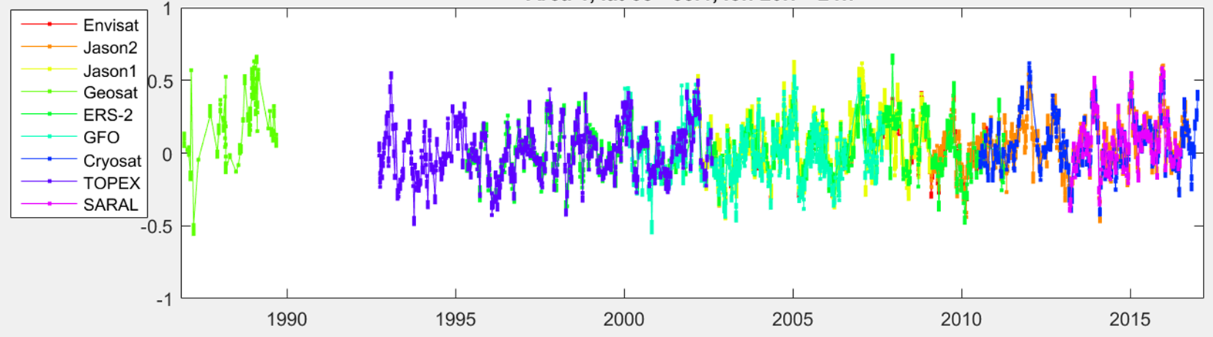
Figure 3.6. Sea surface height (meters) from satellite altimetry for all satellites available in the Baltic Sea since 1986. The naming of the satellites is shown in the Legend.

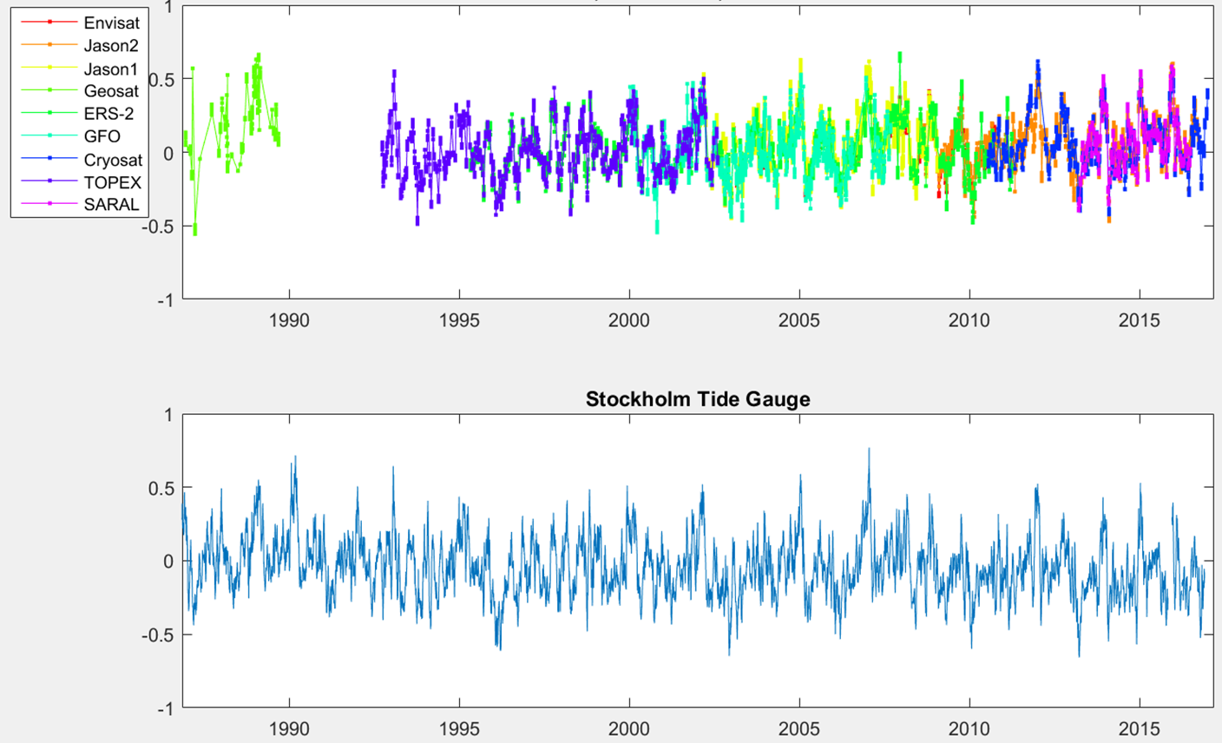
Figure 3.7 Merger of two figures (3.6 and 3.2) to directly compare the Stockholm tide gauge with satellite altimetry since 1986.

Figure 3.7 is very nicely illustrating that all 19 sea level “extremes” at the Stockholm tide gauges have been captured when all satellites have been used. As satellite altimetry in the open part of the Baltic has smaller height variations with a standard deviation of close to 15 cm we lowered the threshold to 2 x the standard deviation or 30 cm. With this threshold we were able to capture all extremes with satellite altimetry in the Baltic Sea.

The DTU altimetry illustrator.
A matlab program was created to visualise altimetric height relative to the MSS for a given region and a given period in order to let FAMOS and other users compare with local tide gauges throughout the Baltic. This is also because tide gauge information is frequently very hard to get at and also measured in the local reference frame which needs to be corrected for.

The program uses a graphical interface to select a region and all satellites available on 1 Hz (shown in Figure 4.1) is plotted as a time series. Figure 3.4-3.6 is generated using the graphical interface in the program.

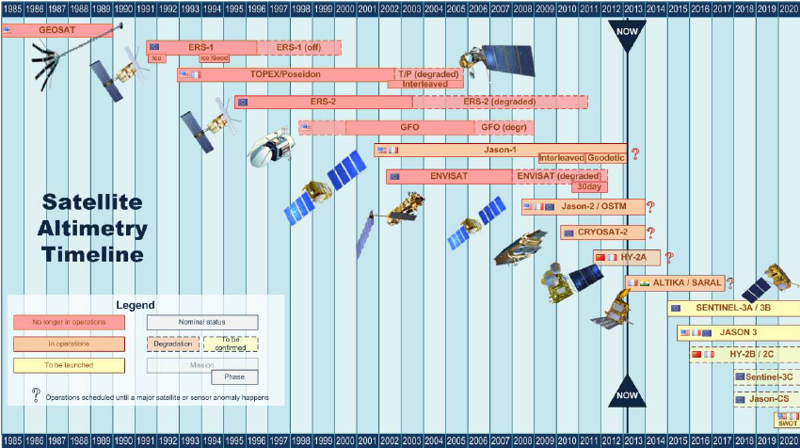

Figure 4.1 Satellite altimetry time line and available satellites for the DTU altimetry illustrator prepared for the FAMOS project.

4.1 Software

The software for windows including altimetry data is available as a zipped archive from the FAMOS ftp site at DTU Space called:
Ftp.space.dtu.dk/pub/Altimetry/FAMOS/EXTREMES2018/Altimetry_plot.zip

The programs and all data are can be extracted with any compressing facility on the users computer and the interface and program is then run as a matlab application.
Disclamer: We have recently been made aware of the fact that the intrinsic routine plot_google_map used to generate the graphical interface requires the user to sign up with Google before the routine works.

