**Abstract and Conclusion**

The processes and tests applied in the intermediate validation of the product

and the conclusions on the product quality drawn herefrom are described in this document.

This product contains the representation of a model of the magnetic field of Earth’s magnetosphere (“MMA” part of product name) using spherical harmonic coefficients (“SHA” part of product name). The model is estimated from Swarm and observatory data using the *Comprehensive Inversion* (CI) scheme within the Swarm Level 2 Processing system (“2C” part of product name). Operational Swarm Level 1b data version 0505/0506, covering the period from 2013-11-25 to 2018-12-31 are used for the model estimation; the product is valid over the same period (“20131125T000000_20181231T235959” part of product name). This is version 0501 of the product (last part of product name), i.e. baseline 05 indicating 5th year CI production, first, minor version. The format of the product is described in “Product Specification for L2 Products and Auxiliary Products”, doc. no. SW-DS-DTU-GS-0001.

The assessment of the product shows good agreement with the magnetic indices *Dst* and *RC*, and with existing mantle conductivity models.

**The DTU SIL’s opinion is that the product is validated and therefore suitable for release.**

Table of Contents

1 Intermediate Validation Report of MMA_SHAi2C 4

1.1 Input data products 4

1.2 Model Parameterization and Data Selection 4

1.3 Output Products 4

1.4 Validation Results 4

1.4.1 Correlation with Dst Index 5

1.4.2 Coherency with RC Index 6

1.4.3 C_Response 7

1.4.4 Data Statistics 8

1.5 Criteria 8

2 Additional Information 9

2.1 Model Configuration and Data Selection Parameters 9

2.2 Comments from Scientists in the Loop 10

2.2.1 Derivation of Model 10

2.2.2 Conclusion 11

Table of Figures

Figure 1‑1: Correlation between  and  of MMA_SHAi2C and Dst index 5

Figure 1‑2: Coherency between dipole terms, RC index, and  of MMA_SHA_2F 6

Figure 1‑3: C-Response estimated from and  7

Table of Tables

Table 1‑1: Input data products 4

Table 1‑2: Observation Statistics: standard deviations of data residuals, Huber weighted, [nT] 8

Table 1‑3: Validation criteria 8

Table 2‑1: Model Configuration 10

Abbreviations

| ***Acronym*** | ***Description*** |
| --- | --- |
| CI | Comprehensive Inversion |
| EUL | Euler Angle |
| L2PS | Level 2 Processing System |
| MMA | Magnetic Magnetospheric field |
| PDGS | Payload Data Ground Segment |
| SHA | Spherical Harmonic Analysis |
| SIL | Scientist in the Loop |
| STR | Star Tracker |
| TDS | Test Data Set |
| VAL | Validation |
| VFM | Vector Field Magnetometer |

***References***

[Grayver, GRL, 2017] *Joint inversion of satellite-detected tidal and magnetospheric signals constrains electrical conductivity and water content of the upper mantle and transition zone*; Grayver, A. V.; Munch F. D.; Kuvshinov, A. V.; Khan, A.; Sabaka, T. J.; Tøffner-Clausen, L.; under review for Geophysical Research Letters, 2017.

[Sabaka, GJI, 2004] *Extending comprehensive models of the Earth's magnetic field with Orsted and CHAMP data*; Sabaka, Terence J.; Olsen, Nils; Purucker, Michael E.; in journal: Geophysical Journal International (ISSN: 0956-540X), vol: 159, issue: 2, pages: 521-547, 2004.

[Sabaka, GJI, 2015] *CM5, a pre-Swarm comprehensive geomagnetic field model derived from over 12 yr of CHAMP, Ørsted, SAC-C and observatory data*; Sabaka, Terence J.; Olsen, Nils; Tyler, Robert H.; Kuvshinov, Alexey; in journal: Geophysical Journal International (ISSN: 0956-540X), doi: [10.1093/gji/ggu493](http://dx.doi.org/10.1093/gji/ggu493), vol: 200, issue: 3, pages: 1596-1626, 2015.

[Sabaka, GRL, 2016] *Extracting Ocean-Generated Tidal Magnetic Signals from Swarm Data through Satellite Gradiometry*; Sabaka, Terence J. ; Tyler, Robert H. ; Olsen, Nils in journal: Geophysical Research Letters (ISSN: 0094-8276), doi: [10.1002/2016GL068180](http://dx.doi.org/10.1002/2016GL068180), 2016

[Sabaka et.al., EPS, 2018] *A Comprehensive Model of Earth's Magnetic Field Determined From 4 Years of Swarm Satellite Observation*; Sabaka, Terence J. ; Tøffner-Clausen, Lars; Olsen, Nils; Finlay, Christopher C. Earth Planets and Space, in preparation (2018).

# Intermediate Validation Report of

## Input data products

The following input data products were used for the estimation of the magnetospheric field model

| **Products** | **Type** | **Period** | **Comment** |
| --- | --- | --- | --- |
| SW_OPER_Q3D_CI_i2__00000000T000000_99999999T999999_0101 | Q-matrix of Earth’s (1-D mantle + oceans) | - | Used for computing induced part of ionospheric field |
| SW_OPER_AUX_OBS_2__20130101T000000_20131231T235959_0117 SW_OPER_AUX_OBS_2__20140101T000000_20141231T235959_0117 SW_OPER_AUX_OBS_2__20150101T000000_20151231T235959_0117 SW_OPER_AUX_OBS_2__20160101T000000_20161231T235959_0117 SW_OPER_AUX_OBS_2__20170101T000000_20171231T235959_0117  SW_OPER_AUX_OBS_2__20180101T000000_20181231T235959_0117 | Observatory hourly mean values | 2013-11-25 – 2017-10-31 | A total of 163 observatories are included |
| SW_OPER_AUX_DST_2__19980101T013000_20190115T233000_0001 SW_OPER_AUX_F10_2__20060101T000000_20190115T000000_0001 SW_OPER_AUX_KP__2__19990101T023000_20190117T133000_0001 | Indices | As indicated by the file names |  |
| SW_OPER_MAGA_LR_1B_*yyyymmdd*T*h1m1s1*_*yyyymmdd*T*h2m2s2*_*vvvv* SW_OPER_MAGB_LR_1B_*yyyymmdd*T*h1m1s1*_*yyyymmdd*T*h2m2s2*_*vvvv* SW_OPER_MAGC_LR_1B_*yyyymmdd*T*h1m1s1*_*yyyymmdd*T*h2m2s2*_*vvvv* | Swarm magnetic data, 1 Hz | 2013-11-25 - 2018-12-31 | Decimated to 1 mnute sampling *vvvv* = 0505 or 0506 |

Table 1‑1: Input data products

## Model Parameterization and Data Selection

See Section 2.1.

## Output Products

The products of this validation report are:

*Swarm Level 2 Magnetospheric field Product:*

*Swarm Level 2 Intermediate Validation Product:*

SW_OPER_MMA_VALi2C

## Validation Results

The tests were conducted between 2019-01-25 and 2019-02-20.

This 5th year CI L2 production, denoted CIY5, is very similar in methodology and results as last year’s production (CIY4) which is thoroughly described in [Sabaka et.al., EPS, 2018]. The following contains the results of the tests performed on the magnetospheric field output product.

### Correlation with Dst Index

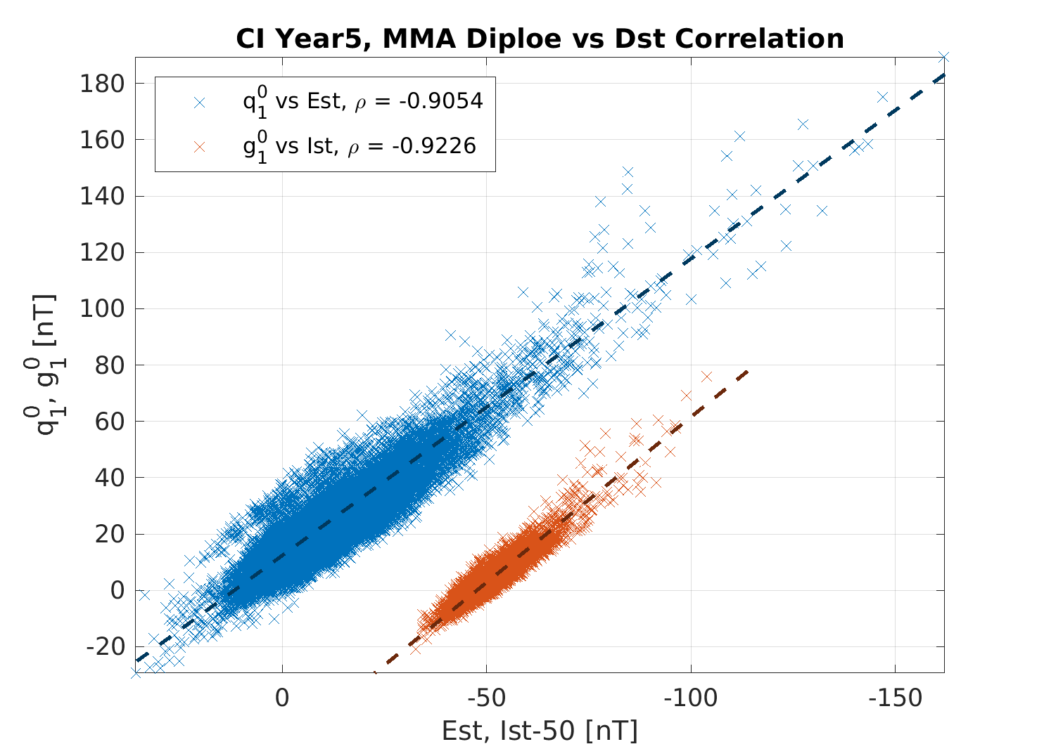Figure 1‑1 below shows the correlation between the main dipole coefficients of the external (inducing), , and internal (induced), , parts of the magnetospheric model and the respective parts, Est and Ist, of the geomagnetic index, Dst. The high correlation numerically above 0.90 demonstrates a good estimation of and .

Figure 1‑1: Correlation between  and  of and Dst index

### Coherency with RC Index

In Figure 1‑2 below, the squared coherences between the external and the induced dipole coefficients of , and of these vs the RC index are shown. In red  vs RCe, in blue  vs RCi, and in black  vs . Coherencies are almost everywhere above 0.85 (except vs. RC for periods shorter than a few days).

Figure 1‑2: Coherency between dipole terms, and RC index

### C_Response

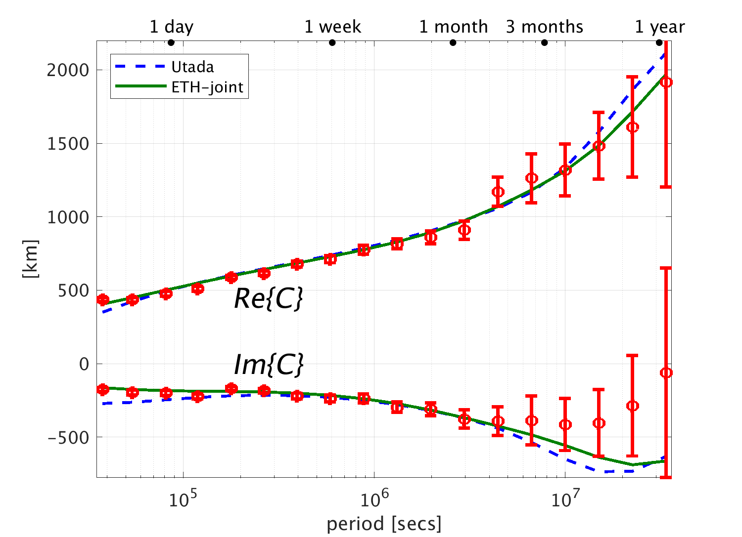Figure 1‑3 below shows the C-response estimates based on  and  in red circles with estimated error bars. The blue dashed curve shows theoretical values based on the conductivity model of Utada et al., whereas the green curves are based on the conductivity model of [Grayver, GRL, 2017]; both are in quite good agreement with the results from the CI MMA dipole terms.

Figure 1‑3: C-Response estimated from and 

### Data Statistics

The statistics of the residuals between the measurement data and the complete CI model are given in Table 1‑2 below. Note that the measurements encompass all data (quiet and disturbed) from both day (sunlit) and night side, high due to its higher altitude latitude data are down-weighted, cf Table 2‑1.

|  | Geomagnetic dipole latitude | | | | | | | | |
| --- | --- | --- | --- | --- | --- | --- | --- | --- | --- |
| Low, ≤ 10° | | | Mid, ]10°..55°] | | | High, > 55° | | |
| σ(Br) | σ(Bθ) | σ(Bφ) | σ(Br) | σ(Bθ) | σ(Bφ) | σ(Br) | σ(Bθ) | σ(Bφ) |
| Swarm A | 3.55 | 5.93 | 6.99 | 3.33 | 7.30 | 7.06 | 24.95 | 53.10 | 57.13 |
| Swarm B | 3.49 | 5.77 | 6.80 | 3.25 | 7.18 | 6.96 | 23.45 | 52.10 | 56.86 |
| Swarm C | 3.56 | 5.93 | 6.91 | 3.32 | 7.31 | 7.05 | 24.94 | 53.10 | 57.15 |
| Observatories | 4.52 | 7.55 | 6.57 | 4.11 | 7.00 | 7.13 | 30.13 | 43.19 | 30.30 |

Table 1‑2: Observation Statistics: standard deviations of data residuals, Huber weighted, [nT]

## Criteria

Table 1‑3 below summarizes the criteria used to check the validity of the product:

| **Input** | **Test** | **Criteria** | **Pass?** |
| --- | --- | --- | --- |
| Observations | Residual statistics | Standard deviation of quiet time vector data below 7 nT.  Standard deviation of scalar data below 5 nT | Ok |
| Satellite Observations | Residual plots | Residuals show expected behaviour | Ok |
| Alternative model | Comparison with model | CI model agrees with alternative models | Ok |

Table 1‑3: Validation criteria

# Additional Information

## Model Configuration and Data Selection Parameters

The product is obtained as an estimation of the residual magnetic vector field after subtraction of a comprehensive co-estimated model of the core, lithosphere, ionosphere, and magnetosphere field contributions including induced contributions based on quite time data similar to [Sabaka et.al., EPS, 2018]. The complete model configuration used is given in Table 2‑1 below; the product is the green part:

| **Model Part** | **Maximum Degree/Order** | **Temporal Characteristics** | **Comment** |
| --- | --- | --- | --- |
| Core | 18/18 | Order 5 B-spline with knots every 6 months | Damping of the mean-square, second and third time derivatives of Br at the core-mantle boundary (at 3480 km radius) with enhanced damping of zonal terms up to degree 9. |
| Lithosphere | 120/120 | Static | Degree 19-120 purely determined by North-South differences from all satellites and East-West differences of lower pair satellite (A and C).  Damping of Br for degrees 91 and above to reduce noise |
| Ionosphere | 45/5 (dipole coordinates) | Annual, semi-annual, 24-, 12-, 8- and 6- hours periodicity | Spherical harmonic expansion in quasi-dipole (QD) frame, underlying dipole SH *n*max = 60, *m*max = 12. Scaling by 3-months averages of F10.7 plus induction via a priori 3-D conductivity model (“1-D + oceans”) and infinite conductor at depth.  Regularisation of:   1. Mean-square current density J in the E‑region within the nightside sector (magnetic local times 21:00 through 05:00; peak damping at 01:00) 2. Mean-square of the surface Laplacian of J multiplied by a factor of sin8(2θ) over all local times, where θ is co-latitude. |
| Magnetosphere, quiet time, external | 3/1 | One hour bins |  |
| Magnetosphere, quiet time, induced | 3/3 | One hour bins |  |
| Magnetosphere, all data, external | 2/2 | Axial dipole term: 1½ hour bins Other terms: 6 hour bins | Determined from vector (residual) data. Data above 55° magnetic dipole latitude are down-weighted by a factor of *sin(θ)/10*, where *θ* is the dipole co-latitude. |
| Magnetosphere, all data, induced | 3/3 | Axial dipole term: 1½ hour bins Other terms: 6 hour bins |
| Toroidal | 45/5 (dipole coordinates) | Semi-annual and six hours periodicity | Meridional currents in QD frame, underlying dipole SH *n*max = 60, *m*max = 12, centred at 400 km altitude. |
| M2 Tidal | 18/18 | Periodicity: 12.42060122 hr, phase fixed with respect to 00:00:00, 1999 January 1 GMT |  |

Table 2‑1: Model Configuration

The data selection criteria for the quiet time data are:

* Coarse agreement with CHAOS-6 field model: ΔB*c* ≤ 500 nT for all components *c=r,ϑ,φ*, and ΔF ≤ 100 nT.
* Kp ≤ 30 for gradient data, Kp ≤ 2- for field data
* Time-derivative of Dst: |dDst/dt| ≤ 3 nT/hour
* 30 second satellite sampling period, NS gradient data computed from 15 second differences
* Core and tidal fields determined from night-side data only, i.e. with Sun ≥ 10° below the horizon

For the estimation of the product all data were used except clearly erroneous data which were removed following visual inspection.

## Comments from Scientists in the Loop

### Derivation of Model

The final Comprehensive Inversion model for the first four years of Swarm data show good agreement with alternative models.

### Conclusion

The estimated model is assessed to be of good quality with good agreement with the magnetic indices Dst and RC, and of the C-response of an alternative induction model.

Further analyses from the derivation of the 3-D mantle conductivity indicate some problems using the non-dipole terms for such studies. This will be pursued in future CI models.

1. Definitions of Tests
   1. Mean square vector field difference per spherical harmonic degree

The mean square vector field difference between models per spherical harmonic degree (*n*) is diagnostic of how closely the models match on average across the globe. The difference between Gauss coefficients of model *i* and model *j* can be defined as:

 Equation A‑1

where *n*  is the degree, *m* is the order, *a* is the magnetic reference spherical radius of 6371.2 km which is close to the mean Earth radius, and *r* is the radius of the sphere of interest, which is taken as r = a for comparisons at the Earth’s surface and r = 3480 km for comparisons at the core-mantle boundary.

Summing over degrees n from 1 to the truncation degree N and taking the square root yields the RMS vector field difference between the models *i* and *j* averaged over the spherical surface:

 Equation A‑2

* 1. Correlation per spherical harmonic degree

Analysis of spherical harmonic spectra is a powerful way to diagnose differences in amplitude between models but tells us little about how well they are correlated. The correlation per degree between two models again labelled by the indices *i* and *j* can be studied as a function of spherical harmonic degree using the quantity: 

 Equation A‑3

Ideally, the correlation should be close to 1 for all models, indicating that they have equivalent features and coefficients. If the correlation falls below 0.5, for degrees 1-9, then the models should be examined in more detail. Coefficients from degree 10-13 in IGRF and WMM are less well-determined (e.g. due to noise) and also change more rapidly so are not expected to be well correlated by the launch of the Swarm mission.

* 1. Visualisation of coefficient differences

A final method of visualising the differences in Gauss coefficients is to plot the differences as a triangular plot, with the zonal coefficients lying along the centre of the triangle, the sectorial coefficients along the edges and the tesseral coefficients filling the central regions. These plots will illustrate which, if any, coefficients are strongly divergent between models

* 1. Visualisation of spatial differences

A geographical investigation of the models can be made by plotting the differences in the Bx, By and B­z components of the field at radius r = a. Studying differences between the Swarm models and reference models in space yields insight into the geographical locations where disparities are located, illustrating whether biases or errors have arisen in certain regions (e.g. polar areas).

.

* 1. Visualisation of spatial differences

A geographical investigation of the models can be made by plotting the differences in the Bx, By and B­z components of the field at radius r = a. Studying differences between the SWARM models and reference models in space yields insight into the geographical locations where disparities are located, illustrating whether biases or errors have arisen in certain regions (e.g. polar areas).